SENIOR SIX AGRICULTURE LESSON NOTES TERM I 2026

CONSTRUCT: CROP PRODUCTION
TOPIC 1/3: Land Policy
Competency: The learner demonstrates an understanding of land rights, land tenure and land reform to ensure sustainable crop production.

Land Tenure System
A land tenure system refers to the rules, laws, and customs that define how land is owned, used, and transferred. It determines who can use land, for how long, and under what conditions. These systems are crucial for economic development, social stability, and sustainable resource management
- Definition: Land tenure is the legal and social framework that governs land ownership and usage rights.
- Purpose: It ensures clarity on who controls land, how it can be used, and how disputes are resolved.
- Scope: It covers ownership, leasing, inheritance, and communal rights.

Types of Land Tenure Systems
- Customary tenure: Land is managed according to traditions and community rules, often without formal documentation.
- Freehold tenure: Individuals have permanent ownership rights, with freedom to sell, lease, or transfer land.
- Leasehold tenure: Land is leased for a fixed period under agreed conditions, often from the government or private owners.
- Mailo tenure: Unique to Uganda, where land is owned permanently but tenants also have occupancy rights.
- Condominium ownership: Common in urban areas, where individuals own units but share common spaces.

Comparison of Tenure Systems
System | Ownership Rights | Transferability | Challenges
Customary | Community-based,  traditional | Limited formal transfer | Lack of documentation, disputes
Freehold | Permanent, individual | Fully transferable | Requires legal registration
Leasehold | Temporary, contractual | Transfer depends on lease terms | Expiry risk, renewal issues
Mailo | Permanent, but tenants have rights | Transferable with restrictions | Conflicts between landlords & tenants
Condominium | Unit ownership + shared areas | Transferable | Complex management of shared spaces

Importance of Land Tenure Systems
- Economic growth: Secure tenure encourages investment in agriculture, housing, and infrastructure.
- Social stability: Clear rights reduce land conflicts and promote peace.
- Environmental sustainability: Proper tenure prevents overuse and degradation of land.
- Legal protection: Provides a framework for resolving disputes and protecting vulnerable groups.
- Investment confidence: Investors prefer areas with clear and enforceable land rights.

Challenges & Risks
- Conflicts: Overlapping claims between customary and statutory systems.
- Documentation gaps: Many rural communities lack formal land titles.
- Gender inequality: Women often face barriers to land ownership under customary systems.
- Corruption: Weak enforcement can lead to land grabbing and exploitation.

How Land Tenure Systems Can Support Sustainable Agriculture
- Customary tenure o Encourage communities to formalize agreements that protect vulnerable groups (e.g., women, youth).
  - Promote collective resource management (water, grazing land) to prevent overuse.
  - Introduce community bylaws for soil conservation and reforestation.
- Freehold tenure o Secure ownership motivates farmers to invest in long-term practices like agroforestry, irrigation, and soil fertility management.
  - Encourage crop diversification and organic farming since farmers are confident they won’t lose their land.
- Leasehold tenure o Design lease agreements that require sustainable practices (e.g., crop rotation, soil conservation).
  - Government can lease land to investors under conditions that protect local communities and ecosystems.
- Mailo tenure o Resolve landlord–tenant conflicts to ensure farmers feel secure enough to invest in sustainable practices.
  - Promote joint agreements where both landlords and tenants benefit from conservation measures.

Practical Applications in Communities
- Secure land rights: Farmers with clear tenure are more likely to plant trees, conserve soil, and invest in irrigation.
- Community land-use planning: Use customary systems to designate areas for grazing, farming, and conservation.
- Gender equity: Ensure women have recognized rights to land, enabling them to adopt sustainable farming practices.
- Education & training: Teach farmers how tenure security links to better yields and environmental protection.
- Conflict resolution: Strengthen local institutions to reduce disputes that disrupt farming and resource management.

Benefits of Linking Tenure to Sustainability
Tenure System | Sustainability Strategy | Community Benefit
Customary | Collective bylaws for soil & water use | Reduced land degradation
Freehold | Long-term investment in agroforestry | Higher yields & resilience
Leasehold | Green clauses in lease agreements | Balanced investor–community interests
Mailo | Conflict resolution + shared conservation | Secure farming & reduced disputes

Why This Matters
- Food security: Sustainable practices ensure steady harvests.
- Economic growth: Secure tenure encourages investment in modern farming.
- Environmental protection: Prevents soil erosion, deforestation, and biodiversity loss.
- Social stability: Reduces land conflicts and promotes fairness in resource use.

Land reforms in Uganda
Land reforms in Uganda have centered on the 1995 Constitution, the 1998 Land Act, and the 2013 National Land Policy, aiming to secure tenure, resolve disputes, and balance customary and statutory systems. Despite progress, challenges like corruption, overlapping claims, and weak enforcement persist.
Key Land Reform Milestones in Uganda
- 1995 Constitution: Recognized four tenure systems (Customary, Freehold, Leasehold, Mailo) and vested land ownership in citizens rather than the state.
- 1998 Land Act: Operationalized constitutional provisions, strengthened tenure security, and gave legal recognition to customary ownership.
- 2013 National Land Policy: Provided a framework for equitable access, sustainable use, and gender-sensitive reforms.
- Ongoing reforms: Introduction of the National Land Information System to digitize records and reduce disputes.

Comparison of Reform Goals and Outcomes
Reform | Goal | Outcome | Challenges
1995 Constitution | Secure tenure & recognize systems | Citizens own land | Overlapping claims
1998 Land Act | Legalize customary tenure | Greater recognition | Weak enforcement
2013 National Land  Policy | Equity & sustainability | Policy framework | Limited implementation
National Land Info  System | Digitize land records | Improved transparency | Corruption, slow rollout

The impact of land reforms in Uganda on sustainable crop production within the community Positive Impacts
- Tenure security: Farmers with recognized rights (customary, freehold, leasehold, or mailo) are more willing to invest in long-term practices like soil fertility management, irrigation, and agroforestry.
- Increased investment: Secure land encourages adoption of modern technologies such as improved seed varieties, organic fertilizers, and conservation farming.
- Community empowerment: Recognition of customary tenure allows rural communities to manage land collectively, promoting sustainable use of shared resources like grazing areas and water.
- Gender inclusion (policy goal): Reforms aim to improve women’s access to land, enabling them to contribute to sustainable crop production.
- Environmental protection: Policies encourage sustainable land use, reducing deforestation and soil erosion.

Challenges Limiting Impact
- Land disputes: Conflicts, especially under the mailo system, discourage farmers from investing in long-term sustainable practices.
- Documentation gaps: Many rural farmers still lack formal titles, leaving them vulnerable to land grabbing and eviction.
- Gender inequality: Despite reforms, women often face cultural barriers to land ownership, limiting their role in sustainable agriculture.
- Corruption and weak enforcement: Policies are strong on paper but often poorly implemented, undermining sustainability goals.
- Population pressure: Increasing demand for land leads to fragmentation, reducing the viability of sustainable farming practices.

Summary Table
Reform Aspect | Impact on Crop Production | Community Effect
Tenure security | Encourages soil conservation & agroforestry | Higher yields, resilience
Customary recognition | Collective land management | Reduced degradation
Gender equity policies | More women in farming decisions | Inclusive sustainability
Digitization of records | Transparency in ownership | Reduced disputes
Weak enforcement | Limited adoption of sustainable practices | Persistent conflicts

Overall Effect
Land reforms in Uganda have created opportunities for sustainable crop production by securing tenure and recognizing customary systems. However, implementation gaps, conflicts, and inequality continue to hinder their full potential. Strengthening enforcement, promoting gender equity, and resolving mailo land conflicts are critical to ensuring reforms translate into sustainable agricultural growth.

Advantages and disadvantages of each land tenure systems in Uganda
1. Customary Tenure

• Advantages
- Cultural relevance: Rooted in traditions, widely accepted in rural communities.
- Accessibility: Easy for community members to acquire land without costly registration.
- Flexibility: Allows communal use and sharing of resources.
• Disadvantages o Lack of documentation: No formal titles, leading to disputes. o Gender inequality: Women often excluded from ownership rights. o Limited investment: Farmers may hesitate to invest in long-term improvements without secure titles.
2. Freehold Tenure

• Advantages
- Permanent ownership: Provides full rights to sell, lease, or transfer land. o Security: Encourages investment in sustainable farming and infrastructure.
- Legal protection: Registered titles reduce disputes.
• Disadvantages o Costly registration: Expensive and bureaucratic for rural farmers. o Exclusion risk: Poor communities may be left out due to costs. o Fragmentation: Land subdivision among heirs can reduce productivity.
3. Leasehold Tenure

• Advantages
- Flexibility: Suitable for investors and short-term projects.
- Government oversight: Conditions can promote sustainable land use.
- Access for non-citizens: Allows foreigners to use land legally.
• Disadvantages o Temporary rights: Farmers may not invest heavily due to expiry risks. o Renewal disputes: Uncertainty when leases end. o Dependence: Tenants rely on landlords or government for continued access.
4. Mailo Tenure

• Advantages
- Legal recognition: Protected under the Constitution and Land Act. o Tenant security: Occupants have rights to stay and use land.
- Transferability: Owners can sell or lease land.

• Disadvantages
- Landlord–tenant conflicts: Frequent disputes over rights and obligations. o Overlapping rights: Both landlords and tenants claim authority.
- Complexity: Difficult to manage and often politically sensitive.

Summary Table
System | Advantages | Disadvantages
Customary | Cultural relevance, accessibility, flexibility | Lack of documentation, gender inequality, limited investment
Freehold | Permanent ownership, security, legal protection | Costly registration, exclusion risk, fragmentation
Leasehold | Flexibility, government oversight, access for non-citizens | Temporary rights, renewal disputes, dependence
Mailo | Legal recognition, tenant security, transferability | Landlord–tenant conflicts, overlapping rights, complexity

Sample Advocacy Letter
[Your Name] [Your Address] [Date]
To: The Local Council Authorities [District/Community Name] Uganda

Subject: Advocacy for Land Reforms to Enhance Sustainable Crop Production
Dear Sir/Madam,
I am writing to respectfully advocate for strengthened land reforms within our community to promote sustainable crop production and ensure long-term food security.
Land is the foundation of agriculture, and secure tenure is essential for farmers to confidently invest in practices that protect soil fertility, conserve water, and increase yields. While Uganda’s Constitution and Land Act recognize multiple tenure systems—Customary, Freehold, Leasehold, and Mailo—many farmers still face challenges such as unclear ownership, disputes, and limited access to formal documentation. These issues discourage investment in sustainable farming methods and hinder our community’s agricultural potential.
By prioritizing reforms that improve tenure security, streamline land registration, and resolve landlord–tenant conflicts, we can empower farmers to adopt practices such as crop rotation, agroforestry, and organic soil management. Furthermore, equitable access to land—especially for women and youth—will ensure inclusive participation in sustainable agriculture, strengthening both our economy and food systems.
I therefore urge the local authorities to:
- Support community sensitization on land rights and responsibilities.
- Facilitate affordable and transparent land registration processes.
- Promote gender-sensitive policies that guarantee women’s access to land.
- Encourage bylaws that integrate sustainable farming practices into land use. • Strengthen mechanisms for resolving land disputes fairly and quickly.
These measures will not only reduce conflicts but also create an enabling environment for sustainable crop production, ensuring that our community thrives both economically and environmentally.
Thank you for your attention to this matter. I trust that with your leadership, we can build a stronger, more sustainable agricultural future for our people.
Yours faithfully, [Your Name]

TOPIC 2/3: Soil Systems
Competency: The learner demonstrates understanding of soil systems for crop productivity.

Soil Properties
In agriculture, soil properties—physical, chemical, and biological—determine how well crops grow. They affect water retention, nutrient availability, root development, and overall productivity.
Key Soil Properties in Agriculture
- Physical properties o Texture: Proportion of sand, silt, and clay; influences water retention and drainage. o Structure: Arrangement of soil particles; affects aeration and root penetration. o Porosity: Spaces between particles; determines water and air movement.
  - Bulk density: Soil compaction level; impacts root growth and tillage.
- Chemical properties o pH: Determines nutrient availability; most crops prefer 6–7. o Cation exchange capacity (CEC): Soil’s ability to hold nutrients like calcium, potassium, and magnesium.
  - Organic matter: Improves fertility, water retention, and microbial activity.
  - Nutrient content: Levels of nitrogen, phosphorus, potassium, and micronutrients.
- Biological properties o Microorganisms: Bacteria, fungi, and earthworms enhance nutrient cycling.
  - Soil biodiversity: Supports resilience against pests and diseases. o Decomposition activity: Breaks down organic matter into usable nutrients.
Soil Properties and Their Agricultural Importance
Property Type | Examples | Impact on Agriculture
Physical | Texture, structure, porosity | Water retention, drainage, root growth
Chemical | pH, CEC, organic matter | Nutrient availability, soil fertility
Biological | Microorganisms, biodiversity | Nutrient cycling, soil health
Why Soil Properties Matter
- Crop productivity: Balanced soil properties ensure healthy plant growth.
- Sustainability: Good soil management prevents erosion and degradation.
- Water efficiency: Proper texture and structure improve irrigation outcomes. (iv) Nutrient cycling: Biological activity reduces reliance on synthetic fertilizers.
Challenges in Managing Soil Properties
- Soil erosion reduces fertility.
- Overuse of chemical fertilizers can disrupt pH and microbial balance.
- Compaction lowers porosity and root penetration.
- Climate change affects soil moisture and organic matter stability.

Fertilizers
Fertilizers are substances added to soil or plants to supply essential nutrients that enhance growth, improve yields, and sustain agricultural productivity. They can be organic (natural) or inorganic (synthetic), each with distinct advantages and trade-offs.
Types of Fertilizers
- Organic fertilizers o Derived from plant or animal matter (e.g., compost, manure, bone meal).
  - Release nutrients slowly, improve soil structure, and boost microbial activity.
- Inorganic (synthetic) fertilizers o Chemically manufactured (e.g., urea, ammonium nitrate, superphosphate).
  - Provide nutrients quickly and in precise amounts, but may degrade soil health if overused.
- Single-nutrient fertilizers o Supply one nutrient (e.g., nitrogen fertilizers like urea).
  - Useful for correcting specific deficiencies.
- Multi-nutrient fertilizers o Contain a mix (e.g., NPK fertilizers with nitrogen, phosphorus, potassium).
  - Balanced nutrition for overall crop growth. (v) Slow-release fertilizers
  - Release nutrients gradually over time.
  - Reduce leaching and improve efficiency.
Comparison of Fertilizer Types
Type | Advantages | Disadvantages
Organic | Improves soil health, eco-friendly, longterm fertility | Slow nutrient release, bulkier to transport
Inorganic | Fast nutrient supply, precise formulation | Risk of soil degradation, water pollution
Singlenutrient | Corrects specific deficiencies | May cause imbalance if overused
Multinutrient | Balanced crop nutrition | More expensive, less targeted
Slow-release | Efficient, reduces leaching | Higher cost, slower initial effect
Importance of Fertilizers in Agriculture
- Boost productivity: Essential for meeting global food demand.
- Improve crop quality: Enhances size, taste, and nutritional value.
- Support sustainability: Organic fertilizers maintain soil health; integrated use balances productivity with conservation.
- Economic impact: Fertilizers increase farmer incomes by improving yields.

Risks and Challenges
- Overuse of synthetic fertilizers can lead to soil acidification, nutrient leaching, and water pollution.
- Dependence on imports makes fertilizer prices volatile in countries like Uganda.
- Environmental concerns: Excess nitrogen and phosphorus contribute to climate change and eutrophication.

Soil detailed notes
Soil is a mixture of weathered rock materials, air, water, organic matter and living organism.
Importance of soil
- It is a medium within which plants grow.
- It provides water to the plant.
- It is a medium for microbial activities.
- It provides air for respiration of plant root.
- It is a medium for anchorage of plant it absorbs and decomposes waste material, thus keeping environment clean.

Soil formation
Soil is formed through the process of weathering.

Weathering
This is the process of breaking down or the disintegration of rocks to form soil.
The rocks that form soil are of three types i.e. igneous rocks, sedimentary rocks, and metamorphic rocks.

Igneous rocks
These are rocks formed by the cooling and solidification of molten magma (Larva) extracted at high temperature from the interior regions of the earth’s crust near on the surface of earth.
The main types of igneous rocks are:-
Granite, diorite, and basalt and gabbro. The minerals present in these rocks are mica, feldspar, quarts, iron oxides and biotite.

Sedimentary rocks
These are formed by the deposition of weather minerals which are derived from igneous rocks. E.g. shales, sand stone, and limestone. The minerals in these rocks are clay minerals, quartz, calcium, phosphate, dolomite, iron oxides.

Metamorphic rocks
These are formed by the action of heat, pressure and chemical changes on igneous and sedimentary rocks e.g. gneiss, schist, slate, and quartzite

Types of weathering
There are three main types of weathering i.e. physical weathering, chemical weathering and Biological weathering.

Physical weathering
This is the mechanical disintegration of rocks which is caused by heat, roots of trees, ice, wind and rain.
Temperature
When rocks are heated, they expand unevenly between their layers. A change in temperature will set up stresses which will result into breaking of rocks. The alternative heating and cooling results into rapturing of rocks.
Ice
When water cools to form ice, it expands. Therefore the presence of water in rocks cracks can lead to the breaking of rocks when it cools to form ice
Rain
Rainfall particularly that with hail stones falls on rocks surfaces crashing and removing some particles from them which are carried by the running water.
Wind
As strong wind, blows it carries away tinny rock particles to different places from the mother rock.
Plant roots
As roots penetrate through the rock cracks, they will cause further cracking as they increase in size through growth.
Chemical weathering
It is the breakdown of rock with accompanied with a change of chemical composition.

Process of chemical weathering
This includes hydrolysis, hydration, oxidation, carbonation, reduction, and solution.
Hydration
This occurs when water combines with minerals like silicates, oxides of iron or aluminum to form hydrated compounds e.g.
2Fe₂O₃ + 3H₃O → 2Fe₂O₃ . 3H₂O
The hydrated compound are softer than the original rock and therefore easily worn away.
Oxidation
It is the addition of oxygen to mineral rocks to form compound that decompose or dissolve easily.
2Fe (s) + 3O₂(s) →2Fe₂O₃(s)
Hydrolysis
This is the use of water to break up chemical bonds of a particular compound e.g
Calcium silicate + water → silic acid + calcium hydroxide
CaSiO₃ + 2H₂O → H₂SiO₃ +Ca(OH)₂
Reduction
It involves the removal of oxygen from minerals, e.g.
Fe₂O₃ → 4FeO + O₂
Solution
It is the dissolution of solid mineral compound in water.
NaCl (s) + aq →Na⁺(aq) + Cl⁻ (aq)
Carbonation
Water and carbon dioxide combine to form a weak carbonic acid which reacts with oxides and hydroxide of calcium and magnesium to form carbonate and bi-carbonates.
CO₂ (g) + H₂O (l) → H₂CO₃ (aq)
Ca(OH)₂ + H₂CO₃ → CaCO₃ + 2H₂O

Biological weathering
It is a type of weathering where rocks are broken down by living organisms, for instance
- Roots of trees grow in the cracks widen the cracks causing the rocks to split
- Burrowing animals e.g. rodents breakdown soft rocks and help in soil profile mixing.
- Living organisms like bacteria and fungi carry out decomposition of dead plants and animals remain leading to soil formation.
- Animal hooves break the rock surface that they walk on.
- The termites are able to convert wood into soil because they have the cellulose enzymes in their guts which act on cellulose in wood.
- The vegetative cover protects the soil surface from soil erosion hence minimizing soil loss.
- Living organisms die and decompose to form soil
- Earth worms grind up mineral particles important in soil formation
- Fungi and algae colonize the rocks and secrete chemicals which dissolve rocks.
- Man’s activities such as cultivation, quarrying breakdown rock

Factors affecting soil formation
These are responsible for the types and nature of soil formed in an area
- Nature of the parent rock
It refers to the material from which soil is formed
  - It determines the type of soil formed for example sand stone gives rise to sandy soil while volcanic ash give rise to very fine soils.
  - Parental material affects the colour of the soil formed
  - Parent material determines the ease of weathering i.e. soft rocks such as igneous rocks are easier to breakdown.
  - Parent material influences the rate of soil profile development
  - Parent material determines the depth of soil formed. For example, soft igneous rocks produce deeper and more fertile soils than hard sedimentary rocks
- Climate
Climatic factors that influence soil formation include temperature, rainfall and wind
(i) Effect of temperature
    - Alternate expansion and contraction of rock surfaces due to temperature changes of day and night cause cracking of rocks to form soil
    - Increase in temperature results in evaporation of soil moisture of soil moisture to form rain which is a weathering agent
    - Increase in temperature promotes activities of soil organisms that cause biological weathering
    - High temperature causes peeling of the rock surface (exfoliation)
    - Low temperature at high altitude cause solidification water into ice that exert pressure and cause rocks to crack
(ii) Effect of rain
    - Rain drops dislodges particles from rocks to form soil
    - Flow of rain water carry solids that knock particle from parent rocks.
    - Rain dissolves carbon dioxide and sulphur dioxide forming acid solution which dissolve rocks.
    - Rain provide water used by soil organisms in decomposed organic matter.
    - Running water helps to remove accumulated materials from rocks surface thus exposing rocks to agents of weathering. (iii) Effect of wind
    - Wind blows sand particles against rock causing abrasion of the rock surface
    - Wind remove accumulated material from rock surface exposing rocks to agents of weathering
- Topography (relief)
  - This influences the amount of rainfall received in an area,
  - Surface erosion which determines soil depth by removal and deposition of soil - Water infiltration into the soil.
  - It also influences vegetation through its influence on rainfall hence affecting soil formation.
- Time
  - It requires a lot of time for a soil to develop up to full maturity. A mature soil will contain all the required nutrients needed by plants.
  - The longer the time the rock is exposed to agents of weathering, the deeper and more fertile the soil will be
  - Clay content of the soil increase with time
  - Organic matter soil content increase with time.
- Human influence
Humans tend to disrupt soil formation through disturbing soil profiles during the cultivation, and construction of buildings, roads and dams.
Man can transform soil in the following ways; o Natural vegetation is destroyed in getting land for agriculture o Fertilizer application interferes with the chemical nature of soil o Topography is altered through constructions of roads and buildings o Application of pesticides changes chemical soil properties o Soil cultivation destroys soil structure
  - Irrigation may interfere with soil nutrient composition and structures
  - bush burning destroys organic matter and raises soil temperature, slowing down the process of soil formation
The stages of soil formation
Soil formation involves 3 stages of disintegration, decomposition and translocation.
  - Disintegration; breaking up of parent material
  - Decomposition; process of decomposing organic materials
  - Translocation; removal of soil or vertical movement of particles and dissolved solids with in a profile and often into the ground
  - Deposition; the soil particles carried away by water and wind are deposited to another area.

Properties of soil
These include soil drainage, water holding capacity, plasticity, aeration, fertility, structure, density texture, porosity, colour, soil fauna, PH, and productivity.
A. Soil structure
It refers to the overall arrangement of soil particles or the compactness or looseness of soil particles Classes of soil structure
- Structure less or single grained: these are single separate grains that do not stick together (ii) Massive: these are less cemented fine particles with limited pores.
(iii) Aggregated: occurs when particles stick together to form secondary and larger particles leaving air space within.
Types of soil structure
(i) Crumb structure
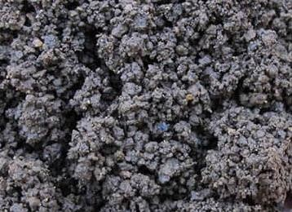
    - It is bread-like textured
    - It is found in top soil
    - It has a lot of organic matter which makes it good for growing crops such as vegetable
    - It is very porous and well drained
- Granular structure

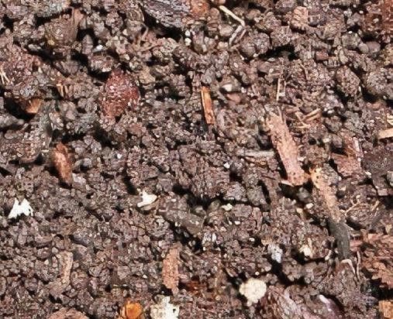
    - Here the particles are in form granules but grouped together
    - It is common in top soil
    - It is porous
- Blocky structure
  - The particles are arranged in form of cubes or block
  - They are hexagonal in apperance with sharp edges
  - Common in subsoil of some heavy clay soil
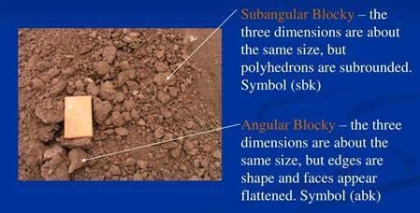
- Columnar soil structure
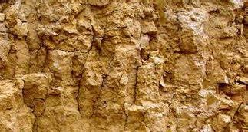
- The aggregates are arranged in form of column-like structures
- Prismatic structure
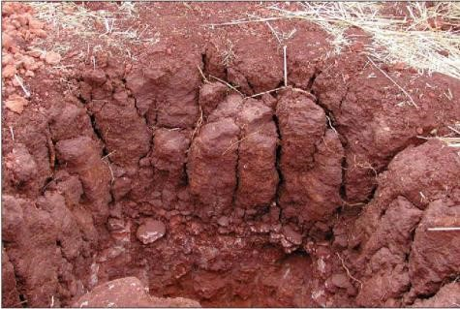
- The soil particles are arranged on form of prisms with leveled tops - It is found in subsoil of arid and semi-arid regions.
- Planty soil structure
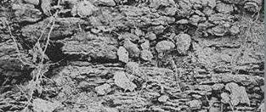
  - Soils particles are arranged on top of each other to form thin horizontal plates
  - They are common at the soil surface or as surface crust. Water mostly moves laterally.
Importance of soil structure
  - It controls passage of water through the soil (soil drainage). The bigger the particles the easier the penetration of water.
  - Controls soil aeration. Soil with big particles contains more air than that with small particles.
  - Controls soil temperature through its control of aeration.
  - Control soil water retention
  - Control soil pH through controlling aeration. High level of carbon dioxide lowers soil pH.
  - It controls workability of the soil i.e. single loose grained soils are easily worked on than sticky soil.
  - It control the ability plant root penetration into the soil.
  - It influences the availability soil nutrients.
  - Control soil erosion; loose soil erodes faster.
Factors that influence the formation of soil structure (aggregation)
  - Organic matter content: organic matter is sticky and binds soil particles together.
  - Soil water: moist soil are plastic than dry soil and so are easy to bind together. Too much moisture causes dispersion of the particles.
  - Living organism: produce substances such mucus that cement soil particles together e.g.
earthworm.
  - Compaction: this is the formation of the platy structure which comes as a result of destruction of other structure
  - Soil texture: soils with large particles e.g. sandy soil are not plastic enough and its particles are not easily bound together.
  - Liming: liming encourages formation of soil aggregates due to favorable effect of calcium on the soil
Activities that can lead to destruction of soil structure
  - Pollution of the soil such as application of fertilizers and insecticides. Also pollution kills microorganisms.
  - Ploughing soil at high moisture content results into mingling of the soil especially those that contain high clay content
  - Excessive leaching especially calcium and iron oxides that bind soil particles
  - Continuous cultivation/tillage of the soil break up soil aggregates
  - Bush burning destroy the organic matter and expose the soil to agents of erosion
  - Soil erosion erodes the aggregates destroying their shape
  - Use of heavy machinery compact the soil and destroy soil structure.
  - Water logging prevents organic matter from decomposing encouraging crumbling of soil structure
  - Mining breaks soil particles
  - Removal of soil cover expose soil to soil erosion
  - Over grazing exposes soil surface to soil erosion
  - Poor harvesting practices that do not add organic matter in the soil
  - Water logging that leads to dispersion of soil particles
How soil structure can be maintained
  - Minimum tillage
  - Growing cover crops that minimize soil erosion
  - Application of organic manures to bind soil particles together
  - Mulching to control soil erosion and add organic manure
  - Bush fallowing involving grass to bind soil particle
  - Afforestation to control soil erosion
  - Draining to remove excess water that cause dispersion
  - Liming to bind soil particles together
  - Controlled irrigation to provide soil moisture
  - Controlled grazing to maintain grass cover
- Resistance to crushing
  - Loose; separate and non-coherent soil particles
  - Friable; lumps that can be crushed into small crumbs with gentle pressure
  - Compact; dense lumps of soil that can be crushed with a lot of difficulty
  - Slightly compact; lumps that can be crushed into fragment with moderate pressure
  - Cemented; soil materials that cannot be broken in hand
  - Plastic; soil that can be moulded when wet without breaking
- Soil texture
This is the roughness or smoothness of soil. It is due to the proportion of sand, silt, and clay in a particular soil. Effects of soil texture
  - The circulation of air in the soil (soil aeration): In fine textured soils, there is limited movement of air due to the small spaces.
  - Water holding capacity: this is higher in fine textured soils like clay than coarse textured soil like sand.
  - Root penetration: this is easier in coarse textured soils and difficult in fine textured soils since the fine particles resist root penetration.
  - Response of plants to fertilizers: poor root penetration means limited response to fertilizers hence fine textured soils are not good when it comes to movement of nutrients.
  - Rate of chemical reaction in the soil: Poor textured soils would limit soil reaction like carbonation, hydration and hydrolysis.
Types of soil textures
Soil | Appearance of particles | Behavior when moist | Feeling
Sand | Loose and single grained | No ribbon formed  Not plastic | gritty
Loam | Soft clods | Weak ribbon formed  Slightly plastic | Gritty
Clay | Hard lumps and highly cemented | Long flexible ribbon  Formed  Highly plastic | Smooth
Soil textual classes
This is done according to the United States Department of Agriculture and the international soil science system. USDA classification
Soil separate Particle diameter (mm)
Very course sand 2.00 – 1.00
Course sand 1.00 – 0.50
Medium sand 0.50 – 0.25
Fine sand 0.25 – 0.10
Very fine sand 0.10 – 0.05
Silt 0.05 – 0.002
Clay below 0.002
Soil textual classes (soil types)
There are three main textual classes (types) i.e. clay soil, Sandy soil and loam soil.
These three give rise to other classes depending on the percentage of sand silt and clay present in a particular soil e.g. sandy clay, clay loam, silty clay loam, sandy clay loam, loamy clay sand and silty clay.

Properties of textual classes
Clay soil
- It has a high water holding capacity - It has a high nutrient holding capacity.
- It has small air spaces
- It is not gritty
- It is not smooth
- It forms extremely cohesive balls and long threads which bend into rings easily when wetted.
Sandy soil
- It is extremely gritty
- It is not smooth
- Its not plastic
- It forms non cohesive balls which collapse easily
- It has a low water nutrient holding capacity - It has big air spaces
- It has big soil particles.
Loam soil
- It is moderately gritty
- It is slightly smooth
- It is slightly sticky
- It is slightly plastic
- It forms moderately cohesive balls
- It forms long threads which bend into rings with difficulty.
- It has a moderate water holding capacity
- It contains 5 – 10% organic matter
- Loam soil is an optimum mixture of sand, silt and clay.
Experiment to determine the different sizes of particles present in the soil:-
- Place 40g of soil in 100cm3 measuring cylinder
- Fill the cylinder with water up to ¾ of it
- Cover the open end firmly with land and shake the content of the cylinder vigorously
- Stand the cylinder on a land flat surface and observe how the suspension settles down.

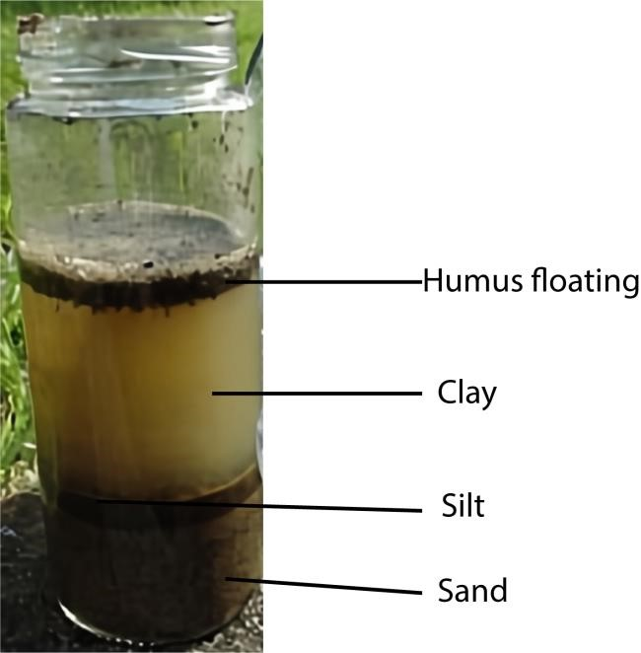
Results
- Some bubble escape from the container indicating the presence of air.
- After shaking, the largest particles fall to the bottom (sand) followed by fine sand, silt, clay and finally organic matter.
Conclusion
Soil is made of different sized particles which when subjected the experiment sediments settle according to sizes

Importance of soil texture
- It controls the passage of water through the soil i.e. granular structure enables are more rapid downward flow of water than planty structure
- It controls aeration of soil
- It controls soil temperature
- It regulate water holding capacity
- Controls soil pH by controlling air passage
- It controls workability of the soil; single, loose grained soil is easier to work than sticky heavy soils.
- It control root soil penetration
- Control soil erosion; loose soil is easily eroded.
- Controls the ability of soil to hold nutrients

D. Soil profile
This is a vertical section from the top of soil to the unchanged parent material beneath showing the various horizons
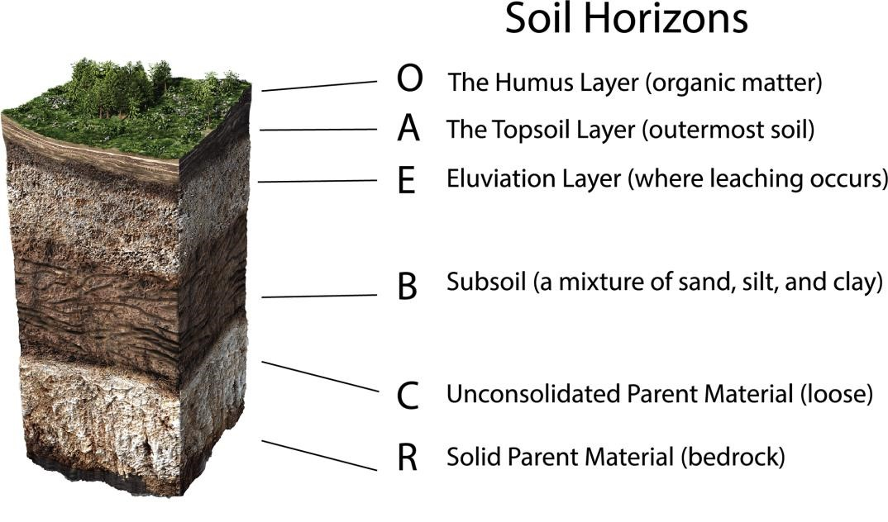
An individual layer in a soil profile is called a horizon.
Change in a horizon is characterized by change in soil colour. There are two types of soil profiles. a. Podzol profile
b. Ferralsol profile.
A podzol profile displays sharp contrast between the horizons and its widely distributed in humid temperate areas.
Ferralsol: It is an example of soil that has developed under humid tropical conditions through progressive weathering of rock.
N.B. Soil catena is the sequence of soil developed from a similar parent rock material under similar climatic conditions but whose x-tics differs due to difference in relief and drainage.

E. Soil temperature
This the degree of hotness or coldness of the soil
Importance of soil temperature
- Affects the rate of weathering
- High soil temperature promotes activities of soil organisms such as nitrogen fixation
- High soil temperature promotes active uptake mineral soil
- High soil temperature promote decomposition and release of nutrients from organic matter - High soil temperature increases water uptake
- Optimum temperature promote germination
- high temperature encourage drying of the soil
- alternate hot and cold temperature promotes weathering of soil
- influences root growth
- influences water loss from the soil through evaporation

Factors that influence the temperature of the soil
- Amount of soil radiation: high solar radiation increase soil temperature
- Soil colour: dark soil color absorbs heat and increases soil temperature
- Crop cover: plant cover lowers soil temperature
- Organic matter increases soil moisture retention and give a darker color to the soil increasing heat retention in the soil
- Soil moisture: retains heat in the soil
- Compositing release heat increasing soil temperature
How to maintain soil temperature
- mulching keeps the soil cold
- shading cools the soil during day
- irrigation lowers soil temperature
- planting cover crops
- application of organic matter
- drainage to remove excess water
F. Soil color
Soil color is determined by the color of the parent rock, iron and organic matter
Significance of soil color
- Can be used to determine the age of the soil
- Indicates presence of organic matter in the soil for i.e. dark color indicates presence of organic matter.
- Demarcates soil profile horizon
- Indicates the extent of mineral loss through leaching
Effect of soil color on soil properties
- Affects soil temperature: for instance black soil increases the soil’s ability to absorb heat and hence causes a rise in soil temperature.
- Affects soil moisture levels: for instance black soil absorbs heat and increase the rate of water loss through evaporation
- Influences microbial activities: high temperature of black soil activates microbial activity.

G. Bulk density
This is the mass per unit volume of un disturbed soil dried to consistent weight at 105⁰C.
Bulk density = 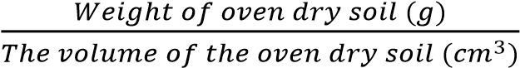

Effects of bulky density
- Water holding capacity
- Soil aeration
- Crop root development
- Seed germination
Factors that influence soil bulk density
- Organic matter content: organic matter is very light and spongy and so increase in organic matter content lowers bulk density of the soil.
- Soil particle size: clay soil with tiny particles have higher bulky density than sand with large particles
- Porosity of the soil: porous soil has lower bulky density than non-porous soil
- Soil depth: bulk density tends to increase the deeper one goes into the soil profile due to lower organic matter and high density of the underlying rocks.
- Level of cultivation: intensive cultivation increases bulk density because it causes rapid break down of organic matter and cause compaction of the soil
- Systems of soil management: addition of manure in large amounts to soil lowers its bulk density.
- Cropping systems: continuous cropping reduces the amount of organic matter in the soil and increases the bulk density.
- Amount of air in the soil: the higher the air in the soil, the higher the bulk density
- Soil structure: the more compacted the soil structure, the higher the bulk density
- Mechanization: use of heavy machines such as tractors during cultivation compact the soil increasing its bulk density.
Particle density
It’s the ratio of weight of solids to volume of solids in soil (g/cm³). The solids in soil are organic matter, inorganic matter, and living organism. In the calculation of particle density, volume of air should be excluded.

H. Soil plasticity
This is the capacity of the soil to be molded without breaking or rupturing.
The terms used in describing the degree of plasticity are non-plastic, slightly plastic, plastic and very plastic.

I. Soil consistency
This is the degree of cohesion of soil or the resistance of the soil to deformation is measured by filling and manipulating the soil by hand or pulling tillage equipment through it. The classes of consistence include:-

J. Soil porosity
This is the measure of the size of pore space in soils. In soils where the particles are closely
together, there is limited pore space and therefore less air in such soils and poor plant root development.
Factors that affect soil porosity
- Soil texture: very fine soil texture such as clay soil lead less porous soil
- Level organic matter in the soil: high organic matter content increase soil porosity by promoting soil aggregate
- Frequent tillage promotes soil porosity by breaking up soil particles
- Soil organisms like earth worms burrow and levels tunnels in the soil improving soil porosity.
- Soil depth: soil porosity tends to decrease and the soil depth increase.

K. Soil fertility
This is the ability of the soil to supply plant nutrients in adequate amount and right proportion for better plant growth.
Characteristics of productive soil - It should be well drained.
- It should be of a sufficient depth for good root penetration and growth.
- It should be well aerated.
- It should have a good water holding capacity.
- It should have enough nutrients which must be the right proportions.
- It should be fee from crop pests and diseases.
- It should have a right PH for the particular crop to be grown on it.
- It should have a good structure and texture.
The causes of low soil productivity/fertility
- Soil erosion leads to loss of crop nutrients
- Leaching leads to inaccessibility of soil nutrients
- Poor drainage may lead to water logging and hence poor soil aeration and unfavorable soil temperature.
- Poor tillage destroys soil structure leading to leaching
- Unfavorable pH
- Soil capping i.e. development of impervious layer on the soil surface
- Development of hard pans or impervious layers below the soil surface
- Lack of required soil nutrients
- Presence of pests and disease causing organisms in the soil
- Presence of weeds which compete which compete with plants for nutrients - Lack of adequate soil moisture.
- Mono-cropping cause soil exhaustion and buildup disease causing organisms
- Burning of vegetation destroys soil living organisms
- Excessive irrigation cause leaching
- Excessive drainage lead to loss nutrients
- Salinity of the soil
Maintenance of soil fertility
The fertility of the soil can be maintained through the following ways:-
- Crop rotation: Is the growing of different crops on the same piece of land in a particular sequence season after season for proper utilization of nutrients Follow the guide lines.
  - Legumes should alternate with other crops since they increase soil fertility by fixing nitrogen
  - Crops with high nutrient requirement should come first on a newly cultivated piece of land to utilize a high content of nutrients present at this stage.
  - Deep rooted crops should alternate with the shallow rooted crops since deep rooters bring nutrients to the upper layers of soil for shallow rooters to use
  - Cover crops should be included in the rotation to control erosion.
  - A fallow period should be included in the rotation to preserve soil structure and restore the lost nutrients.
  - Crops that are easy to weed should alternate with those that are difficult to weed.
  - Crops attacked by similar pests and diseases should not succeed one another in the rotation to reduce spread
Importance of crop rotation
  - There is maximum use of soil nutrients since different crops with different nutrients requirements are involve in the rotation.
  - Pests and diseases are easily controlled by breaking their cycle and starvation.
  - Parasitic weeds like string spp in sorghum are easily controlled under crop rotation.
  - The nitrogen content of the soil can be improved more especially if legumes are included in the rotation.
  - Good rotation evens out labor requirement throughout the year.
  - It spreads financial risks over several crops
  - Some deep rooted crops in the rotation will recycle nutrients.
  - Soil erosion can be controlled during the fallow period when grasses are allowed to grow on the land or by the binding action of the plant roots.
The role of crop rotation in maintaining soil fertility
  - Rotating crops of different rooting system enables plants to absorb nutrients at different soil layers
  - Different crops prefer different nutrients which prevent soil exhaustion.
  - Some plants like legumes fix nitrogen to the soil
  - Crops rotation improves soil structure such as those with fibrous roots.
  - Crop rotation controls pests and diseases by breaking their life cycles
  - Crop rotation controls some weeds such as striga
  - Resting helps regain fertility
  - Nutrient recycling i.e. deep rooter against shallow rooter
  - Conserve soil moisture when cover crops are planted
  - Control soil erosion by maintain soil structure or planting cover crops, An example of a four year crop rotation
Year | Plot 1 | Plot 2 | Plot 3 | Plot 4
1 | Sweet potatoes | Beans | Cassava | Millet
2 | Millet | Sweet potatoes | Beans | Cassava
3 | Cassava | Millet | Sweet potatoes | Beans
4 | Beans | Cassava | Millet | Sweet potatoes
 | Fallow | Fallow | Fallow | Fallow

NB After the fourth year the farmer can decide to have a fallow period
Limitations of crop rotation
  - Shortage of land due to an increasing human population
  - Presence of permanent building that cannot be rotated
  - Introduction of perennial crops with a long gestation period
  - Merits of the practice cannot be easily recognized by farmers hence difficult to convince them
- Proper weed control: weeds compete with crops for soil nutrients. A high population of weeds will extract a lot of nutrients from the soil making it infertile in the long run.
- Mulching: Is the covering of top soil with dry plant materials or artificial substances like polythene papers. Apart from conserving the soil moisture and suppressing weeds, mulches also rot and add fertility to the soil.
- Minimum tillage: Minimum disturbance of the soil will conserve its organic matter content and moisture hence maintaining fertility.
- Soil pH control: At different pH some macro and micro elements are present while others are absent. The soil pH can be maintained through liming and addition of fertilizers.
- Addition of manure: The addition of both organic and inorganic manure will increase the amount of soil nutrients therefore maintaining the fertility. However, over use of artificial manure can cause acidic conditions in the soil that may lower soil fertility.
- Soil erosion control: The washing away of he most fertile top soil leads to loss of soil fertility as well. Methods of controlling soil erosion like terracing, mulching, contour ploughing etc should be used.
- Improving on soil drainage: This will eliminate water logging with all its disadvantages like increased leaching
- Improving on the water holding capacity of the soil: Water is needed by plants in the absorption of soil nutrients and in photosynthesis therefore water holding capacity of the soil should be improved to maintain the soil fertility through the addition of organic manures.

Loss of soil fertility
Soil can lose fertility through:-
- Change of soil PH: some plants nutrients are available to the plants at low PH e.g. iron, Mg, A1,
Zn, K and Boron while others are favored by a high PH e.g. phosphorous and molybdenum
- Buildup of pests and diseases in the soil
- Burning that destroy useful microorganisms and also destroy soil structure
- Formation of hard pans which restricts root development and access to water and nutrients. Hardpans also impede water drainage which can lead to waterlogging above the hardpan and drought conditions below it.
- Soil compaction by heavy machinery and overgrazing that may reduce the soil’s ability to hold water and nutrients
- Deforestation that lead to soil erosion
- Monoculture practices/over cultivation leading to nutrient depletion
- Crop removal during harvesting carries away all the nutrients concentrated in their tissue and seeds.
- Leaching: washes out of soil nutrients in both solution and suspension to the deeper layers of the soil where plants cannot utilize it.
The factors that affect leaching in the soil
- Soil structure; weak structure encourages leaching
- Soil texture; coarse texture encourages leaching
- Rainfall intensity; high rainfall water encourages leaching
- Vegetation cover minimizes leaching
- Soluble nutrients are easily leached
- Tillage removes vegetation cover and encourages leaching
- Cation exchange capacity of the soil; high exchange capacity increases leaching
- Level of humus in the soil; high content of humus reduces the rate of leaching

- Large number of weeds competes with plant for nutrients.
- Overuse of fertilizers and pesticides that can alter soil pH and kill beneficial microorganisms - Salinization due to irrigation
- Over cultivation causes rapid oxidation of organic matter by microorganisms leading to loss of fertility
Effects of over cultivation of arable land
- Destroys Soil structure making the land more prone to erosion
- Increases production costs by engaging more labor in cultivation
- Can destroy crop roots
- Can increase evaporation of moisture from soil by increasing surface area for loss.
- Increases oxidation of crop nutrient hence loss of fertility
- Soil erosion: carries away the more productive top layer of soil leading to loss of fertility
How soil productivity can be improved
- Through application of manure and fertilizers
- Practicing crop rotation to promote usage of different nutrients - Irrigation to provide water in the soil.
- Drainage of excess water
- Modifying soil pH
- Prevention of soil erosion
- Control pests and diseases
- Proper cropping like preventing overcrowding
- Applying effective method of water conservation

Components of soil
Soil is composed of living organisms (micro and Macro), air, mineral elements, organic matter and water.
- Living organisms
These include microorganisms like bacteria, fungi, protozoa, etc. It also includes macro living organisms like earth worms and some insects.
Importance of soil organisms:
Positive importance
    - Decompose plant and animal remaining into humus
    - They are used for nitrogen fixation
    - Help in soil aeration e.g. earthworm
    - Mix up soil particles
    - Produce mucus causing aggregation of soil particle e.g. earthworms
    - Improve soil drainage
    - Improve soil aeration
Harmful effects of soil organism to crop
    - Some organism destroy plant tissue e.g. millipedes
    - Some organisms such as fungi cause disease
    - Termites burrow deep and bring to the surface poor unfertile soil which reduces soil fertility.
    - Soil organism e.g. nematode suck plant sap and block the transport tissues thereby hampering growth.

Factors that influence abundance of soil living organisms
    - Temperature of the soil: different organisms prefer different temperature ranges
    - pH influences enzyme activities in microorganisms; very high and very low pH hinder multiplication of microorganisms
    - Aeration / oxygen for respiration
    - Presence of organic matter in soil that act as food to microorganisms - Presence of certain minerals such as iron II which provide respiratory energy.
    - Presence of pollutants that poison microorganisms.
    - Depth of the soil: deep soil provides space for microorganism to live.
    - Soil moisture: soil organisms require moisture is essential for life and for enzyme activity and metabolism and, is a solvent for biological nutrients and other chemicals. Also moist soil facilitates movement of organisms in the soil.
    - Light require by phototrophic microorganisms immediately below or on the surface of the soil. Light also warms the soil while some sunlight component (uv) skills microorganisms.
    - Type of plant grown e.g. legumes house nitrogen fixing bacteria
    - Tillage not only kill soil organisms but also destroy their microhabitats
    - bulk density, dry weight, porosity affect burrowing of macro-organisms in the soil
    - Soil salinity: high salinity reduces microbial growth
Factors that affect symbiotic nitrogen fixation in the soil
    - Presence of nitrogen fixing bacteria (of the genus Rhizobium)
    - Presence of root legume roots in whose root nodule bacteria live
    - Presence favorable temperature
    - Presence of oxygen in the soil for respiration of bacteria
    - Presence of nitrogen in the soil to be fixed
    - Presence of zinc in the soil: zinc is necessary for nitrogen fixation acting as a secondary signal for nitrogen fixation
    - Presence of antimicrobial agents in the soil
- Soil air
Soil contains air, the biggest portion being CO₂ and O₂. Soil air is used by living organisms in respiration and also the plant roots.
N.B. Water and air occupy the same position and therefore high level of water in the soil will reduce the amount of air in that particular soil.
Importance of soil air
    - It is required for root respiration and root development
    - Supports nitrogen fixation in root nodules
    - It required for respiration of soil microbe
    - Required for oxidation in weathering
Effects of poor soil aeration
    - Reduced microbe activity
    - Reduced root growth and expansion
    - Increased denitrification
    - Wilting and yellowing of plants due to reduced absorption of salts
    - Anaerobic conditions leading to formation of harmful acids
How to improve soil aeration
    - Turn over the top layer of soil through tilling.
    - Drain water logged soil
    - Use additives such orchid bark, perlite, coarse sand, vermiculite, and agricultural charcoal.
    - Create holes for oxygen to penetrate the ground using spike aerator.
    - Add wetting agents to improve oxygen levels.
    - Incorporate organic matter such as compost, leaf litter, or manure to improve soil texture
    - Cover crops like clover or rye can help break up compacted soil and improve its structure over time
    - Limit foot traffic not to compact soil
    - Broad forking manually loosen the soil without turning it over can help improve aeration while preserving soil structure
    - Practice crop rotation to prevent soil compaction
- Soil water
It is found in the macro and micro pores of the soil
Importance of soil water
      - It a medium/solvent through which mineral nutrients are absorbed by the plant
      - Promote weathering and soil formation
      - Soil water is absorbed and used for photosynthesis,
      - Absorbed soil water is used transpiration and cooling of the plant.
      - Helps biological decomposition of dead plant remaining into humus
      - Regulates soil temperature i.e. evaporation of water from the soil cools it
      - Soften soil and ease root penetration and cultivation - Promote seed germination
Ways of improving water retention in the soil.
      - Increase organic matter like compost and peat moss in your soil.
      - Till less frequently.
      - Keep your soil covered or mulched.
      - Use soil amendments like perlite, vermiculite or biochar
      - Plant cover crops like clover or legume to improve soil structure and reduce soil erosion - Plant windbreaks to reduce wind erosion
      - Remove weeds that would compete with the plants for water
Dangers are associated with excess moisture in the soil or waterlogging
      - Insufficient supply of oxygen, which slows or stops plant growth.
      - Accumulation of carbon dioxide, which impedes the growth of plant roots.
      - Inhibition of aerobic respiration, limiting energy metabolism and restricting growth and developmental processes.
      - Promotes denitrification leading loss of soil fertility
      - Leads to accumulation of toxins in the soil
      - Promotes rotting of roots
      - Photosynthesis decline due to closure of stomata, degradation of chlorophyll
Soil drainage
Drainage is the removal of excess water from the soil
Ways by which drainage affects agricultural production
      - Improves soil aeration
      - Prevents buildup of toxic substance from decomposition of organic matter.
      - Cause favorable soil temperature that promote germination and plant growth
      - Frees soil of excess water
      - Make the soil lighter and easy to till
      - Helps control pests and diseases
      - Discourage leaching
      - Facilitate growth of plants that do not require water logged conditions - Reduces soil erosion - Prevents rotting of roots.
Problems that may result from draining agricultural land - May lower water table
      - May lead to death of water loving organisms such as frogs
      - Lead to loss of dissolved nutrients
      - May dry up soil
      - May cause unfavorably high temperature
      - Salinization of the soil surface
      - Upset ecosystem

Signs of poor drainage
      - Stagnant water present on the soil
      - A wet spongy soil surface
      - Accumulation of organic matter on the soil surface
      - Presence of short shallow rooted vegetation

Factors to consider choosing a method of draining
      - Topography of the area. A slopping area can easily be drained by surface method - Affordability
      - Skill
      - Level of drainage required
      - Soil properties e.g. sand soil require surface drainage
      - Economic returns anticipated determine the investment in drainage
      - Climatic factors such as heavy rainfall require permanent drainage - Farmer’s preference
      - Type of crop to be grown: whether it requires a lot of water or not
      - Government policy: government may subsidize the cost of pipes promoting sub-surface drainage.

Methods of drainage
(i) Surface drainage (open ditch drainage)
Land is excavated and a ditch is dug at the low lying part of the field. The ditches facilitate collection of excess water which flows freely from agricultural land.
Advantages of surface drainage
        - It is cheap to establish
        - Blockage can easily be seen
        - It is easy to maintain
Disadvantages of using surface drainage channels in draining land
        - Waste land since channels are constructed on the soil surface
        - Ditches interfere with agricultural operations and livestock movement
        - The open channels are prone to silting
        - Expensive to maintain
        - Promote gulley erosion
        - Require leveling before water can flow into the drains
        - Ditches may become hiding places for dangerous animals

Maintenance of surface drainage
        - Plant the channels with vegetation for stability and efficiency of drainage
        - The dimensions of the ditches should be maintained by removing silt
        - Do not allow people or livestock to use channels or edges of the channels as walk ways.
- Sub-surface or underground drainage
Tiles or pipes are established beneath the soil surface. These trap excess water and carry it away from farm land.
Procedures for sub-surface drainage
  - Land is cleared
  - Ditches are constructed where pipes are to be laid
  - Pipes are then laid in the channels
  - The pipes are covered with soil
Advantages of sub-surface drainage
  - The field is free from surface obstruction and thus does not interfere with movement of animals and machines
  - They do not encourage gulley erosion since water flows inside the pipes
  - No need to level land to facilitate drainage
  - It removes only excess water and not water required by the plant
Disadvantages of sub-surface drainage
  - It may lead to excessive leaching in areas of heavy rainfall.
  - It has high initial cost
  - Requires skilled labor
  - Pipes may be blocked or damaged by crops or animals - Blockade is difficult to trace
Maintenance of sub-surface drainage
  - Control soil erosion to prevent exposure of pipes
  - Replace old and damaged pipes
  - Construct silt traps to prevent pipe blockage
  - Avoid compaction of soil
- Sub-soiling
It done by a sub-soiler a tillage implement that penetrate soil up to 60cm. The operation cracks and loosens the subsoil facilitating water movement and root penetration
Use of deep-rooted crops
Deep rooting crops as lucerine and eucalyptus can be planted; their roots penetrate compacted subsoil facilitating movement of water to subsoil.
(d) Organic matter
It is the non-mineral portion of soil solids from decayed and partial decayed plant and animal’s residue. It is composed of carbohydrates, proteins, fats, pigments, lignin, bones
Classes of organic matter
- Litter which includes relatively undecomposed dead parts of plants and animals and their waste that have just been deposited on the soil surface.
- Residues which include the dead parts of plant and animals which are actively decomposing
- Humus which is the well decomposed and stable organic matter; it is the final product of organic matter decomposition
Importance of organic matter
- Provide food and shelter for soil living organism
- Source of plant nutrients
- Buffers pH
- Reduce soil erosion by binding soil particles together
- Provide attachment sites for mineral ions
- The organic acids released during the process of organic matter breakdown promote weathering
- Promote soil drainage
- Improve soil texture
Properties of humus
- Dark brown
- Odorless
- Colloidal
- Insoluble in water
- soluble in dilute alkali giving a dark colored solution
- contains modified plant residues and synthesized microbial compounds
- has high cation exchange capacity
- has high water absorbing capacity about 5-7 that of clay
- has high relative molecular mass
- light amorphous material with very low bulk density(0.2 -0.5mg/g)
Uses of humus in the soil
- it is a source of N, P, S and most micro-nutrients
- It increases cation exchange capacity (CEC) of the soil because organic matter is negatively charged.
- Source of food for soil organisms
- It increases water holding capacity especially of sand soil
- It improves soil structure by binding soil particles together
- Ti reduces the impact of compaction and capping in soil
- It buffers pH change
- It promotes root penetration into the soil because it keeps soil soft
Experiment to find the percentage of humus in the soil
- Dry the soil sample (w g) in an oven at 1050C to a constant weight x g - Heat the soil until red hot to a constant mass y.
- Percentage of humus =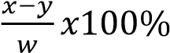
Factor that affect the rate of decomposition of organic matter
(a) Biological factors
- Age: young plant decompose faster than old ones because of high moisture content, they are less fibrous, and have low C:N ratio.
- Moisture content: succulent plants decompose faster than those which are non-succulent - Carbon: nitrogen (C:N) ratio: legumes with low C:N ratio decompose faster than cereals.
- pH of the material: plants e.g. pine give acidic residue which are very difficult to breakdown.
(b) Climatic factors
- Temperature: very low temperature hinder decomposition because microorganisms are inactive, increase in temperature promotes decomposition due to activation of microorganisms, high temperature hinder decomposition because of death of microorganisms. Very high temperature accelerates chemical degradation of organic matter.
(c) Soil factors
- Soil moisture: influences activity of soil living organisms
- Soil temperature influences activity of bacteria
- Mineral content
- Presence of living organism
How organic matter level can be increased
- Application of organic manures e.g. farm yard manure (FYM), compost and green manure
- Minimum tillage
- Mulching
- Ploughing back crop residue into the soil
- Liming to increase the living organism
- Proper drainage to encourage the soil microorganisms
How organic matter contributes to soil conservation
- Bind soil particles together reducing soil erosion
- Add nutrients to the soil
- Provide food to soil microorganisms
- Bind soil particles improving soil texture
- Increase water retention in sand soil
- Buffer soil pH
- Impart dark color to the soil that increase soil heat absorption
- Increase cation exchange capacity of the soil
The factors that affect the rate of decomposition of organic matter in the soil
- Age of the plant- young plant materials decompose faster than old ones
- Amount of water in the material: wet materials decompose faster than dry ones
- Carbon: nitrogen ration – legumes decompose faster than cereals because they have high percentage of nitrogen.
- Presence of putrefying organisms; for instance sterilizing soil with heat delays decomposition
- Soil temperature: rate of decomposition increases with soil temperature
- Soil aeration: adequate oxygen in the soil encourages growth of microorganism and promotes decomposition.
- Soil pH between 6 and 8 promotes growth of microorganisms and thus promotes decomposition
- Pollution kills microorganisms and delays the rate of decomposition
- Climatic factors such as rainfall that provides water necessary for rotting

L. Soil permeability
This is extent to which a soil allows water to pass and spread through it. However sometimes soil permeability and soil drainage are considered to be the same.
M. Capillarity in soil
It is the ability of water to rise through the small pores of the soil buy the forces of cohesion and adhesion.
Importance of capillarity
- It makes water available to the plant
- Enable plants access nutrients dissolved in soil
Experiment to investigate soil capillarity
- Get three tube open on both ends and plug one side with cotton wool.
- Fill one tube with dry clay soil and another with dry loam soil and the third with dry sand soil
- Place the tube with soil in cold water bath with the plugged sides immersed in water as shown below
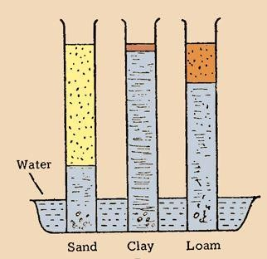
Observations
- Water rises fastest in sand soil but highest in clay soil.
- The level of water increase from sand soil to loam soil and highest in clay soil.

Factors affecting soil fertility
Soil depth, soil structure, soil drainage, soil PH, soil aeration, water holding capacity, availability of plant nutrients, presence of pests and diseases, soil compaction, living organisms, accumulation of salts, soil capillarity, hard pans, soil capping and presence of polyethene materials in soil.
Soil depth
Soil depth is associated with the maturity of the soil and it also influences the amount of water retained in it for plant use. Soil structure
This affects the amount and movement of air and water within the soil and also the transfer of heat. Therefore a good soil structure gives ideal conditions for plant growth.
Soil drainage
This refers to the ease with which excess water drains out of the water logged soils. There is poor aeration, low temperature, poor soil structure, and low PH in water logged soils. All the above will interfere with normal crop growth.
Soil aeration
Adequate air in the soil particularly oxygen improved water and nutrients uptake and also encourages better root development. The air is also needed by the soil organisms during the decomposition of plant or animal remains.
Polyethene materials in soil
Affects soil aeration, root development and water infiltration which all affect soil fertility

Soil capping
This affects soil drainage which determines pest attack, soil Ph and root development in crops and hence soil fertility.
Hard pans
This impedes water infiltration hence affecting soil fertility.
Availability of plant nutrients
Plant nutrients are needed by plants and therefore a soil which contains most of the nutrients and can easily supply them is said to be fertile.

Soil pH (soil reaction)
This is the acidity or alkalinity of the soil.
Importance of soil pH
- It affects the presence of certain plant pathogens like bacteria and fungi are not common at low PH but fungi are common
- At very low PH the concentration of certain nutrients such as iron and Aluminium in the soil becomes toxic to plants.
- Soil PH has a strong influence on the availability of various plant nutrients.
- Very low or very high PH inhibits the activity of the soil micro-organisms more especially the nitrifying bacteria.
- It influences the (ability) availability of plant nutrients e.g. at lower PH (acidic) phosphorous and molybdenum are not available but iron, Mg, Zn, K and Boron are available yet unavailable again at high PH (alkaline)

Testing for soil pH
- Place a sample of soil in a dry test tube
- Add barium Sulphate / ammonium Sulphate to the soil sample
- Add distilled water to the mixture and shake gently
- Add 3 drops of the universal indicator and allow the contents to settle for about 45 minutes
- Use the pH chart to find the pH of the soil by relating with the color of the contents in the test tube
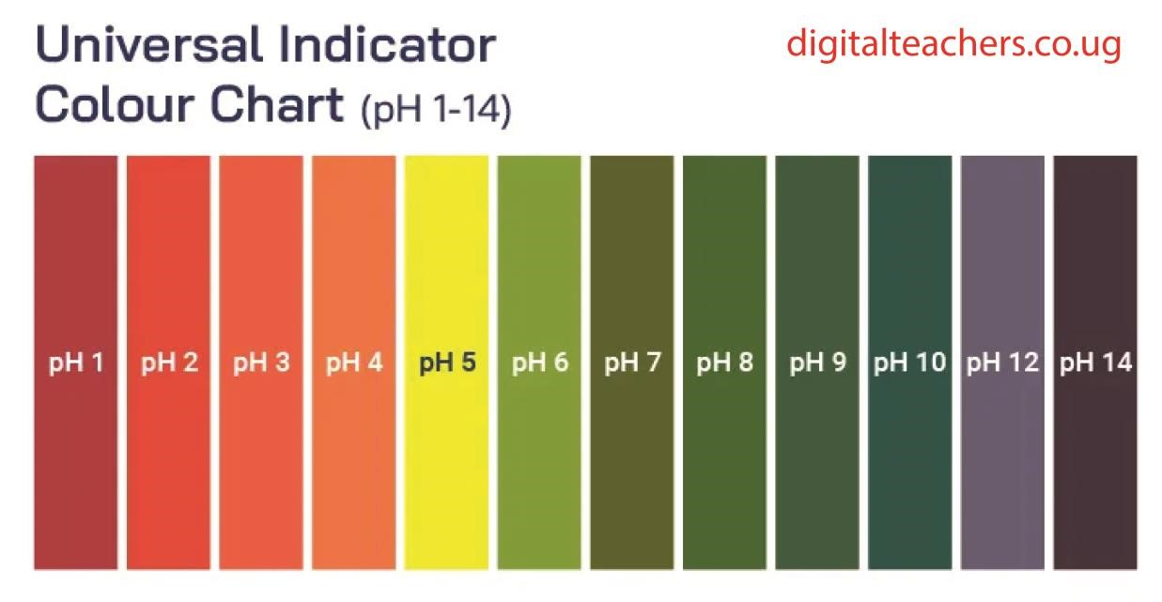
Acidity of the soil
An acidic soil has pH less than 7
Causes of acidity in soils
- Soil formed from acid rocks: Rocks such as granite contain an excess of silica (Quartz) which combine with water to form acids.
- Presence of humus: Humus may react with iron and aluminum to form complexes which undergo hydrolysis to yield hydrogen ions responsible for acidity.
- Presence of soluble salts: These may be acidic, neutral, or basic arising from fertilizers mainly.
- Water lodging: This causes hydrolysis of some of cautions in the soil which may release hydrogen ions leading to soil acidity
- Rain water: atmospheric carbon dioxide combines with rain water to form a weak carbonic acid responsible for soil acidity.
- Cultivation of crops: The growing of crops can cause acidity when the plant absorbs cations that can be replaced by hydrogen ions.
- Fertilizers application: Application of fertilizers increases cations and anions content in the soil. When the nitrates are leached they move along with cations leaving the H+ behind
- Biological activities in the soil: Anaerobic decomposition of organic matter leads to formation of weak acids in the soil e.g. lactic acids, ethanoic acids (Organic acids)
- The presence of sulphides in the soil: The sulphides in the soil can also cause soil acidity due to the production of H⁺ ions.
- Presence of sulphides: These can cause acidity to the production of H⁺.

Ways of raising soil pH
- Addition of lime

Examples of liming materials
- Calcium carbonate (Calcite)
- Calcium magnesium carbonate (dolomite)
- Calcium oxide(quicklime)
- Wood ash - Paper mill
- Magnesium carbonate. - Sugar factory lime
- Calcium hydroxide
Characteristics of a good liming material
- It should have a mild balkanizing effect
- It should have a favorable effect on soil
- Should be cheap and readily available
- Should not affect soil microbes
- Should not affect availability of crop nutrients
Factors considered before liming
- Soil pH; very high or low pH may require amending
- Buffer capacity of the soil i.e. ability to resist change in pH after addition of lime - Amount of bases in the exchange complex.
- Type of crops to be grown i.e. each crop requires a different pH
- Fineness of the materials to be used for liming
- Amount of manganese present in the soil
Importance of liming
- It increases the use of nutrients by crops leading to increased yields.
- It increases the microbial activity in the soil
- Organic matter decomposition in the soil is accelerated
- It increases the availability of plant nutrient and their supply like phosphates.
- Make soils easy to cultivate more especially clay soil
- Ensures sufficient utilization of soluble acidic manures such as phosphates
- Keeps the soil in good condition for crop growth.

Negative effects of liming
- It can lower the yields of crops in later years if the PH is allowed to increase continuously.
- It is expensive therefore can increase the production.
- It decreases the future supply of plant nutrients
- Accelerated organic matter (OM) decomposition causes a decline in organic matter content of the soil.

Soil alkalinity
An alkaline soil has a pH greater than 7

Causes of soil alkalinity
- Weathering of limestone
- Addition of bases e.g. lime
- Irrigation using saline water
- Drought condition
- Underground water
Ways of lowering soil pH
- Addition of acidic organic matter e.g. organic matter from pine needle
- Addition of acidic fertilizers e.g. Sulphate of ammonia.

Cationic exchange
This is interchange between positively charged ions in the soil solution with the adsorbed positively charged ions on the soil colloids such as clay or humus.
A cation is positively charge ion of a metal
Soil cation exchange capacity (CEC)
CEC is the total sum of the exchangeable cations adsorbed per unit weight of soil at a particular pH. CEC measures the number of adsorption sites per unit weight of a soil at a particular pH. It measured in centimols per kilogram of soil, (cmolkg⁻¹)
Importance of CEC in the soil
- Help to fix mineral nutrients into the soil due to the negative charges
- Store nutrients for the plants
- Minimize leaching and retains plant nutrients
- Influence pH of the soil - Helps soil stability
Factors which affect the rate of cation exchange in the soil
- Concentration of cations in the soil solution. Concentrated cations in soil solution replace the less concentrated ones
- The speed of movement of hydrated ions: movement of hydrated ions is slow compared to those not hydrated
- The amount of charge: ions with more charges replace more ions with fewer charges less number of charges.
- The type of colloid: humus has a higher cation exchange capacity than clay.
- The number of charge on the exchange complex: monovalent charged elements have higher cation exchange than divalent charged elements.
- Soil type, the soil pH and the soil organic matter content.
- Influences absorption of nutrients: nutrient uptake from soil is achieved when root hairs pump hydrogen ions into the soil through proton pumps. The hydrogen ions displace cations attached to negatively charged particles (micelles) so that the cations are available for uptake by the roots through root hairs.

Plant nutrients
Plant nutrients can be divided into two major groups i.e. Macro and Micro nutrients.
Macro nutrients (major elements)
These are nutrients needed by plants in large quantities e.g. carbon, oxygen, hydrogen, nitrogen, phosphorous, potassium, calcium, magnesium and Sulphur.
Micro elements (trace elements)
These are nutrients needed by plants in small quantities though they are very important for plant growth. E.g. iron, manganese, copper, molybdenum, zinc, chlorides and cobalt.
Graph showing the effect of macro and micro nutrients supply (kg/Ha) on crop yield.
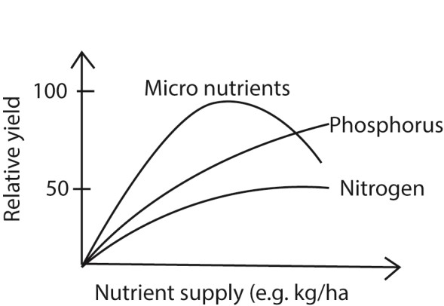

Micro-nutrient deficiency
Micro-nutrient deficiencies have rarely been a serious problem under traditional farming practices in the tropics because
- The bush fallowing system ensures recycling of nutrients from the subsoil through the organic matter accumulation.
- The unimproved, low yield crop varieties make little demand on soil nutrient resource.
- Few fertilizers provided supply the required nutrient.
Micro-nutrient antagonism
- Excess copper or Sulphur retards the utilization of molybdenum.
- Iron deficiency is more pronounced if there is an excess of zinc, manganese and copper.
- Manganese uptake is reduced by excess calcium or lime.
- Boron uptake is reduced by excess calcium or lime
- Zinc uptake is reduced by excess phosphate fertilizers.
- Copper deficiency is intensified by excess nitrogenous fertilizers.

Nutrient uptake and absorption by plants
Nutrient uptake from soil is achieved by cation exchange Capacity where root hairs pump hydrogen ions into the soil through proton pumps. The hydrogen ions displace cations attached to negatively charged particles (micelles) so that the cations are available for uptake by the roots through root hairs.

Ways by which plant roots absorb the nutrients
- Simple diffusion: gases like oxygen and ammonia are passively absorbed along concentration gradient
- Facilitated diffusion: this is a rapid movement of solutes or ions along concentration gradient aided by transport proteins
- Active transport: is an energy requiring process that absorb nutrients against their concentration gradient
- Root interception; nutrients collide with roots in the soil as the roots form a dense network
- Nutrients are moved inside the plant to where they are needed and converted into biochemical compounds.
Association between nutrients uptake and pant growth
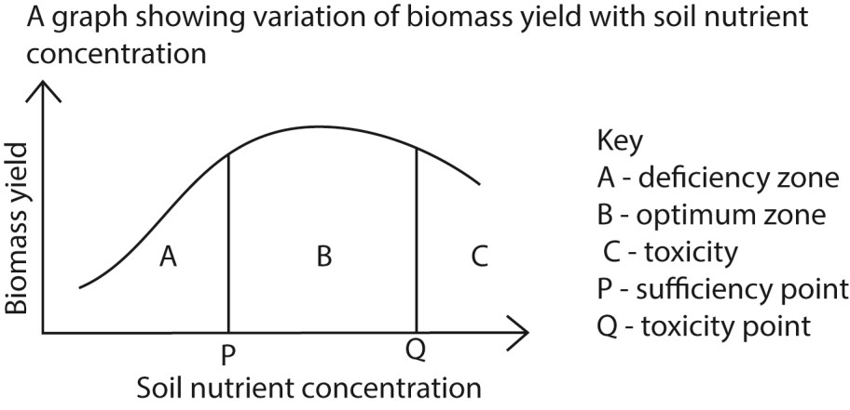
- Region A/deficient zone: crop production increases with soil nutrient concentration due to increase nutrient usage by the plant as soil nutrient concentration increase.
- Region B/Optimum zone: crop production almost remains constant as soil nutrient concentration because the plant achieves enough/adequate/optimal nutrient concentration. This zone is most suitable for feeding the pasture plants to livestock due to high pasture yield and quality.
- Region C/toxic zone: Biomass yield decreases because excessive nutrients lowers biomass yield due to toxicity such as soil acidification, mineral antagonism and reverse osmosis in roots, reducing soil fertility and capability to support plant growth.
Other factors that may affect shape the graph above or affect biomass yield of plants are.
- Soil water: soil provides water to plant which is a reagent in many biochemical reactions. However optimal amount is required because too little water may not be absorbed by plant while too much water reduces the amount of air in the soil.
- Soil air: this provides oxygen for root and microorganisms’’ respiration and nitrogen for fixation by root nodules.
- Light: increase in light intensity increases biomass yield
- Prevailing carbon dioxide concentration in air: high concentration of carbon dioxide in air increases biomass yield.
- Soil microorganism; these play a role in soil aeration, recycling of nutrients, and provision of nutrients to plant when they die and decompose
- Temperature: promote plant growth by activating enzymes. At very low temperature the enzymes are inactive while at very high temperature the enzymes are denatured and the plant dies.
- Soil pH affects activity of enzymes; optimum pH necessary depending on plant type
- Soil structure: this is the proportion of sand, silt, and clay in a particular soil. Soils structure determines water retention and aeration of the soil. Plants prefer different soil structure.
- Soil pollution: this may affect the micro and macro-organisms content and quality, pH and other soil contents and interaction.
Note that under normal conditions, nutrient uptake determines plant growth in predictable way during most of crop’s growth.
Macro nutrients
Nitrogen:
This is one of the most important elements needed by plants yet its deficient in most areas of East Africa.
Forms of nitrogen in the soil Nitrates
Nitrites Ammonium compounds
Uses of nitrogen to plants
- It’s necessary for the formation of chlorophyll
- It improves the quality and quantity of leaf crops such as cabbages, dodo, etc.
- It is a constituent of plant proteins.
- It facilitates in cell division and therefore responsible for growth - Controls the use of phosphorus and potassium in the plants
- Regulates availability of P and K.
Deficiency symptoms of Nitrogen in plants
- Leaves become yellowish i.e. suffer from chlorosis - There is restricted root development - Plants become stunted.
- There is even yellowing and loss of leaves
- There is pre-mature ripening of fruits.
Signs of excess nitrogen in plants
- Excessive leaf production
- Delayed maturity
- Leaf and stem logging
- Scotching of leaves
- Poor crop yields
Fate /loss of nitrogen from the soil - Crop removal during harvesting - Soil erosion.
- Through leaching
- Burning of crop residues
- Volatilization (denitrification; oxidation of nitrates to atmospheric nitrogen)

Sources of nitrogen
- Commercial fertilizers e.g. NPK, Urea, CAN, Sulphate of ammonia, Diammonium phosphate (DAP)
- Organic fertilizers like farm yard manure, compost manure and green manure.
- Lightening.
- Nitrogen fixation by nitrogen fixing bacteria

Phosphorous
Importance of phosphorus to the plants/crops

Encourages the formation, development and establishment of roots.
It is necessary in the formation of fruits and seeds.
It is needed for cell division Production of fats and proteins.
It helps in nitrogen break-down during respiration
It is a constituent of nucleic acid (DNA, RNA) - It is important in the synthesis of nucleoprotein - It is a constituent of phospholipids.
- It gives resistance to certain diseases in crops.
- Its essential part of all the sugar phosphate in photosynthesis and other metabolic processes. - Improves the quality of crops more especially vegetables.
Deficiency symptoms of phosphorus to the plants
- Purple coloration of the leaf especially at the margin.
- Low yield of grains, fruit and root crops
- Slow growth rate resulting into late maturity of the crops.
- Red necrotic areas on the leaves, petioles etc.
- Distortion of the leaf shape
- Older leaves become dark brown.
- There is a general overall stunted ness and leaf fall.
Factors affecting availability of phosphorus in the soil
- P: P is available at pH 6-7 and not available at extremes
- Iron, aluminium, and manganese ions form insoluble salts with P and prevent its availability in soil for plant use.
- Calcium precipitates phosphate ions in alkaline soil
- Decomposition of organic matter releases phosphorus into the soil - Microorganisms breakdown organic matter to release phosphorus to the soil - Clay soil adsorbs phosphorus and make it unavailable in the soil.

Potassium
Importance potassium to the crops/plants
- It increases resistance to certain diseases
- Activate enzymes used in metabolic processes such as photosynthesis
- It encourages root development and growth
- It is necessary for formation of starch and transport of sugar within the plant.
- It is essential for chlorophyll formation.
- It is needed in nitrogen metabolism and protein synthesis.
- It reduces lodging in plants by strengthening cellulose cell wall.
- It controls stomatal movement hence loss of water.
- It’s important to folic metabolism
- It has been linked with carbohydrates metabolism.
- It regulates water in plant cells.
Deficiency symptom of potassium to the plants/crops
Retarded root development
Plants are easily attacked by diseases
Leaves dry out at the edges Premature loss of leaves
scotching
Chlorosis can also be experienced
- In cereals cell at the leaf tip and margin die first.
Factors affecting the availability of potassium in the soil
- Soil moisture: Too much moisture interferes with exchangeable moisture.
- Soil PH: High soil PH favors potassium fixation
- Temperature: High temperature favors the level of exchangeable potassium
- Types of colloids: Potassium fixation is usually done in soil containing montimolironite.

Reasons to explain why crops continue to show potassium (K) deficiency symptoms even after applying the right amount of Sulphate of potash in a given field
- Perhaps there was a lot of soil moisture that reduced the exchangeable potassium elements
- Drop in soil temperature which lowered the level of exchange potassium making it unavailable to the plants
- Perhaps the field has 2:2 expanding clay soil which fixes potassium and make unavailable to the plant
- Presence of antagonistic nutrient elements in the soil preventing use of potassium by the plants

Calcium
Importance of calcium to crops/plants
- Raises soil PH which favors nitrogen fixing bacteria
- Improves root development and growth
- It improves vigor and stiffness of the stem,
- It governs the availability of certain essential minerals like phosphorus and potassium.
- It is an activator of enzymes in plants
- It is associated with cell wall structure
- In increases carbohydrates content in crops like cotton.
- It increases the number of mitochondria in wheat plants.
- It protects plants from injuries due to the effect of hydrogen ions.
Deficiency symptoms of calcium to the plants/crops
- The roots become stunted
Death of the leaves occurs
Formation of weak stem
Leaves become chlorotic and chlorosis occurs along the margin of younger leaves.
Terminal buds and tips of roots do not grow well
There is distortion of the growing shoot tip
Cell walls become rigid and brittle
Sources
- Crop residues
- Manure i.e. organic and inorganic
- Weathering of sol minerals
- Agricultural lime

Magnesium
Importance of magnesium to the plants
- It is a constituent of chlorophyll hence responsible for the green colour.
- It is important in the formation of oils in plants.
- It encourages the production and transportation of carbohydrates and proteins in growing plants.
- It maintains the integrity of chromatic fiber and ribosomes.
- It is necessary for full activity of two principle carbon dioxide fixing enzymes.
Signs of magnesium deficiency in crops
- Yellowing of leaves
- Development of purple, orange, and red patches in horticulture crops such as cabbages.
- It causes extensive chlorenchyma development and scanty pith formation.

Sulphur
Importance of Sulphur to plants
- It is needed in protein synthesis as it’s a component of some amino acids.
- It is used in the production and activation of some enzymes.
- It increases the oil content of crops (plants)
- It is essential in the production (formation) of some vitamins like biotine.
- Sulphur together with iron form enzymes important in photosynthesis, respiration, and nitrogen metabolism.
Deficiency symptom of sulphur
- Lack of root nodules in legumes.

Stems are thin and plants are extremely small and short.
There is complete chlorosis
There is rapid leaf fall
Leaf tips and margins are rolled inwards.
Terminal bud growth is inhibited and lateral buds develop pre-maturely.

Fertilizers and manures
A fertilizer is any organic or inorganic material of natural or synthetic origin that is added to the soil to supply one or more elements essential for the plant growth.

Types of fertilizers
- Organic fertilizers are materials containing carbon and other plant nutrients i.e. hydrogen or oxygen
- Inorganic fertilizer is a material in which carbon is not essential component of its basic chemical structure.
- Compound fertilizer is a fertilizer formulated with two or more major plant nutrients.
- Single/straight/simple fertilizer is a fertilizer formulated with only one major plant nutrient.
- Complete fertilizer is a chemical compound containing significant quantities of NPK
- Fertilizer analysis is the percentage composition of fertilizer determined in the laboratory and expressed as the total nitrogen, available phosphorous and water soluble potash.
- Fertilizer grade is the guarantee minimum analysis in percentage of the major plant material.

Organic fertilizer
These are materials derived from decayed plant and animal residues. Examples include farmyard manure, compost manure, green manure and mulches.

Advantages of organic fertilizers
- They supply organic matter that increases the cation exchange capacity of the soil.
- They supply a variety of plant nutrients.
- They act as food for microorganisms.
- They improve soil structure by binding soil particles together.
- They are cheap to purchase - They are locally available - They buffer pH.
- They have long residual effect
- They impart dark color to the soil which improves heat absorption.
- They require no special technique for application.
- They improve on water infiltration and moisture conservation in the soil Disadvantages of organic fertilizers

- They release available nutrients slowly that they may not fully benefit the crop.
- They are bulky making them difficult to store and transport
- They may transmit pest and disease
- They are difficult to apply using machines - They do not a constant composition - Have irritating smell.
- May encourage rapid weed growth

- Compost manure
It is made of partially decaying organic residues such as weeds, crop remaining after harvesting, domestic wastes etc. Compost manure is made by decaying these organic residues in a pit called compost heap. Composting is aerobic decomposition of organic matter by microorganisms while fermentation is anaerobic decomposition organic matter in a pit or container.
Advantages of composting
  - The organic matter is made less bulky and easier to handle
  - The weeds and plant pathogens are destroyed from the heat generated.
  - Compositing lowers the carbon to nitrogen ratio of organic matter so that the nitrogen in the soil is not immobilized by the microbial decomposers.
Reasons for composting kitchen residue
  - to make nutrients available
  - to kill harmful organism in the kitchen refuse
  - to avoid burning plant roots when decomposing in the garden
  - to allow breakdown of any toxic substances in the kitchen refuse
-
Conditions for compositing

  - Adequate moisture
  - Optimum temperature
  - Adequate aeration
  - Correct pH
  - Availability of microorganisms

Procedure for making compost manure using the pit method
Material: water, ash, urine, saw dust, lime, straw, crop residue, grass, phosphatic fertilizers Procedure
  - Dig 5 pit each 1.2m x 0.6m. The last pit should be larger than others because it receives ready manure
  - Put a foundation layer of dry straw.
  - A thin layer of ash is added to supply mineral salt to manure
  - A layer of composting material which includes cut grass, kitchen refuse is added to provide living organisms.
  - A layer of top soil or old compost is added to supply microorganism that decompose the material.
  - Artificial fertilizers (phosphatic) are added to increase the nutrient level of the compost.
  - Lime is added to adjust the pH of the materials
  - A stich is inserted to create a hole that give avenue for addition of water and estimating the temperature of the material.
  - Cover the pit with soil to protect the material from drying up
  - A layer of polythene may be put to protect materials from rain that cause leaching of nutrients.
  - After 3-4 weeks, the materials are transferred to another pit and turned.
  - The process continues until the fifth pit.
  - The materials are then transferred to the garden.

- Farm yard manure (FYM)
It is made of animal excreta e.g. cow dung, urine, chicken droppings, mixed with beddings and remains of food provides to the animals; poultry manure is the best for vegetables because it has a high nitrogen continent which encourages vegetative growth of leaves
FYM consists of the liquid component and solid component in ratio 3:1. The liquid is mainly urine which supplies available nutrients, solids supply NPK.
The manures are mainly made indoor where animals are fed and kept under zero grazing system. The beddings used should be a kind that absorbs urine from the dung.

Procedure of making Farm Yard Manure
  - The manure is made under a shade where animals are kept.
  - The excreta, beddings and food remains are trampled on the floor and mixed; the floor should be made out of concrete to avoid loss of nutrients into the soil by leaching.
  - The mixture is removed periodically and heaped in a shelter to avoid loss of nutrients through exposure to sunshine and rain wash.
  - The place should be well drained or raised to avoid seepage of water into the manure.
  - The manure heap is covered with 5cm layer of soil to preserve it and allow it to decompose before it is added to the soil.

Major characteristics of FYM
  - It is low in mineral nutrients but high in organic content. - It has relatively high moisture content - It is imbalanced in nutrient content.
  - The residual effect of FYM is relatively shorter than that of compost.
  - It is dark in colour therefore helps to absorb heat - Its composition largely depends on the source - It releases nutrients slowly.

Factors that influence quality of FYM
  - The type of feeds given to the animal supplying manure: feeds rich in proteins or minerals salts give rich manure or high quality manure than feeds rich in starch.
  - Type of animal affects the quality of FYM; for instance, non-ruminant produce rich manure than ruminants.
  - Type of litter/beddings provided in animal house: bedding consisting mainly of grass plant material produces poor quality FYM than those rich in nitrogen such as legume.
  - Method of storage: poor storage causes leaching leading poor quality FYM.
  - Age of the manure/degree of rotting: this refers to the length of time the FYM has been left to rot. Well decomposed FYM is richer in plant nutrients tan freshly applied manure. Fresh FYM may scotch the plants if applied directly.
  - Age of the animals: mature animals give better manure than young animals
  - Thickness of the beddings: enough beddings give better FYM than small units of litter because it is able to absorb enough urine.

- Green manure
This is manure made by ploughing vigorously growing plants or crop into the soil. The crop should be ploughed into the soil before flowering. Preference is given to legumes because they have nodules Quality of good green manure plant
  - Should have fast growth rate
  - Should be highly vegetative/leafy
  - Should have high nitrogen content e.g. legumes - Should be free from pests and diseases.
  - Should be drought resistant
  - Should be evergreen in color
  - Should not act as a competitor to the crops
  - Should be able to establish on non-fertile soil
  - Should decompose readily
  - Should be easy to plough
Advantages of green manure
  - Use of leguminous crops aids to fix nitrogen into the soil
  - They act as cover crops hence control soil erosion
  - They add organic matter to the soil which improves soil erosion and water infiltration. - Provide food to soil organisms
  - It is cheap and readily available
Disadvantage of green manure
  - They compete with crops for nutrients
  - They may act as alternative host to pests and diseases
  - The plants used may be used as human food or animal feeds
  - Ploughing plants into the soil is expensive
  - Compete with plants for water
  - Use of green manure delays the cropping program.

- Organic mulches
These are materials used to cover the soil surface, they include
  - Natural mulches: these consist of coffee husks, cereal straw, elephant grass, banana leaves etc. - Artificial/synthetic mulches e.g. polythene materials
Advantages of organic mulches
  - They reduce evaporation and maintain soil moisture in the soil
  - They control soil erosion
  - They control growth of weeds
  - They promote soil organisms
  - They protect fruits such as tomatoes, apples from mechanical damage
  - Organic mulches control some pests like banana weevil
  - Organic mulches decompose and add nutrients to the soil
Disadvantages of organic mulches
  - Spread pests and disease
  - Act as breeding grounds for pest and disease
  - Are fire hazards in hot and dry weather
  - They are bulky and require much labour to transport and apply.
  - They may cause nutrient imbalance since bacteria that decompose the mulches use part of the nitrogen
- Inorganic mulches
These include gravel, black plastic and landscape fabric.
Advantages of inorganic mulches
  - They smoother weeds effectively
  - They maintain soil temperatures longer
  - They are easy to lay over a wide area and can be stored for future use
  - They can be sterilized against pests and diseases
  - They are attractive in appearance
Disadvantages of inorganic mulches
  - They hinder aeration of the soil
  - The do not improve organic matter of the soil
  - They are expensive
  - They prevent water infiltration into the soil
  - They cause soil pollution
  - They cause fire hazard

Inorganic fertilizer
These are chemical compounds artificially prepared to supply nutrients to plants for appropriate growth and development. The major elements supplied are nitrogen, phosphorus and potassium.
Reasons for applying fertilizers in the soil
- To replace the nutrients lost through harvesting crops. - To add nutrients deficient in a soil - To get consistent yield.

Advantages of inorganic fertilizer
- They are less bulky thus easy to transport and store.
- They are easy to apply.
- Contain known nutrients required by the plant
- They are soluble and release nutrients easily to the plants
- They are easily applied by machines
- They can be applied at any stage of plant growth.
- Contain nutrients at known concentration
Disadvantages of inorganic fertilizers
- They are expensive to buy
- They pollute the environment when misused
- Change soil pH
- They are easily leached
- Influence survival of microorganisms
- Do not improve soil structure
- Pollute water bodies
- Have low residual effect
- Excessive application of some inorganic fertilizers e.g. nitrogenous fertilizers cause lodging of crops.
Characteristics of a good fertilizer
- Should have high nutrient content
- Should supply required nutrients to the soil
- Should be easy to apply
- Should be cheap
- Should be easy to store
- Should add long lasting effect to the soil
- Should not affect soil pH
Classification of inorganic fertilizer
- According to chemical/nutrient composition
  - Direct fertilizers: are made of readily available plant nutrients e.g. potassium nitrate, magnesium Sulphate, ammonium Sulphate etc.
  - Straight/single fertilizers are fertilizers that contain one of the major plant nutrients e.g. SSP (single super phosphate), DSP (double super phosphate), TSP (triple super phosphate)
  - Mixed/compound fertilizers are inorganic fertilizers that contain and supply two or more organic plant nutrients e.g. NPK, DAP, ammonium phosphate.
- According to fertilizer material/nutrient content
- Nitrogenous fertilizers: these are fertilizers which supply nitrogen when applied to the soil.
Examples are
  - Urea (CO(NH₂)₂ or NH₂CONH₂)
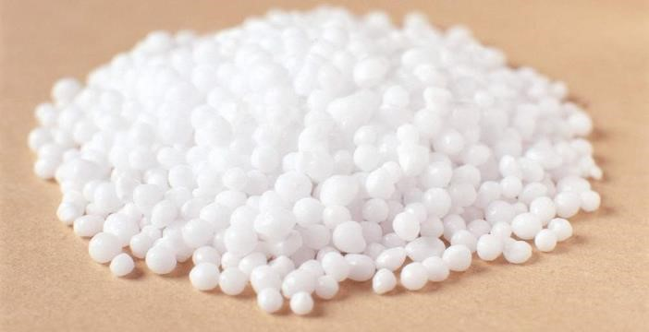
  - It contains 45 – 46% nitrogen
  - It is a white granular substance
  - It is highly soluble in water
  - It is acidic
  - It hydrolyzes in water to produce ammonium carbonate which converted to nitrates by nitrifying bacteria.
  - Calcium ammonium nitrate contains 25- 28% nitrogen
  - Ammonium Sulphate [(HN4)2SO4] contains 21% nitrogen
  - Ammonium phosphate contains 11% nitrogen

Why nitrogen fertilizers are usually top dressed
  - They are highly soluble and easily washed down the root zone
  - They are required by plants at a later stage of development and not at germination
  - They are applied at establishment to avoid misuse by weeds because at this stage plants can fully utilize it
  - They are very soluble and volatile if applied on dry soil
  - Slow release nitrogen fertilizers are fertilizers that that gradually release nitrogen to the soil at a slow rate e.g. sulphur coated with urea. Advantages of slow releasing fertilizers
  - They reduce nitrogen loss due to leaching
  - There is reduction in immobilization
  - There is reduction in denitrification
  - There is better season distribution of vegetative growth
  - They have improved storage and handling properties
  - There is a reduction of seed and seedling damage from highly localized concentrated salts.

- Phosphatic fertilizers supply phosphorus e.g. DSP and TSP. Genera characteristics of posphatic fertilizers
    - They are sparingly soluble in water
    - They are added to the soil before or during planting
    - They have a lower scotching effect on plants
    - Have high residual effect
    - They are soluble in acidic conditions

- Potassic fertilizers which supply potassium e.g. potassium nitrate, potassium chloride etc.

Advantages of compound fertilizers
- They contain and supply many plant nutrients
- Application of compound fertilizers save time and labour compared to several application of single fertilizers
- They occur in different rations and analysis. This enables easy choosing of a given material on a given soil
- The mixture is usually well mixed, dry, fine that can be applied by hand and fertilizer drill.
- They do not deteriorate on storage

Disadvantages of compound fertilizers
- They are expensive to buy
- Require skill selection of the fertilizer for a given soil

Methods of fertilizer application

- Broadcasting where the fertilizer is spread or scattered uniformly over the field after the land has been ploughed and then mixed into the soil.
- Plough sole application where a fertilizer is placed in a continuous band at the bottom of the plough furrow. Each band is covered as the succeeding furrows are turned over.
- Foliar application is where the fertilizer is directly sprayed on the crop e.g. urea and micro nutrients of copper, iron, magnesium and zinc.
- Drilling where a fertilizer is applied with a drill at the same time the seeds are sown
- Top dressing where a fertilizer is applied on the soil surface at a distance from the crop after the crops have emerged/or germinated from the soil.
- Fertigation where the fertilizers are applied with irrigation water during irrigation. It is used for water soluble fertilizers.
- Side dressing where a fertilizer is applied besides the plant between plant rows. It best for perennial crops and fertilizers are placed 2-4cm deep.
- Band placement; the fertilizers are placed in bands on one or both sides of the row.
- Ring placement; the fertilizers are placed around each and every crops within reach of crop roots.
- Pumping into the soil; liquid fertilizers are pumped into the soil using pressure to the required depth.
- Perforation; many holes that extent into the soil are dug around a tree under the shade and fertilizers are placed into the holes

Factors that affect the choice of method of application of fertilizers
- Crop type i.e. different crops have varying nutrient requirements and root structure which may dictate the most effective application method
- Soil conditions such as soil structure, pH, moisture level and organic content can influence availability and uptake
- Nutrient requirements: The specific nutrient needed by the crop at different growth stage can influence whether fertilizer are applied to the soil or directly to the plant leaves (foliar feeding).
- Timing: the growing stage of the crop is crucial, for example, young plant might benefit more from band placement, while mature plants might need broadcasting.
- Environmental conditions; weather conditions such rainfa, temperature and wind can impact the effectiveness of fertilizer application
- Availability of equipment for application of fertilizers
- Cost benefit consideration
Factors affecting the response of crops to the fertilizer
- Age/stage of the crop: different nutrients in the fertilizers are required at different stage of the crop
- Soil texture: this affects nutrient retention and cation exchange capacity of the soil. Coarse soils have low adsorption of nutrients and encourage leaching
- Type of the soil for instance clay soil fix nutrients making them unavailable to the plants.
- Soil pH: extreme pH reduced availability of some nutrients to the plants because it affects solubility and ionization of fertilizers.
- Method of placement of fertilizer: fertilizers placed within reach of the plant roots are readily absorbed
- Amount of water in the soil: water dissolves and helps absorption of fertilizers. While too much moisture can lead to leaching.
- Plant density: proper plant spacing reduces competition for the fertilizer and help their optimal used by plants
- Amount of fertilizer applied: optimal amounts of fertilizers are recommended; too little may not illicit proper response while too much is poisonous
- Rooting habit of a crop: plants with roots near the surface easily take up fertilizer and show fast response.
- Amount of bioactivity in the soil: some organism help in the transformation of nutrients into absorbable form e.g. mycorrhiza.
- Health status of the crops: healthy crops respond optimally to the fertilizers
- Level of weed infestation: weeds compete with plants for nutrients thus limiting utilization of fertilizers by the plants.
- Solubility of the fertilizer: soluble fertilizers are easily utilized by the plant and lead to fast response
- Good crop management practices such as thinning, pruning produce good results from application of fertilizers
- Weather conditions: wet and warm weather conditions increase solubility and absorption of fertilizers.
- Soil permeability; if the movement of soluble fertilizers is impended by hard pans, the crops will have a low response to the fertilizer than if movement is free.
- Soil structure; poor structure may interfere with root growth which may fail to benefits from a fertilizers
- Soil temperature; if the temperature is high, volatilization of a fertilizer may occur reducing the amount of fertilizers available to the plant and hence low plant response.

Irrigation
It is artificial supply of water to crops or soil when rain is inadequate.

Importance of irrigation
- Provides soil water to the plants
- Modifies soil temperature
- Controls wind soil erosion
- Increases cultivable land
- Safe guards against food shortage
- Make soil soft for tilling
- Can be used to some pest in crops e.g. aphids which are most serious in dry seasons.
- It may control weeds in some crop field e.g. in rice field
- It ensures timelessness in agriculture

Disadvantage/ problems cause by irrigation
- It to spreading of water borne diseases such as bilharzia
- May lead to accumulation of salts in soil when salty water is used
- May lead to soil erosion
- Reduce the amount of air in the soil
- Causes leaching of nutrients
- May cause waterlogging and death of microorganism
- It is expensive

Methods of irrigation a) Surface method
This is application of water over the surface of land. They include
- Furrow irrigation: this is where water is supplied to ridged land from the main source through supply channels which allow water to flow into the field along the ridges. Excess water is collected at the bottom of the field
Advantage of furrow irrigation
  - Cultivation and irrigation can both go on the same time
  - Less evaporation of water takes place
  - It is heap where land is leveled
  - It does not require special skill
  - It reduces leaching since less water is used
  - It is easy to control water supply than in flooding system - Labour costs are relatively low. Disadvantages of furrow irrigation
  - Salts tend to accumulate in the furrow.
  - Sometimes the ends of the furrow do not receive enough water.
  - Furrows interfere with movement of machinery
  - High cost of unblocking furrows
  - Requires leveling land
- Uncontrolled flood: in this method water is applied by flooding flat areas. It is only applicable in areas with abundant water supply. Advantage of uncontrolled flood irrigation
  - It is cheap
  - Requires no special skills to apply - Supplied enough water to the crops.
Disadvantages of uncontrolled flood irrigation
  - It may cause soil erosion
  - May cause waterlogging
  - It require a lot of water
  - Causes a lot leaching
  - Land cannot be worked immediately
- Boarder irrigation: this where water from the supply canal is applied to the top end of the strips of land which are divided by low earth bunds.
Advantages of boarder irrigation
  - Different crop can be grown in different bunds since they can be watered differently. - It requires less labour
  - Requires no special skill
  - It is cheap
  - It gives good water distribution if bunds are correctly made
Disadvantages of boarder irrigation
  - It may require leveling of land that may make it expensive
  - It is unsuitable for sand soil
- Basin irrigation: this is a method where water is allowed to flow from irrigation canals into basins (water trough). The basin may vary in size and may be for trees or group of trees. Water is retained in the basin until infiltration take place. Lateral canals convey water from one basin to another.

Advantages of basin irrigation
  - Uses little water
  - Reduces soil erosion
  - It conserves irrigation water and rainfall water
  - It helps to flash out excess salts from soil
Disadvantages of basin irrigation
  - Requires leveling of land
  - A lot of land is required for canals and basins
  - Requires high labour when basins are big
  - It may not be suitable for crops that require free drainage of soil
- Subsurface irrigation
This is the method of irrigation where underground ditches or perforated pipelines are used to supply water to the plants. The water is applied to the root zone directly such that the plants can have access to it immediately.
Advantage of subsurface irrigation
    - Little water is lost through evaporation
    - Does not promote soil erosion
    - Water is readily accessible by plant roots since it is applied to the root zone - Saves land for crop cultivation
Disadvantages of subsurface irrigation
    - It is expensive to buy pipes
    - Requires skill in application
    - Difficult to locate fault and maintain the system
- Aerial irrigation
This is the method of irrigation where the water flows through the pipes above the ground and is delivered to the plants
  - Overhead/sprinkler irrigation is a system of aerial irrigation where water is pumped under pressure and allowed out of the pipes through small nozzles and falls the ground as rain.
Factors that affect the efficiency of sprinkler irrigation
      - Quality of water: good quality water is required to prevent blockade of pipes
      - Type of soil affects the rate of water infiltration
      - Pump pressure affects the rate of water delivery
      - Weather conditions such as strong wind may change the direction of water leading to ineffective irrigation of some parts of the field
      - Temperature affects the rate of evaporation
  - Drip/trickle irrigation: in this system water is applied to the rows of crops through pipes with nozzles that deliver water around the plant roots
Advantages of aerial irrigation methods (drip and sprinkler methods)
  - They efficiently supply water to the plants
  - Can work well on rugged surfaces
  - Fertilizers may be applied during irrigation
  - Flow rate is controlled minimizing waterlogging
  - Does not promote growth of vectors such as mosquitoes - It is preferable in green houses - Easy to operate.
Disadvantages of aerial irrigation
  - It is expensive to install
  - Required power to run the pump
  - Expensive to maintain - Requires clean water
  - Promote pests and diseases.
Factors that determine the method of irrigation to use
  - Topography of the area: surface methods are best for slanting land - Type of soil: surface methods are not suitable for sand soil.
  - Availability of water: uncontrolled flood irrigation requires a lot of water while aerial methods require clean water.
  - Type of crops e.g. uncontrolled flood method is best for rice cultivation
  - Distance from water source: aerial methods require nearby water to minimize cost.
  - Availability of funds for initial cost e.g. buying pipes in aerial irrigation.
  - Availability of labour
  - Technology and skills

Soil Erosion is the washing away of top soil
Types of soil erosion
  - Sheet erosion: the surface of the soil is removed evenly over the whole surface of a slope
  - Rill erosion: top soil is removed to an extent that small channels in which the run-off is concentrated appear
  - Gully erosion: top soil is removed to an extent that deep valleys are formed by water run-off. Agents of soil erosion
  - Wind
  - Water
  - Animals
Man’s activities that cause soil erosion include
  - Overgrazing
  - Clearing land for agriculture
  - Deforestation
  - Road construction
Methods to reduce soils erosion are
  - Afforestation
  - Planting grass cover
  - Mulching
  - Strip cropping
  - Terracing
  - Contour cropping

Soil sampling
Soil sampling refers to the act of taking or obtaining small quantities (samples) of soil from different parts of the field and taking them to the laboratory for analysis. Aims of soil sampling
- To test for pH
- To determine organic matter content
- To determine soil mineral composition
- To determine drainage and water retention of the soil
- To determine soil aeration
- To find out the presence of microorganisms in the soil
- To determine the best crop for the soil
Methods of soil sampling
  - Transverse method: the soil samples are taken from selected sited along the diagonals from the corner of the field
  - Zigzag/random method: soil samples are randomly picked.
Procedures for obtaining a soil sample
- Determine the size of land area where sampling is to be carried out and determine the number of samples to be picked.
- Obtain clean sampling materials required e.g. polythene bags, soil auger and shovel.
- Decide on the sampling method to be used
- Identify and clear the vegetation from the sampling sites (about 20)
- Pick small sample at a depth 2cm – 15cm from each sampling site in a big polythene bag into which these samples are mixed thoroughly.
- Then a representative sample is picked from the mixture; labeled with date, plot or field number location and signature of the responsible person
- The representative sample is carried to the laboratory for testing

Revision questions
- The main disadvantage of broad casting fertilizers during seed bed preparation is that
  - There is wastage of fertilizers where seeds will not land
  - The spread of fertilizers is not uniform throughout the field
  - Some of the fertilizers is leached before crop emerge
  - Weeds are also stimulated to grow with the crops at the same time
- The reactions below represents a process of weathering
2Fe₂O₃ (s) → 4FeO(s) + O₂(g)
Which of the following processes in rock weathering is represented by the equation?
  - Reduction
  - Hydrolysis
  - Oxidation
  - hydration
- What happens during rock weathering by the process of hydrolysis?
  - Metallic cations in the rock are replaced by hydrogen ions B. Hydroxyl ions in the rock are replaced by metallic cations
  - Metallic cations in the rocks are replaced by hydroxyl ions
  - Hydrogen ions in the rock are replaced by metallic ions
- Interveinal chlorosis of leaves in a crop is a symptoms of
  - Magnesium deficiency B. Calcium deficiency
  - Phosphorus deficiency
  - Sulphur deficiency
- Biological activities in the soil may cause acidity through
  - Microbes secreting acids into the soil
  - Anaerobic decomposition of organic matter
  - Plant roots secreting acids into the soil
  - Their interaction with fertilizers
- Which one of the following may lead to increase in the population of earthworms in the soil?
  - Drainage
  - Application of artificial fertilizers
  - Cultivation to loosen the soil
  - Application of organic manure
- Organic matter buffers soil pH because of its
  - High cation exchange capacity
  - Adsorption capacity
  - Neutral nature
  - Amphoteric nature

- Which of the following factors least affects the efficiency of sub-surface drainage
  - Soil structure
  - Soil porosity
  - Volume of water
  - Type of land use
- The purple coloration of leaf margins in cereals is a deficiency symptoms of
  - Phosphorus
  - Magnesium
  - Nitrogen
  - calcium
- Which of the following characteristics of water contribute least to weathering? It
  - Expand on freezing
  - Dissolves most natural materials
  - Has a high specific heat capacity
  - Seeps into narrow cracks and crevices
- Which of the following characteristics makes clay and humus an essential component of arable land?
  - Dispersion effect
  - Cation exchange capacity
  - Ability to swell and shrink
  - Ability to obey the cohesion-tension theory
- Leterisation in the tropics is likely to occur if the parent rock is
  - Sandstone
  - Oxisol
  - Red tropical soils
  - ferralsols
- Which of the following is the biggest disadvantage of classifying soils as silt, clay and sand? It
  - give no information about mineral origin
  - relies too much on management practices
  - over emphasize the effect of climate
  - does not discuss forming process
- Why is classifying soils as silt, clay and sand not appropriate method? It
  - does not discuss forming process
  - over emphasizes the effect of climate
  - gives no information about mineral origins of the soil
  - relies too much on management practices
- Which of the following process occur when rocks disintegrates by hydration during soil formation?
  - Metallic cations in rocks take up water molecules
  - Metallic cations in rocks are replaced by hydrogen ions
  - Metallic cations in rocks are turned into hydroxides
  - Metallic cations in rocks form strong bonds with hydrogen ions.
- Which one of the following best explains why plants of the same species may respond differently in deficiency of the same nutrient?
  - Uneven distribution of the same nutrient
  - Genetic variation of the plant
  - Uneven distribution of water in the soil
  - Different photosynthetic mechanism of the plant
- Which of the following does not adversely affect the pH of the soil?
  - Absorption of bases by plants
  - Production of carbon dioxide by the roots
  - Leaching
  - Water logging
- Clays soils retain more water than sandy soils because clays have
  - Tiny particles and long macro pores
  - Large particles and tiny micro pores
  - Tiny particles and tiny micro pores
  - Tiny particles and large micro pores
- Moderate moisture in the soil is important because it;
  - Dissolves organic matter
  - Source of water to living organism
  - Regulates soil temperature
  - Neutralizes acidity of the soil
- The purple coloration of leaf margins in gramminae is a deficiency symptoms of
  - Magnesium
  - Calcium
  - Phosphorus
  - potassium
- the term soil reaction refers to
  - mineralization of elements in organic matter
  - antagonism between soil nutrients
  - hydrogen potential of the soil
  - fixation of nitrogen in the soil
- sub-soiling is carried out in order to
  - mix the soil
  - encourage soil drainage
  - discourage soil erosion
  - expel soil organism

- When a super phosphate fertilizer is applied to a clay soil, crop may not show a positive response because
  - Phosphate uptake by crops is suppressed y other minerals in clay
  - The acidity of clay soils reduce the solubility of phosphates
  - Phosphates get fixed into insoluble minerals, once in clay
  - Clay soils are usually water logged and dissolve the phosphates which are less leached
- Which of the following is the reason why regular turning of material during composting is recommended
  - Allow even distribution of nutrients
  - Prevents loss of nutrients through seepage
  - Allow uniform decomposition of the compost materials
  - Allow adequate wetting for proper decomposition
- Which one of the following may lead to increase in the population of earthworms in the soil?
  - Drainage
  - Application of artificial fertilizers
  - Cultivation to loosen the soil
  - Application of organic manure
- A nutrient is essential for plant growth and development if A. It is required by the plant at the critical stage of growth
  - Its presence in the plant does not cause a growth abnormality
  - Its deficiency results into a growth deformity
  - It is easily absorbed by the plant
- Which one of the following is an advantage of using farm yard manure over inorganic fertilizers?
Farm yard manure
  - Contains more nutrients
  - Adds organic matter which improves on soil structure
  - Does not alter soil pH
  - Supplies all the micro-nutrients required by the plant
- Phosphatic fertilizers are normally applied at planting time because they
  - Do not scorch the seedling
  - Promote growth
  - Are required for seed germination
  - Promote root growth
- Inorganic fertilizers are not usually applied on a sandy-silty because they
  - Rarely retain minerals
  - Hardly support crop growth
  - Contains sufficient minerals
  - Are acidic

- What do you understand by ‘heavy soils’
  - Soil that is difficult to cultivate
  - Very dark colored soils
  - Soils very rich in mineral components
  - Soils with plenty of organic matter
- In which of the following will terracing be most applicable?
  - Contour farming
  - Crop rotation
  - Mixed farming
  - Strip farming
- In chemical weathering:
  - The weak carbonic acid dissolves the rocks slowly
  - Chemical elements in the rocks react and disintegrate
  - Chemical reactions are speeded up to break down rocks slowly
  - The rocks break down slowly soon after physical weathering
- In which ionic form is nitrogen not available to plants?
  - NH₄⁺
  - NO₂⁻ C. NO₃-
D. NH₄⁻
- The nutrient which causes short joints and unthrifty growth in plants is
  - Calcium
  - Nitrogen
  - Phosphorus
  - potassium
- Which one of the following is not a disadvantage of sub-surface drainage?
  - They are expensive and require skilled labor
  - They are liable to be obstructed by roots
  - They leave the field free of obstruction
  - With heavy rainfall, nutrients may leach
- Which one of the following does not affect the amount of nitrogen released during ‘nitrogen flush?’
  - Soil temperature
  - Organic matter content
  - Length of dry period
  - Number of cultivators
- Mulching is known to reduce caking in
  - Loam soils
  - Clay soil
  - Sandy soil
  - Sandy loam soils
- The severe nitrogen deficiency in the soil which follows that addition of fresh plant residues with high carbon : nitrogen ratio is due to
  - Less nitrogen content in the plant residue
  - Ammonia compounds being fixed
  - Less decomposition arising from the damage
  - Lack of competition between microorganisms and plants
- The amount of fertilizer applied in a given field depends mainly on;
  - The type of fertilizer
  - Result of soil analysis
  - The type of crop grown
  - Soil structure and texture
- For which of the following reasons is excess water never present in plants
  - Water loss is always greater than gain
  - When the cells become turgid no more water is absorbed
  - The greater the water content in the leaf space the greater the rate of transpiration
  - The root hairs are too short lived
- Deflocculating is not a desirable process in soil because it
  - Leads to the destruction of soil structure
  - Disperse soil nutrients from the root zone C. Leads to fixation of plant nutrients in the soil
D. Leads to leaching of plant nutrients.
- Plants grown in clay soils are likely to show phosphate deficiency symptoms because
  - Phosphates is unavailable to the plants in poorly aerated soils
  - Plant roots are poorly developed in poorly aerated soils
  - Fixation of phosphorus occurs in clay soils
  - Phosphorus will get lost through leaching
- The major reason for adding sand to clay soil for crop production is to
  - Decrease acidity
  - Improve drainage
  - Improve water retention capacity
  - Decrease alkalinity
- Supply excess nitrogen to the plant may cause A. browning of leaves and premature drop off
  - chlorosis
  - delayed maturity
  - production of pigments other than chlorophyll

- Good drainage and ploughing of soil reduces the process of
  - Nitrification
  - Decomposition
  - Denitrification
  - Nitrogen fixation
- The conversion of nitrates into proteins in the soil by microbe can be termed as
  - Mineralization
  - Immobilization
  - Denitrification
  - fixation

- Root nodules formation is a result of infection of the root cortex by a group of bacteria called
  - Azotobacter
  - Nitrobactor
  - Rhizobia
  - Nitrosomonas
Answers to objective questions
1D | 6D | 11B | 16B | 21B | 21B | 26A | 31A | 36D | 41A | 46B
2A | 7D | 12A | 17B | 17B | 22B | 27A | 32B | 37B | 42C | 47C
3A | 8D | 13A | 18C | 18C | 23B | 28D | 33D | 38B | 43B
4A | 9A | 14C | 19C | 19C | 24C | 29A | 34D | 39B | 44C
5D | 10C | 15A | 20C | 20C | 25D | 30A | 35C | 40C | 45C

- Give three reason why kitchen refuses should be composted before application
  - to make nutrients available
  - to kill harmful organism in the kitchen refuse
  - to avoid burning plant roots when decomposing in the garden
  - to allow breakdown of any toxic substances in the kitchen refuse
- (a) what is cationic exchange
This is interchange between a positively charge ion in the soil solution with the adsorbed positively charged ions on the soil colloids such as clay or humus.
(b) Outline three factors which affect the rate of cation exchange in the soil
    - Concentration of cations in the soil solution. Concentrated cations in soil solution replace the less concentrated ones
    - The speed of movement of hydrated ions: movement of hydrated ions is slow compared to those not hydrated

The amount of charge: ions with more charges are more in replacing those with less number of charges.
The type of colloid: humus has a higher cation exchange capacity than clay.
    - The nature of charge on the exchange complex: monovalent charged elements have higher cation exchange than divalent charged elements.
    - soil type, the soil pH and the soil organic matter content.
- (a) Describe the methods of applying solid fertilizers to the soil
    - Broadcasting: the fertilizer is scattered uniformly over the field either by using hand or machine broadcaster
    - Band placement: fertilizers are placed in bands on one or both sides of the crop row, about 5cm below the seed and 4cm away from the seed or plant
    - Top-dressing: involves application of fertilizers to the soil after the crop is fully established.
    - Side dressing: the fertilizer is placed alongside the band besides the crop row after planting and establishment of the crops
    - Frill/dibble placement: a hole is made in the soil where the fertilizer is placed and then covered with the soil.
    - Application by plough: the fertilizer is placed in continuous bands at the bottom of the plough furrow. Each band is covered as the succeeding furrows are turned over.
    - Application through irrigation system: fertilizers are mixed with water for irrigation
    - Spraying on leaves of the crop especially urea
    - Contact placement: the fertilizer is mixed with planting seed so that the seed and fertilizer are simultaneously placed in the soil.
    - Ring placement: the fertilizer is placed in a circular manner around the plant.
    - Basal placement: the fertilizer is placed directly into the planting hole, covered with soil before the seed.
(b) Discuss the factors affecting the response of crops to the fertilizer
    - Age/stage of the crop: different nutrients in the fertilizers are required at different stage of the crop
    - Soil texture: this affects nutrient retention and cation exchange capacity of the soil. Coarse soils have low adsorption of nutrients and encourage leaching
    - Type of the soil for instance clay soil fix nutrients making them unavailable to the plants.
    - Soil pH: extreme pH reduced availability of some nutrients to the plants because it affects solubility and ionization of fertilizers.
    - Method of placement of fertilizer: fertilizers placed within reach of the plant roots are readily absorbed
    - Amount of water in the soil: water dissolves and helps absorption of fertilizers.
    - Plant density: proper plant spacing reduces competition for the fertilizer and help their optimal used by plants
    - Amount of fertilizer applied: optimal amounts of fertilizers are recommended; too little may not illicit proper response while too much is poisonous
    - Rooting habit of a crop: plants with roots near the surface easily take up fertilizer and show fast response.
    - Amount of bioactivity in the soil: some organism help in the transformation of nutrients into absorbable form e.g. mycorrhiza.
    - Health status of the crops: healthy crops respond optimally to the fertilizers
    - Level of weed infestation: weeds compete with plants for nutrients thus limiting utilization of fertilizers by the plants.
    - Solubility of the fertilizer: soluble fertilizers are easily utilized by the plant and lead to fast response
    - Good crop management practices such as thinning, pruning produce good results from application of fertilizers
    - Weather conditions: wet and warm weather conditions increase solubility and absorption of fertilizers.
- (a) State the major forms of nitrogen in the soil
Nitrates (NO₃⁻)
Nitrites (NO₂⁻)
Ammonium compound (NH₄⁺)
(b) Outline uses of nitrogen to crops
    - Increases the sizes of grains
    - Encourages growth of vegetables
    - Formation of plant proteins
    - Promotes formation of chlorophyll
    - Regulates the availability of potassium and phosphorus to the plants
    - Required in fruit formation e.g. pineapple, cucumber, water melon
(c) State the factors that affect leaching in the soil
    - Soil structure; weak structure encourages leaching
    - Soil texture; coarse texture encourages leaching
    - Rainfall intensity; high rainfall water encourages leaching
    - Vegetation cover minimizes leaching
    - Soluble nutrients are easily leached
    - Tillage removes vegetation cover and encourages leaching
    - Cation exchange capacity of the soil; high exchange capacity increases leaching
    - Level of humus in the soil; high content of humus reduces the rate of leaching
- Give reasons to explain why crops continue to show potassium (K) deficiency symptoms even after applying the right amount of Sulphate of potash in a given field
Perhaps there was a lot of soil moisture that reduced the exchangeable potassium elements
Drop in soil temperature which lowered the level of exchange potassium making it unavailable to the plants
Perhaps the field has 2:2 expanding clay soil which fixes potassium and make unavailable to the plant
- Presence of antagonistic nutrient elements in the soil preventing use of potassium by the plants
- (a) Explain the factors that affect the rate of decomposition of organic matter in the soil - Age of the plant- young plant materials decompose faster than old ones
    - Amount of water in the material: wet materials decompose faster than dry ones
    - Carbon: nitrogen ration – legumes decompose faster than cereals because they have high percentage of nitrogen.
    - Presence of putrefying organisms; for instance sterilizing soil with heat delays decomposition
    - Soil temperature: rate of decomposition increases with soil temperature
    - Soil aeration: adequate oxygen in the soil encourages growth of microorganism and promotes decomposition.
    - Soil pH between 6 and 8 promotes growth of microorganisms and thus promotes decomposition
    - Pollution kills microorganisms and delays the rate of decomposition
    - Climatic factors such as rainfall that provides water necessary for rotting
(b) Define the following terms as used on nutrient deficiency
- Chlorosis: this is general yellowing of the leaf tissue. It is very common deficiency symptoms since many nutrients affect the photosynthesis process directly or indirectly.
- Coloration abnormalities: some deficiency lower the amount of photosynthesis and chlorophyll which is produced by the plant
- Firing: yellowing followed by rapid death of lower leaves moving up the crop.
- Interval chlorosis: yellowing in between leaf veins, but with the veins themselves remaining green in grasses, this is called stripping.
- Necrosis: severe deficiencies result in death of the entire plant or part of it.
- Stunting: many deficiencies result in decreased growth. This result in shorter height of the affected plant
- Die-back of shoots in plants: refers to death of death tips or meristems viii. Mobility of nutrients in plants: mobile nutrients can be translocated from old tissue (bottom of the plant) to new tissues (top of the plant). Deficiency symptoms occur on the lower older leaves; nutrients that are mobile include nitrogen, phosphorus, potassium, magnesium etc. ix. Immobile nutrients: these are nutrients which are not easily translocated in plants e.g. iron, calcium, copper, manganese, molybdenum etc. Deficiency symptoms occur in new leaves.
x. Volatilization refers to sublimation of ammonium compounds to form nitrogen that escapes to the atmosphere. The process is favored by high temperature, high soil reaction, leaving fertilizers on the soil surface and soil with low cation exchange capacity or when urea is applied on grass or soil surface.
54. (a) suggest conditions that encourage soil aggregation
- Soil organic matter binds the soil particles together
- Soil water: moist soils are more plastic than dry ones
- Liming: calcium has a capacity to flocculate soil colloid
- Living organisms produce substance such as mucus that binds soil particles together
- Compaction lead to formation of platy structures
- Soil texture: soils with large particles are not plastic enough so their particles easily detach.
- Explain the importance of soil structure in crop production.
  - It controls the passage of water through the soil i.e. granular structure enables are more rapid downward flow of water than planty structure
  - It controls aeration of soil
  - It controls soil temperature
  - It regulate water holding capacity
  - Controls soil pH by controlling air passage
  - It controls workability of the soil; single, loose grained soil is easier to work than sticky heavy soils.
  - It control root soil penetration
  - Control soil erosion; loose soil is easily eroded.
  - Controls the ability of soil to hold nutrients
- Outline the effects of soil erosion in farming
  - Leads to loss of nutrients
  - Wash away/dislodges crops and planting materials
  - Creates gullies that make movement of machineries and livestock difficult and also reduce available land for farming.
  - Creates sand deposition to cover fertile soil.
  - Cause silting of water bodies and drainage tunnels
  - Gullies reduce the size of the farm
  - It may bury crops
  - It promotes spreading of water borne disease - Spreads pests by dispersing crop debris.
  - Spreads weeds
  - Lead to landslides and destruction of life
-
- (a) Give the reasons for the increase in soil nitrate level soon after the first rains after a dry season Accumulation of organic matter from plant tissues in the soil during dry season. These decompose and release nitrates.

Rapid multiplication of decomposers
Rapid increase of nitrifying bacteria that oxidize ammonium compounds into nitrates
Rapid increase of the population of nitrogen fixing bacteria
- Nitrogen fixation by lightening
(b) Explain the factors affecting nitrification in the soil
  - Level of ammonia: nitrification takes place when there is a source of ammonia.
  - Aeration: nitrification process requires air.
  - Temperature: high temperature favors nitrification and nitrogen fixation
  - pH: nitrification and nitrogen fixation require favorable pH
  - chemical kill nitrifying and nitrogen fixing bacteria and reduce the level of nitrification
  - moisture content of the soil: nitrification is slowed by very high and very lower soil moisture
- (a) Give four ways in which soil organism contribute to soil fertility
  - Decompose plant and animal remaining into humus
  - They are used for nitrogen fixation
  - Help in soil aeration e.g. earthworm
  - Mix up soil particles
  - Produce mucus causing aggregation of soil particle e.g. earthworms
  - Improve soil drainage
  - Improve soil aeration
(b) State four harmful effects of soil organism to crop
- Some organism destroy plant tissue e.g. millipedes
- Some organisms such as fungi cause disease
- Termites burrow deep and bring to the surface poor unfertile soil which reduces soil fertility.
- Soil organism e.g. nematode suck plant sap and block the transport tissues thereby hampering growth.
- (a) Distinguish between bulk density and particle density in soil.
Bulk density is the weight per unit volume of a dry sample of soil in its natural structure intact while particle density is the mass per unit volume of soil solids. (b) Explain factors that influence bulk density
    - Organic matter content: organic matter is very light and spongy and so increase in organic matter content lowers bulk density of the soil.
    - Soil particle size: clay soil with tiny particles have higher bulky density than sand with large particles
    - Porosity of the soil: porous soil has lower bulky density than non-porous soil
Soil depth: bulk density tends to increase the deeper one goes into the soil profile due to lower organic matter and high density of the underlying rocks.
Level of cultivation: intensive cultivation increases bulk density because it causes rapid break down of organic matter and cause compaction of the soil
Systems of soil management: addition of manure in large amounts to soil lowers its bulk density.
    - Cropping systems: continuous cropping reduces the amount of organic matter in the soil and increases the bulk density.
    - Amount of air in the soil: the higher the air in the soil, the higher the bulk density
    - Soil structure: the more compacted the soil structure, the higher the bulk density
    - Mechanization: use of heavy machines such as tractors during cultivation compact the soil increasing its bulk density.
(c) Suggest activities that can lead to destruction of soil structure
    - Pollution of the soil such as application of fertilizers and insecticides.
    - Ploughing soil at high moisture content results into mingling of the soil especially those that contain high clay content
    - Excessive leaching especially calcium and iron oxides that bind soil particles
    - Continuous cultivation of the soil break up soil aggregates
    - Bush burning destroy the organic matter and expose the soil to agents of erosion
    - Soil erosion erodes the aggregates destroying their shape
    - Use of heavy machinery compact the soil and destroy soil structure.
    - Water logging prevents organic matter from decomposing encouraging crumbling of soil structure

- (a) Explain ways through which soil becomes acidic
    - Application of organic manure: decomposition of organic manure produces acidic substances
    - Application of Sulphur and nitrogen containing inorganic fertilizers
    - Leaching of bases such as calcium, magnesium and potassium leaving aluminium ions.
    - Water logging cause anaerobic respiration that produce carbon dioxide and lowers pH - Acidic rain
    - Acidic parent rock from which soil is formed
    - Uptake of bases by the plant roots and replaced by hydrogen ions from the plants.
    - Release of acidic industrial and domestic wastes.
    - Water logging causes acidic hydrolysis of salts such aluminium salts.
  - What is the importance of lime to the soil?
    - Improve soil structure by binding soil particles
    - Neutralizes acidic soils
    - Supplies calcium to the soil
Binds soil particle to make aggregates that improves soils aeration and drainage.
Prevents some plant diseases such as fungal diseases
Makes availability of plant nutrients such phosphorus and nitrogen
Make clay soil less sticky and easy to till
Promotes soil organism’s activity and nitrogen fixation in root nodule Promotes decomposition of organic matter. Reduces toxicity of aluminium
  - Explain factors to be considered before applying lime to the soil
    - pH of the soil; the amount of lime required depends on the acidity of the soil
    - size of particles of limestone or carbonates: this affects the solubility
    - type of crops grown; different crops require different pH
    - the amount of manganese and aluminium present
    - The texture of the soil: fine textured soils have high cation adsorption capacity and less leached than coarse textured soil so more lime is applied.
    - The amount of organic matter in the soil. Soil with much organic matter requires more lime because it has high cation adsorption capacity.
    - Depth of the soil: deeper soil experiences high rate of leaching and thus requires larger amounts of lime.
    - Frequency of application of lime; infrequent application of lime requires high amount per application.
    - Fineness of limestone or carbonate used

- (a) Distinguish between soil texture and soil structure (02marks)
Soil structure refers to the fineness or coarseness of the mineral particles of the soil while refers to the general arrangement of soil particles within a soil mass to form aggregates.
  - Explain how soil structure can be destroyed.
    - Continuous cultivation of the soil breaks soil aggregates
    - Ploughing soil with high moistures breaks soil aggregate
    - Soil erosion washes away top soil
    - Poor sol drainage limits soil organisms that would otherwise enhance soil structure
    - Excessive leaching of calcium and iron that bind the soil aggregate
    - Pollution that kill microorganism that would otherwise enhance soil structure
    - Use of heavy machines that deform/compact soil
    - Poor harvesting practices that do not add organic matter to the soil
  - Explain how soil structure can be maintained.
    - Minimum tillage
    - Growing cover crops to reduce soil erosion
    - Mulching to reduce soil erosion, maintain soil moisture and add organic manure to the soil.
Bush fallowing with grasses so that fibrous roots bind soil particles
Proper drainage to remove excess water that cause dispersion
Liming to bind soil particles
Controlled irrigation to provide soil moisture

Controlled grazing to prevent soil compaction and erosion

- (a) What are the causes of low soil productivity/fertility?
    - Soil erosion leads to loss of crop nutrients
    - Leaching leads to inaccessibility of soil nutrients
    - Poor drainage may lead to water logging and hence poor soil aeration and unfavorable soil temperature.
    - Poor tillage destroys soil structure leading to leaching
    - Unfavorable pH
    - Soil capping i.e. development of impervious layer on the soil surface
    - Development of hard pans or impervious layers below the soil surface
    - Lack of required soil nutrients
    - Presence of pests and disease causing organisms in the soil
    - Presence of weeds which compete which compete with plants for nutrients - Lack of adequate soil moisture.
    - Mono-cropping cause soil exhaustion and buildup disease causing organisms
    - Burning of vegetation destroys soil living organisms
    - Excessive irrigation cause leaching
    - Excessive drainage lead to loss nutrients
    - Salinity of the soil
(b) Explain how soil productivity can be improved
- Through application of manure and fertilizers
- Practicing crop rotation to promote usage of different nutrients - Irrigation to provide water in the soil.
- Drainage of excess water
- Modifying soil pH
- Prevention of soil erosion
- Control pests and diseases
- Proper cropping like preventing overcrowding
- Applying effective method of water conservation

- (a) Explain the benefits of draining agricultural land
    - Improves soil aeration
    - Prevents buildup of toxic substance from decomposition of organic matter.
    - Cause favorable soil temperature that promote germination and plant growth
Frees soil of excess water
Make the soil lighter and easy to till
Helps control pests and diseases
Discourage leaching
Facilitate growth of plants that do not require water logged contions
Reduces soil erosion
Prevents rotting of roots.
Prevents accumulation of toxins
(b) What problems may result from draining agricultural land?

    - May lower water table
    - May lead to death of water loving organisms such as frogs
    - Lead to loss of dissolved nutrients
    - May dry up soil
    - May cause unfavorably high temperature
    - Salinization of the soil surface - Upset ecosystem
(c) Outline the disadvantages of using surface drainage channels in draining land.
    - Waste land since channels are constructed on the soil surface
    - Ditches interfere with agricultural operations and livestock movement
    - The open channels are prone to silting
    - Expensive to maintain
    - Require leveling before water can flow into the drains.
- (a) Explain what should be considered when designing a crop rotation
    - Nutrient requirement of the crops
    - Rooting system of crops: deep and shallow rooted crops should alternate.
    - Botanical families to which the crops belong: crops should be rotated from one family to another.
    - Cover crops: the rotation should include cover crops to control soil erosion
    - Pest and disease control: crops affected by the same pests and diseases should not be grown in succession.
    - Rest phase should be included in the rotation
    - Growth habits of the crops: crawling crops should be alternated with erect crops.
    - Water requirement of the crops: crops that required a lot of water should be grown during wet seasons and those that require less water in dry seasons.
    - Ease of weeding: crops which are easy to weed should alternate with crops difficult to weed.
    - Inclusion of legumes such as beans, peas, groundnuts in the cycle to add nitrogen
(b) Explain the role of crop rotation in maintaining soil fertility
    - Rotating crops of different rooting system enables plants to absorb nutrients at different soil layers
    - Different crops prefer different nutrients which prevent soil exhaustion.
Some plants like legumes fix nitrogen to the soil
Crops rotation improves soil structure such as those with fibrous roots.
Crop rotation controls pests and diseases by breaking their life cycles
Crop rotation controls some weeds such as striga
    - Resting helps regain fertility
    - Nutrient recycling i.e. deep rooter against shallow rooter
    - Conserve soil moisture when cover crops are planted
    - Control soil erosion by maintain soil structure or planting cover crops,
- Explain how each of the following affects crop growth (a) Soil pH on crop production
    - Affects availability of plant nutrients e.g. low pH makes phosphorus and molybdenum unavailable while high pH makes manganese and potassium less available.
    - At low pH, iron and aluminium become excessively available and become toxic to the plants.
    - Very low pH inhibits nitrogen fixation
    - pH determines the types of crops that can grow in an area e.g. tea and pineapples prefer low pH.
    - Control prevalence of disease causing organisms, e.g. fungal disease are common in acidic soils.
    - It influences the type of fertilizer to be applied e.g. sulphates of ammonia should not be applied to acidic soil.
  - Soil temperature on crop production
    - warm temperature encourages decomposition of organic matter to release plant nutrients - low temperature discourages germination
    - high temperature encourage drying of the soil
    - increase in temperature increase cell wall permeability
    - low temperature lowers the rate of photosynthesis and respiration
    - very high temperature cause wilting and death of the plant
    - affects solubility of nutrients
    - affects absorption of water and nutrients i.e. warm temperature encourages absorption
    - alternate hot and cold temperature promotes weathering
    - Influence nutrient loss from the soil for instance volatile ammonium compounds are lost on hot weather.
  - Soil organisms on crop production
    - fix nitrogen to the soil
    - decompose organic matter to release nutrients
    - some cause diseases to the crops
    - denitrifying bacteria reduce nitrogen from the soil
    - compete for oxygen in the soil with roots
    - some organisms produce toxic substances that cause disease to the crops
- Explain the factors to consider when deciding on which crop to grow.
Soil type; different crops prefer different soils
Rainfall
Temperature
Prevent weed
    - Labor requirement
    - Food value
    - Taste preference
    - Soil fertility
    - Cost of production
    - Available size of land
    - Government policy – the government may dictate crops to be grown
    - Altitude
    - Land ownership may determine whether to grow annual or perennial crop
    - Price of the crop
    - Purpose of the crops either for animals or human or drug
    - Gestation period
    - Culture for instance Baganda prefer growing bananas

- (a) Discuss factors that affect soil porosity
    - Soil texture: very fine soil texture such as clay soil lead less porous soil
    - Level organic matter in the soil: high organic matter content increase soil porosity by promoting soil aggregate
    - Frequent tillage promotes soil porosity by breaking up soil particles
    - Soil organisms like earth worms burrow and levels tunnels in the soil improving soil porosity.
    - Soil depth: soil porosity tends to decrease and the soil depth increase.
  - Means by which plant root take up nutrients
    - Simple diffusion
    - Facilitated diffusion
    - Active transport
    - Root interception

- (a) Outline six properties of humus
  - Dark brown
  - Odorless
  - Colloidal
  - Insoluble in water
  - soluble in dilute alkali giving a dark colored solution
  - contains modified plant residues and synthesized microbial compounds

  - has high cation exchange capacity
  - has high water absorbing capacity about 5-7 that of clay
  - has high relative molecular mass
  - light amorphous material with very low bulk density(0.2 -0.5mg/g)
  - Give five uses of humus in the soil
  - it is a source of N, P, S and most micro-nutrients
  - it increases cation exchange capacity (CEC) of the soil because organic matter is negatively charged.
  - Source of food for soil organisms
  - It increases water holding capacity especially of sand soil
  - It improves soil structure by binding soil particles together
  - Ti reduces the impact of compaction and capping in soil
  - It buffers pH change
  - It promotes root penetration into the soil because it keeps soil soft
  - Describe any appropriate test that can be used to find humus content of the soil
Procedure
  - Dry the soil sample (w g) in an oven at 105⁰C to a constant weight x g - Heat the soil until red hot to a constant mass y.
  - Percentage of humus =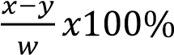
- Suggest the factors which influence soil erosion
  - The amount/density of rainfall: in areas which receive heavy rainfall, the rain drops hit the ground with much force causing splashing of the soil and the soil is carried in running water
  - Steep relief encourages soil erosion
  - Type of soil: loose soil particles are easily carried away by the agents of soil erosion. - Vegetation cover minimize soil erosion
- (a) List five factors that affect symbiotic nitrogen fixation in the soil (05marks)
  - Presence of nitrogen fixing bacteria (of the genus Rhizobium)
  - Presence of root legume roots in whose root nodule bacteria live
  - Presence favorable temperature
  - Presence of oxygen in the soil for respiration of bacteria
  - Presence of nitrogen in the soil to be fixed
  - Presence of zinc in the soil: zinc is necessary for nitrogen fixation acting as a secondary signal for nitrogen fixation
  - Presence of antimicrobial agents in the soil

  - Give five uses of nitrogen in plants (05marks)
  - used in synthesis of chlorophyll
  - used in production structure i.e. constituent of proteins
  - used in synthesis of enzymes
  - used in synthesis of hormones
  - used in synthesis of poisonous substance that protect the plants from predators.
  - Controls the use of phosphorus and potassium in the plants
  - It improves the quality and quantity of leaf crops such as cabbages, dodo, etc.
  - It helps in cell division and therefore responsible for growth
  - Controls the use of phosphorus and potassium in the plants

- (a) State three factors that influence the temperature of the soil. (03marks)
    - Amount of soil radiation: high solar radiation increase soil temperature
    - Soil colour: dark soil color absorbs heat and increases soil temperature
    - Crop cover: plant cover lowers soil temperature
    - Organic matter increases soil moisture retention and give a darker color to the soil increasing heat retention in the soil
    - Soil moisture: retains heat in the soil
    - Compositing release heat increasing soil temperature
-
  - Explain the effect of temperature on soil productivity. (04marks)
    - High soil temperature promotes activities of soil organisms such as nitrogen fixation
    - High soil temperature promotes active uptake mineral soil
    - High soil temperature promote decomposition and release of nutrients from organic matter
    - High soil temperature increases water uptake
    - low temperature discourages germination
    - high temperature encourage drying of the soil
    - alternate hot and cold temperature promotes weathering of soil
  - Explain three ways by which a farmer can modify soil temperature. (02marks)
    - Mulching lowers soil temperature
    - Drainage increase soil temperature
    - Planting of cover crops

TOPIC 3/3: Crop Production and Husbandry
Competency: The learner applies evidence-based husbandry practices to ensure optimal quality production.

Business Model Canvas
An example Business Model Canvas (BMC) for a coffee enterprise that integrates optimal production practices such as sustainable farming, quality control, and community engagement is given below

Business Model Canvas – Coffee Enterprise (Optimal Production Practices)
Building Block | Details
Key Partners | - Local farmer cooperatives  - Agricultural extension services  - Certification bodies (Fairtrade, Organic)  - NGOs supporting sustainability  - Export agencies and logistics providers
Key Activities | - Sustainable coffee cultivation (shade-grown, organic inputs)  - Quality control and grading  - Processing (washing, drying, roasting)  - Packaging and branding  - Marketing and distribution
Key Resources | - Coffee plantations and farmer networks  - Skilled agronomists and workers  - Processing equipment (wet mills, roasters)  - Certification and quality assurance systems  - Strong brand identity
Value Proposition | - High-quality, sustainably produced coffee  - Traceability from farm to cup  - Fairtrade and organic certification  - Unique flavor profiles (single-origin)  - Contribution to community development
Customer Relationships | - Direct trade with roasters and cafes  - Transparent communication about sustainability  - Loyalty programs for retail customers  - Storytelling about farmers and origins
Channels | - Export markets (Europe, US, Asia)  - Local supermarkets and cafes  - Online platforms (e-commerce)  - Farmer’s markets and specialty shops
Customer Segments | - International specialty coffee buyers  - Local cafes and restaurants  - Health-conscious consumers (organic buyers)  - Ethical consumers (Fairtrade supporters)
Cost Structure | - Farm inputs (organic fertilizers, pest control)  - Labor and training  - Processing and packaging costs  - Certification and compliance fees  - Marketing and distribution expenses
Revenue Streams | - Coffee bean sales (green and roasted)  - Premium pricing for certified coffee  - Direct-to-consumer online sales  - Value-added products (cold brew, flavored coffee) - Export contracts

Optimal Production Practices Integrated
- Sustainable farming: Shade-grown coffee, organic fertilizers, crop rotation.
- Quality assurance: Grading, cupping tests, and certifications.
- Community empowerment: Fair wages, training, and cooperative structures.
- Environmental stewardship: Soil conservation, water management, biodiversity protection.
- Innovation: Exploring value-added products like cold brew and eco-friendly packaging.

Occupational Health Practices in crop production
- Protective equipment: Use of gloves, masks, boots, and goggles during pesticide application, harvesting, and processing.
- Training: Educating workers on safe handling of chemicals, machinery, and tools.
- Medical check-ups: Regular health screenings for workers exposed to dust, chemicals, or heavy labor.
- Ergonomics: Providing proper tools and techniques to reduce strain during harvesting and processing.
- Hygiene facilities: Access to clean water, sanitation, and rest areas to maintain worker health.

Safety Practices in crop production
- Safe chemical handling: Proper storage, labeling, and controlled use of fertilizers and pesticides.
- Machinery safety: Training operators and maintaining equipment (e.g., pulping machines, roasters) to prevent accidents.
- Emergency preparedness: First aid kits, fire extinguishers, and evacuation plans at farms and processing plants.
- Workplace organization: Clear pathways, safe storage of tools, and prevention of slips or falls.
- Child labor prevention: Ensuring compliance with labor laws to protect vulnerable groups.

Environmental Protection Practices in crop production
- Soil conservation: Techniques like terracing, mulching, and cover cropping to prevent erosion.
- Water management: Recycling water in wet processing, preventing contamination of rivers and streams.
- Waste management: Composting coffee pulp and husks instead of dumping them.
- Agroforestry: Growing coffee under shade trees to preserve biodiversity and reduce deforestation.
- Reduced chemical use: Promoting organic fertilizers and integrated pest management (IPM).
- Climate adaptation: Planting resilient coffee varieties and diversifying crops to withstand climate change.

Summary Table
Category | Practices | Benefits
Occupational  Health | PPE, training, medical check-ups | Protects worker health, reduces illness
Safety | Safe chemical handling, machinery safety, emergency preparedness | Prevents accidents, ensures compliance
Environmental  Protection | Soil conservation, water recycling, waste composting, agroforestry | Sustains ecosystems, improves long-term productivity

Why These Practices Matter
- Worker well-being: Healthy workers are more productive and motivated.
- Community safety: Reduces risks of accidents and chemical exposure.
- Sustainability: Protects soil, water, and biodiversity for future generations.
- Market advantage: Certified sustainable coffee (Fairtrade, Organic) fetches premium prices.

Plant propagation and breeding in agriculture
Plant propagation is the process by which new plants grow from various sources, including seeds, cuttings, and other plant parts. Plant propagation may refer to both man-made and natural means.

Types of propagation
- Sexual propagation: occurs through the natural growth of viable seeds.
- Asexual propagation: allows for the creation of new plants using cuttings from vegetative parts, like the roots, leaves, and stems.

Selection of planting material
In order for a farmer to reduce the expenses the need to select the planting material that he is sure of.

Characteristics of a good planting material
- Should be readily available within locality to reduce transport expenses and time wasted in looking for it.
- It should be pest and disease free to reduce the transmission of such diseases and pest to the seedling.
- It should be easy to transport i.e. should not be bulky.
- In case, of seeds should be of uniform size and shape to allow easy mechanization during planting.
- It should be easy to store so that it can used in future when needed.
6 In case of seed they should have passed the dormancy stage.
- The planting material should be highly viable to reduce the costs involved in filling up the gaps where they did not germinate.
- Seeds should be of uniform colour to allow easy sorting and planting.
- The planting material should be of high proven performance give high returns once planted.
- Materials should be free from contamination by weeds.
- Should be free from mechanical damage.
- In case of seeds, should be large enough.

Seed propagation
This is where seeds of mature plant having desirable qualities are used for planting.
Qualities of good seed lot for planting
  - Should be viable
  - Should be disease
  - Should be free from mechanical damage
  - Should be mature
  - Should have appropriate size to ensure enough food reserve
  - Should be free from contamination
  - Should be of desired genetic make up
  - Should be plump i.e. well-formed and not wrinkled
Reasons for drying seeds before storage
  - To prevent molds and rot: seeds with high moisture rot easily
  - Properly dried seed have long shelf life
  - To prevent germination before planting
  - To reduce pathogenic contaminations
  - Maintain seed quality such good color

Advantages of propagation from seeds
- Seeds are not bulky and therefore are easy to handle and convenient to transport.
- They can be stored for a long time while retaining viability
- Seeds are easy to treat against pest and seed bone diseases
- Minimizes spread of disease from parents to offspring
- They are cheaper planting materials
- Seeds are easy to use during machine planting.
- Seed planting is a quick method of increasing a crop population in a short period.
- Some crops are difficult to plant from vegetative parts.
- Plants raised from seeds have a longer life span than those raised by vegetative means. Disadvantages of propagation from seeds
- Some seeds are delicate hence difficult to handle during planting.
- They promote spread of seedling or seed borne disease.
- Seeds require special field preparation before planting more especially those with small seeds.
- Some seed may not breed true to type hence disappoint farmers
- The formation of seeds requires special condition during pollination and fertilization.
- Due to interference during pollination seeds may be formed but of a high degree of variability.
- Crops raised from seeds take a longer time to mature.
- Some plants do not have viable seeds.

Analysis of seed purity
This refers to the process of determining whether the purchased seed or processed seed have contamination such as weed seeds, inert materials, stones, other crop seeds etc.
Percentage purity = 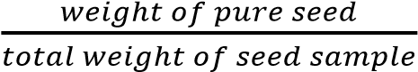

Seed treatment
- Seed dressing –coating seeds with pesticides e.g. copper Sulphate.
- Chitting or encouraging sprouting e.g. in potato seeds.
- Inoculation, usually done legumes where seeds are coated with correct bacterial for nodule formation.
Importance of inoculation
- Promotes formation of root nodules
- Increases nitrogen fixation to the soil
- Minimizes use nitrogenous fertilizers
- Hot water treatment against viral diseases e.g. in sugarcane and cassava.
- Fumigation of seeds is use of volatile chemicals in seed store to kill pests in the room

Seed viability
It is the ability of a seed to germinate and develop into a healthy seedling under favorable conditions.

Seed longevity
It is the period of time that seeds remain viable
Germination
It is the development of a seed into a seedling

Physiological processes that take place during seed germination
- Imbibition is the uptake of water by diffusion due to presence of solid particles or colloids in the seed causing the seed to swell.
- Activation of hydrolytic enzymes following uptake of water.
- Hydrolysis of storage food material into soluble products by hydrolytic enzymes
- Translocation/transport of soluble products (glucose and amino acids) from endosperm (storage area) to the actively growing centres of the embryo.
- Synthesis of enzymes, nucleic acids, structural proteins
- Respiration to provide energy for cellular activities
- Cell division, elongation and differentiation lead to immergence of a seedling from a seed.
measures

Measures to increase the ability of seeds germination
- Proper drying of seeds before storage reduce moisture content and risks of pests and diseases
- Harvesting mature seeds
- Controlling oxygen supply during storage of seeds
- Maintaining proper temperature
- Treatment of seeds to avoid pest and diseases
- Proper seed bed preparation especially for small seeds
- Soaking seeds in growth stimulants
- Soaking seeds in water overnight before planting to soften their testa.
- Prechilling of seeds with hard coats to ease entry of water and air.
- Avoid prolonged storage of seeds.

Methods to determine the viability of seeds
- Germination Test: Place a specific number of seeds (e.g., 100) on a moist paper towel, fold it, and place it in a plastic bag. Keep it in a warm place and check after a few days to see how many seeds have sprouted.
- Water Test: Place seeds in a container of water. Viable seeds will sink, while non-viable seeds will float.
- Excised Embryo Test: This involves removing the embryo from the seed and placing it in a nutrient solution to see if it grows.
- Chemical Test: Some seeds can be tested using chemicals that react with living tissues, indicating viability.
  - Viable seeds soaked in 0.1% tetrazolium salt solution and left for 24 hours will have their embryo stained red.
  - Viable seeds decolorize warm potassium permanganate solution
- The electrical conductivity test measures the leachate’s conductivity when seeds are soaked in water, providing an indirect assessment of seed viability.

Seed dormancy
Seed dormancy is the inability of a viable seed to germinate under conditions favorable for germination.

Causes of seed dormancy
- Seed coats impermeable to water: dormancy remains until the testa layer decay by soil.
- Seed coat impermeable to oxygen: but later seeds become more permeable to oxygen so that it germinates afterwards.
- Mechanically resistant seed coat: In certain seeds of weeds have hard seed coats that prevent the expansion of embryo.
- Immaturity of the embryo that do not germinate until allowed time to mature.
- Due to the effect of germination inhibitors such as abscisic acid that prevent germination of seed.
- Low temperature: In certain plants the seeds remain dormant after harvest because they require low temperature for germination. The seeds germinate in the spring season.
- Light sensitive seeds: some seeds require light to germinate and will not germinate in its absence

Methods of breaking dormancy
- By soaking the seeds in growth stimulating hormone
- By pre-chilling i.e. seeds are exposed to very low temperature for a short time before planting in normal conditions
- Soaking seeds in cold water overnight before planting in normal condition
- Scarification / mechanical removal of testa
- Heat treatment: seeds are soaked in hot water at about 800C for 3 – 5 minutes before planting - Exposure to light: some seeds need to be exposed to light in order to germinate.

Advantages of seed dormancy
- Seed are able to withstand adverse external conditions such as very cold or very dry weather.
- It allows seed and fruits to disperse
- Prevents death of entire population in bad times since all seeds do not germinate at ago - Prevents pre-harvest germination - Facilitate proper storage of seed.

Methods of planting seeds
- Broad casting
This is the scattering of seeds all over the field in random manner. It is usually used for seeds which are very small that cannot easily put in holes Advantage of planting seeds by broadcasting
  - It quick
  - Easy and simple
  - Requires less labour
  - Minimize soil erosion due to good crop cover
  - Best for small seeds such as millet and simsim
Disadvantages of planting seeds by broadcasting
  - Cannot be mechanized
  - Difficult to weed
  - Uneven distribution of seedlings
  - Some seeds are eaten by birds
- Row planting
Here seeds are planted in holes, drills or furrows that are in rows/lines
Advantages of row planting of seeds
  - Uses fewer seeds
  - Gives optimum plant population
  - Planting can be mechanized
  - Promote uniform germination
  - Easy to weed
  - Plant get enough space
Disadvantages of row planting of seeds
  - Requires a lot of labour
  - Tedious
  - Requires skill
  - Not suitable for small seeds

Nursery bed
A nursery bed is a small portion of land prepared for raising seedlings before transplanting.
A seed bed is a piece of land which has been prepared and ready to receive the planting materials where they can grow up.
Advantages of raising seedlings in a nursery bed
- Many seedlings can be prepared in small area
- Make it easy to carry out routine management.
- Provide the best conditions for growth i.e. fine tilth.
- Allows transplanting of healthy and vigorous seedlings
- Preparing seedling is source of income/employment
Factors to consider when selecting a site for a nursery bed
- Source of water for irrigation
- Gentle slope to minimize soil erosin and flooding
- Security to protect from thieves, bird and animals
- Nursery bed should be sheltered from strong wind that would destroy seedling
- Nursery bed should point in north-south direction to expose the seedlings to adequate sunlight.
Nursery management
- Watering in the morning and afternoon
- Weeding
- Pricking out/remove of weak and unhealthy seeding and planting them in another nursery bed
- Providing a shade
- Mulching when necessary
- Pest control by applying the recommended pesticides
- Hardening off or gradual reduction of shade and watering before transplanting
- Disease control
-

Vegetative propagation
This is the reproduction of plants from plants part that are not associated with reproductive organs.
Advantages of vegetative propagation
- The offspring is similar to the parent in all ways hence preserve good mother characters.
- Offspring grows faster and mature early.
- Offspring are strong and hardly compare with seedling obtain from seeds.
- Vegetative propagation is the best way for propagating plants with no viable seeds.
- Daughter plants obtain food from their parents until they are sufficiently strong hence increasing chances of survival.
- Multiplication of the plant population is faster
- Over comes the problem of prolonged dormancy in some seeds
- Less risk of seedling disease
- Doesn’t require much care
- Does not require pollinating agents
Disadvantages of vegetative propagation
- It may cause overcrowding due to the ability to establish quickly and grow fast.
- It may cause overcrowding due to the ability to establish quickly and grow fast.
- The planting materials are quite bulky and therefore difficult to handle store and transport.
- Due to their high moisture content vegetative materials are difficult to store.
- Some vegetative methods of propagation are complex and hence need a lot of skill to execute.
- A small hectare can be covered during planting as compared to seed propagation.

Methods of vegetative propagation
- Layering - Mainly used in passion fruits.
- Grafting - Used in most fruits like citrus, avocado, mangoes etc.
- Budding - Can be used in fruits also like citrus.
- Tissue culture- group of cells are developed into a new plant or plants

5 Use of storage structures
- Bulbs - Used in onions and garlic.
- Bulbils - Used in sisal
- Suckers - Used in banana and pineapple
- Rhizomes. - Used in ginger
- Runners - Used in strawberry
- Corms - Used in cocoyam
- Splits - Used in pyrethrums
- Stem tubers - Used in Irish potatoes.
i Cutting - Used in cassava sweet potato, clonal coffee.

GRAFTING
This is where two different stems are united in woody plants of the same species. The upper part of the union is called a scion while the lower part is called a stock.

PRINCIPLES OF GRAFTING
For successful grafting, there are about five principles which must be adhered to;
- Compatibility – The scion and stock must be related or close to facilitate sexual hybridization.
- The scion and the stock should be disease free.
- Use suitable equipment or tool for grafting
- Scion should have a bud
- Both scion and stock should be woody
- Both scion and stock should be from quality plant
- Graft quickly
- Cambial alignment – The cambium of the scion and root stock should be aligned for the union form.
- Timing of the grafting operation – Grafting must be done at a time when the root stock is in a proper physiological state.
- Avoiding desiccation – After grafting operation make sure that all the surface is sealed off using wax or grafting tape around the joining
- Pressure – Apply a pressure after aligning the cambium of the root stock and scion such that the xylem stays in contact.
Advantages/reasons for grafting plants
- It changes the tree top from being undesirable to desirable
- It makes it possible to grow more than one fruit or flower in the same plant.
- Root stocks with desirable character like disease resistance, problem of water logging are used which may be beneficial to the scion and farmer.
- It helps to propagate clones that cannot be propagated by any means.
- Can be used to repair damaged trees e.g. bridge grafting 6. It helps propagating special plants form e.g. seedless oranges.
- Helps in change variety for more especially when the acid
- Virus indexing – Plants having viral infection with no signs will show signs when grafted. Disadvantages/limitation of grafting
- Incompatibility – this failure of grafted material to survive due to a difference in genetic constitution.
- Certain undesirable characteristic of the stock are transferred to offspring
- Requires a lot of skills and experience for successful grafting to occur.
- Requires a lot of time for tangible results to be got.
- Absence of genetic variation
- Apply to plant of the same species only
- Leads to premature againg
- 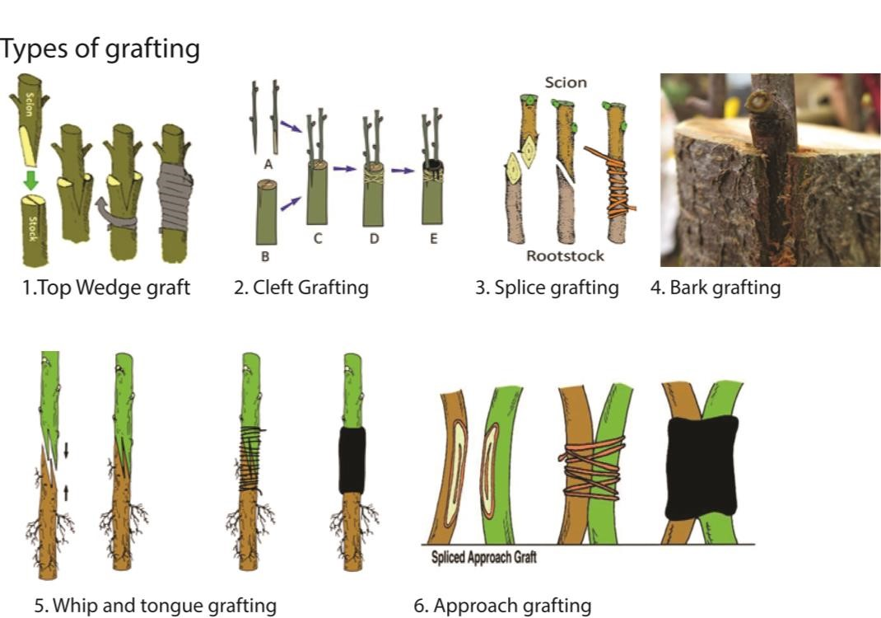
- Top Wedge: a cut surface of the scion forms a wedge that is inserted into a vertical slit on the root stock that has been slash.
- Cleft Grafting / Top working grafting: this involves grafting a scion into a canopy of a relatively large established tree.
- Splice grafting: a long slanting cut is made in both scion and root stock which is later tied together.
- Bark grafting: a bark grafting is a plant made by slitting the back of the stock and inserting the scion beneath it. It is often used to regenerate an adult tree that has stopped being productive and to replace its structural branches. The cambium of the scion must line up as closely as possible with the cambium of the stock for a good graft union
- Whip and tongue grafting: this is done if the root stock and scion have the same dimensions. A stanty cut is made at the base of the scion top of the root stock. The two are fitted together and waxed
- Approach grafting: Here both the scion and stock remain attached to another plant until a secure union has been formed.
- Bridge grafting: This is used in repairing damage free plant normally woody trunks of valuable established trees.

Budding
This type of vegetative propagation the bud or scion is united with a seedling or a mature tree.
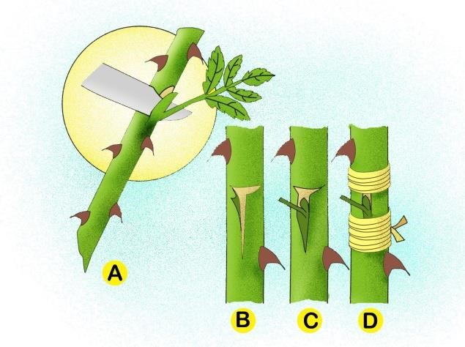

TYPES OF BUDDING
- T-budding: a t-Shaped cut is made on the back of the root stock and a bud is made on the back of the root stock and the bud fitted in
- Patch budding: a rectangular piece of bud is cut of the root stock. A matching piece of bark with a bud is cut from the bud wood and matched into the prepared root stock.
- Top budding: buds from young plants are inserted at desired location on the stock and after setting the original branches are cut.

LAYERING
This involves inducing a part of plant usually a branch to produce roots while still attached to the mother plant.
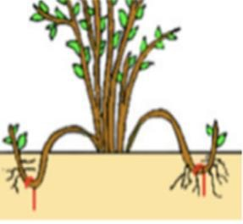
TYPES OF LAYERING.
- SIMPLE LAYERING
This involves bending a stem and covering it with soil to produce roots.
- TIP LAYERING
The whole shoot is bent and covered in the soil
- COMPOUND LAYERING (SERPENTINE)
This is achieved by bending a stem several times and sometimes at a point of covering.
- MOUNT / STOOL LAYERING.
A stem is cut just above the ground and the under shoot starts
- TRENCH LAYERING
Here a trench is dug near the plant and a branch is layed on the trench to facilitate root development.
- AIR / MACOTTING LAYERING.
The bark of a tree is open at a point and a wet mass is placed around the ring bar to keep it open. This stimulates root to develop at that point.

Tissue culture
It is the development of organisms or organs from cells and tissues under sterile conditions and nutrient media
Advantages of tissue culture
- A large number of plants can be grown in a short period of time
- Healthy plants can be grown from diseased plants
- Plants without seeds can be multiplied
- Produces genetically uniform crops
- Requires small space to raise many plantlets
- Plantlets are not bulky and easy to transport
- Method can be used to produce useful chemicals for medicine
Disadvantages of tissue culture
- Requires all skills
- Since clones are identical can easily be wiped out by environmental disasters. - expensive

Crop breeding / improvement
This is a process of changing crops genetically to suit man’s needs of food, easy harvesting etc.
Or
It’s a directed adjustment of crop plants to fit specific environment and production practices.

Germplasm is the genetic material that can be used to perpetuate a species or population. It is only has reproductive value, but through genetic manipulation (plant breeding), germplasm can be improved for better performance of the crop. Germplasm provides materials (parents) used to initiate breeding.

Aims of crop breeding / improvement
- To increase crop yields so as to save the problem of hunger and food shortage.
- To increase the nutrient content of the crop product to solve nutrient deficiency in consumers.
- Produce better size and colour of fruits / seeds that can attract consumers.
- To reduce the gestation period of a crop so as to solve food shortage.
- Conferring disease and pest resistance in crop.
- Production of crops that can tolerate adverse environmental conditions like drought, low soil fertility, high temperature.
- To change growth characteristics of a plant in order to suit harvesting spraying and weeding.
- to improve on the short life of the sowed crop production
- To improve on seed viability character in plants so that there is no wastage of seeds during planting. - Improving the taste and flavour of certain crop products.
- To produce crop products that is easy to prepare as food for consumers.

Methods of crop breeding/improvement They include
- Selection
- Introduction
- hybridization
1. Selection
It is a process of picking from a number of individuals with desirable characteristics to be parents of future generation. Selection can be natural or artificial but artificial selection is most important.
- Natural selection: Here crops or animals that are better suited to the environment survive and produce more offspring for the next generation while the less suitable dies off.
- Artificial selection: A farmer selectively breeds animals and crops with desirable traits.
Methods of in crop selection
(a) Pure line selection: in this method a single good looking plant is chosen and its offspring used to develop a new variety. It is a passive process since it eliminates variations instead of creating it.
It is used to improve self-fertilized plants
Procedure of conducting pure line selection
- A large number of good looking plants with desirable qualities are identified.
- Seeds are collected from the plants from those with desirable qualities and kept separately
- The seeds from each plant are planted separately on isolated fields to prevent mix ups.
- The performance of the seeds from each plants and best performing plants noted.
- The seeds of the best performing plant are selected and identified as new variety.
- Mass selection
Seeds are collected from many good looking plants and mixed together. It used for breeding self-pollinated plants species (Dioecious plants)
Procedure of conducting mass selection
  - Seeds from many plants with desirable characteristics are collected and mixed together.
  - The seeds are planted on the same field and the result seeds from these crops are selected and marked as a new variety
Advantages of mass selection
  - It simple
  - fast
  - cheap
  - the cultivar is phenotypically fairly uniform even though it is a mixture of pure lines hence genetically broad based, adaptable and stable
Disadvantages of mass selection
  - requires a uniform environment to achieve optimal results
  - Phenotypic uniformity is less than that of pure line selection
  - Desired qualities are a mixture of heterozygous and homozygous individuals thus a possibility of recessive traits in future generations.

- Pedigree selection
It a breeding method in which the breeder keeps records of the ancestry of the cultivar.
Hybridization is used to generate genetic variability
Procedure of pedigree selection
  - The homologous parents of desirable qualities are identified and crossed.
  - Seeds (F1) from superior plants are selected, identifies, planted separately and records kept.
  - Procedure (ii) is repeated several time until cultivar of desired quality are produced.

Advantages of pedigree selection
  - Record keeping provides a catalog of genetic information of the cultivar unavailable from other methods
  - Selection is based not only on phenotype but also on genotype (progeny row) making it an effective method for selecting superior lines from among segregating plants.
  - Using the records, the breeder is able to advance only the progeny lines in which plants that carry the genes for target traits occur.
  - High degree of genetic purity is produced in cultivar
Disadvantage of pedigree selection
  - Record keeping is slow, tedious and expensive
  - The method is not suitable for species in which individual plants are difficult to isolate and characterize
  - Pedigree selection is a lengthy process requiring 10 – 12 years or more to complete
  - The method is more suitable for qualitative than quantitative breeding
  - Selection in F2 (early generation testing) on the basis of quantitative traits such as yield may not be effective.
2. Introduction
This involves improvement of plants by introducing crops from their centers of origin or supposed centers of origins to other areas where they can survive and adapt to the environmental conditions. The introduced crops may be in form of planting material or pollen from suitable varieties for conducting artificial pollination.

Forms of introduction
- Direct for good economic use e.g. rubber and cocoa can be introduced and grown without any modification
- Can be used for selection of suitable crop cultivation
- Can be used for hybridization or other breeding programs.
Problems of crop introduction
- The introduction of plants needs other aspects of the environment for success such as pollinators.
- The introduced plant may not be adapted to the local environment
- Pests and diseases may be introduced with the new crops
- Requires a lot of research on climate and soil conditions before introducing a new crop.
3. Hybridization
It is the crossing of pure lines to produce a hybrid. Or it is the crossing of different varieties or species of plants to produce hybrids. It is mainly used in breeding for disease resistance.

Pure line cultivar are produced for species that are highly self-pollinated.

Hybrid cultivar are produced by crossing inbred lines that have been evaluated for their ability to produce hybrids with superior vigor above those of the parents

Procedure of hybridization
- Plants with desirable qualities are identified
- Seeds from the identified plants are collected and selfed to obtain homozygosity i.e. pure lines. This is only done in cross pollinated plants; self – pollinated plants are already homozygous due to natural selfing.
- Seeds of pure lines are then selected and planted.
- The male parts of the plant from one group and female parts from another group are removed before flowers are mature which allows cross pollination between the different groups.
- Seeds are then collected after maturity and sown.
- The offspring of F1 are tested at various research stations to find out the suitability to various environments.
- If found suitable, the seeds are multiplied, identified and released to the farmers.

Revision question 1

- (a) What is genetic engineering? (02marks)
Genetic engineering refers to the artificial manipulation of DNA to alter an organism's characteristics in a particular way.
  - Explain three benefits of genetic engineering in agriculture (03marks)
  - Faster growing plants and animals.
  - More nutritious food.
  - Tastier food.
  - Drought-resistant plants that require fewer environmental resources (such as water and fertilizer)
  - Pest and disease resistant crops and animals
  - Increased supply of food with reduced cost and longer shelf life. - Increased medicinal content
  - Outline five challenges of genetic engineering in agriculture. (05marks)
  - Loss of nutritional value of foods
  - Low rate of seed germination - Produce cause allergies and diseases - It can lead to more birth defects.
  - Immune suppression
  - Antibiotic resistance
  - Environmental concerns
- (a) Give the meaning and one benefit of the following as used in crop breeding (06marks)
(i) Polyploidy
Polyploidy is a condition in which an organism’s cells have more than two complete sets of chromosomes.
Benefits of polyploidy
      - increased sized of plant
      - reduced fertility
      - high resistance to harsh climate
      - increased yield
      - increased resistance to diseases

(ii) Hybridization
Hybridization or cross breeding refers to the process of producing offspring by mating two parents from different varieties or species.
Benefits of hybridization in agriculture
Produces varieties that are
      - disease resistant crops
      - high yielding
      - drought resistance
(iii) Back crossing
This is a cross between hybrids in F1 generation with one of the parents or an organism genetically equivalent to the parents.
Benefit of back crossing
Back crossing is mainly aimed at increasing the genetic contribution of one particular parent to the off spring.
  - Describe the procedure of mass selection in crop improvement. (06marks)
    - Seeds from many plants with desirable characteristics are collected and mixed together.
    - The seeds are planted on the same field and the result seeds from these crops are selected and marked as a new variety.
  - Outline the husbandry practices a farmer should adopt to obtain high maize yields. (08marks)
    - Till the field remove weeds and improve on the soil aeration
    - Timely planting at the beginning of the season
    - Plant high yield, drought and disease resistant maize seeds
    - Maintain proper spacing
    - Apply fertilizers
    - Keep the field free of weeds
    - Spray pests and disease
    - Practice crop rotation to maintain soil fertility.
- (a) Give four reasons for drying seeds before storage. (04marks)
  - To prevent molds and rot: seeds with high moisture rot easily
  - Properly dried seed have long shelf life
  - To prevent germination before planting
  - To reduce pathogenic contaminations
  - Maintain seed quality such good color
  - Outline the physiological changes that take place during seed germination. (04marks)
  - Hydrolysis of storage food material into soluble products
  - Translocation of soluble products from storage area to the actively growing centres.
  - Synthesis of enzymes, nucleic acids, structural proteins
  - Respiration to provide energy for cellular activities
  - Glucose and amino acids are translocated from the storage centres (endosperm or cotyledon) of the seed to the growing regions of the embryo.
  - Cell division, elongation and differentiation leads to immergence of a seedling from a seed.

  - Give the importance of air and temperature in the process of germination. (02marks)
  - Air (oxygen) is required for respiration
  - Optimum temperature activates enzymes
- (a) What are the benefits of irrigation in Agriculture? (08marks)
  - Provides water and reduce water stress of plants and increases crop yields - Cools soil.
  - Increases amount of cultivable land
  - Reduces wind erosion
  - Improves the quality of agricultural produce e.g. plumpness of seeds and fruits
  - Provides food security
  - Control some pests such as aphid that are more serious in dry weather
  - Control weeds for instance in rice fields by flooding
  - Soften soil to cultivation
  - Enable timely planting
  - It can help dilute toxins in the soil
(b) Explain the problems that may result from irrigation
- Promotes water borne diseases
- Leads to soil erosion
- Causes leaching
- Reduces soil aeration
- Leads to accumulation of salts in the soil causing soil salinity
- Make soil heavy for cultivation
- May cause death of microorganism due to poor aeration
- Cause denitrification due to poor aeration

5. (a) Give six consideration that should be made by a farmer when selecting and preparing seeds for planting. (06marks)
- Should be viable
- Should be disease
- Should be free from mechanical damage
- Should be mature
- Should have appropriate size to ensure enough food reserve
- Should be free from contamination
- Should be of desired genetic make up
- Should be plump i.e. well-formed and not wrinkled
(b) Four advantages of planting crops on ridges. (04marks)
- Improved weed control: ridges reduce weed density
- Warmer soil temperature: the ridges warm up sooner because the residue from the previous crop settle between them
- Better soil moisture
- Better aeration
- Erosion control: ridges act like mini terraces, reducing soil erosion
- Reduced herbicide costs due to the effective weed control
- Controlled traffic patterns: this system helps in managing traffic patterns, reducing soil compaction

Crop protection
It a practice of defending crops from weeds, pests and diseases as well as droughts and floods from the tine of planting to the harvest.

Weeds and weed control methods
Weeds are plants that compete with crops for nutrients, water, sunlight and space.

Importance of weeds
Positive importance /advantages
- provide humus and nutrients to the plants after decomposition
- Can be used for mulching
- Some of used as vegetables and source of vitamins
- Can act as soil cover to prevent soil erosion and excessive evaporation
- Are used as animal feeds
- Some fix nitrogen to the soil
- Some are used for medicinal purposes
- Take up and store nutrients thereby preventing leaching.
- Weeds, such as Chrysanthemum cinerariifolium, provide insecticide pyrethrum.
- Weeds tap nutrients from deeper soil layers and return them to the surface through litter leading to nutrient recycling
- Habitats for wild life

Negative importance/disadvantages
- Compete with plants for water, light, space, and nutrients and therefore reducing crop yields
- Are host for vectors and pests
- Some weeds are poisonous to livestock and man
- Weeding requires money
- Block irrigation and drainage channels
- Water weeds suffocate fish, impede fishing and water transport
- The presence of weeds limits farm size.

Effects of weeds on crop production
- Compete with plants for nutrients and light leading to low yield
- Parasitic weeds hinder plant growth
- Weeds lower the quality of crops through contamination e.g. black jack seeds - Weed control is expensive
- Harbor pests and diseases
- May block irrigation channels
- Some weeds produce poisonous substances that reduce plant growth e.g. striga species.

Qualities/characteristic/factors than make weeds successful competitors
- Rapid rate of growth and maturation
- Drought resistant
- Resistant to pest and disease
- Some are parasitic
- Produce large volume of seed to increase their chance of survival
- Vegetative reproduction allows weeds to develop from any part of the plant
- Weeds employ various mechanisms of dispersal using wind, water, animals and selfdispersal mechanisms.
- Produce poisonous substances to crops
- Can obtain nitrogen from carnivorous behavior
- Are protected by structures such thorns and itching hairs that protect them herbivores. - Some are resistant to herbicides

Farming practices that encourage weed infestation.
- Late planting, make weeds to sprout before planting
- Use of weed contaminated planting materials promoting weed growth
- Continuous tillage destroy soil structure and break up weed rhizomes into pieces that are spread
- Big plant spacing provides room for growth of weeds
- Continuous use same herbicides promote resistant weeds
- Mono cropping promotes growth of the same weeds
- Poor spacing; large spacing leave room for weeds
- Not planting crops in line making it difficult to control weeds

Methods of weed control
- Tillage/cutivation to remove weeds with hand hoe or machines
Benefits/Advantages of weed control by tillage
  - Cheap especially for small plots of land
  - Improve soil aeration
  - Loosen soil particles
  - Nonpoisonous to the crop and does not pollute the environment like herbicides - Requires little skill
  - Break up life cycle of crop pests by burying them or exposing then to harsh climatic condition
  - Burying of weeds promotes their decomposition to provide nutrients to the plant.
  - Improves water filtration
  - Fast when machines are used
  - Allows simultaneous application of fertilizers and weeding
  - It allows earthing up of crops such as potatoes
  - Can be used to control both annual and perennial crops

Disadvantages of weed control by tillage/cultivation
  - Destroy soil structure
  - Tiresome and laborius
  - Increase water loss through evaporation
  - Damage roots of the crops
  - Burry and encourage germination of weed seed - Encourages soil erosion

- Mulching
Advantages of mulching
  - Protects the soil from erosion
  - Retains moisture in the soil and reduces evaporation
  - Reduces the growth of weeds
  - Improves the fertility and nutrient content of the soil - Insulates the soil from extreme temperatures

- Lethal wilting with high heat; Heat is reflected from hard surfaces to cook weeds to death

- Burning of weeds
Advantages of burning as a method of control of weeds
  - Quick and effective method of destroying weeds and their seeds
  - Add nutrients to the soil
  - Kill pests and disease causing organisms
  - Non-toxic
Disadvantages of burning weeds as a method of weed control
  - Risk of fire to unwanted parts of the farm
  - Destroy soil structure
  - Releases carbon dioxide that leads to global warming - Promote leaching of the released nutrients.

- Controlled grazing/biological control or use of an animal to feed on weeds such as rabbits for example use rabbits to control McDonald’s eye in banana plantation, beetles to control water hyacinth, control of lantana camara by bugs and goats. Advantages of biological control of weeds
  - Reducing the pest population by using a natural parasite, predator or pathogen of the pest.
  - Does not pollute the environment
  - Does not affect soil structure
  - Enhancing crop yield by managing pests that damage crops, leading to more productive farming.
  - Preventing economic damage to agricultural products.
  - cheap
Disadvantages of biological control of weeds
  - biological control agents are not selective for weed
  - biological control agents do not control all weed
  - cannot eliminate weeds with dormant seed
Precautions using a biological control
  - carefully matching of climate conditions to ensure that they favor the natural enemy of the pest
  - the biological control agent should be specific to the crop pests or weed
  - control agent should be released when there is reasonable amounts of the target pest or weed

- Use of herbicides
An herbicide is a substance that is toxic to plants, used to destroy unwanted vegetation or weeds

Examples of herbicides
  - Phenoxyalkanoic acids, such as 2,4-D, which are selective herbicides that kill broadleaf weeds but not grasses.
  - Substituted alkanoic acids, such as dicamba, which are also selective herbicides that control broadleaf weeds in crops like corn and soybeans.
  - Chlorinated aliphatic acids, such as dalapon, which are non-selective herbicides that kill grasses and sedges.
  - Substituted triazines, such as atrazine, which are selective herbicides that inhibit photosynthesis in weeds.
  - Substituted triazoles, such as amitrole, which are non-selective herbicides that interfere with the synthesis of chlorophyll and other pigments in plants.
Advantages of using herbicides
  - Requires less labour
  - Herbicides can be applied before the weeds grow unlike other methods of weed control, it is possible to apply herbicides in the pre-plant and pre-emergence stages.
  - Herbicides can get rid of deep-rooted weeds
  - Herbicides prevent weeds from growing for a long time
  - Herbicides can get rid of structurally similar weeds
Disadvantages of herbicides
  - Poisonous to human
  - Non-selective herbicide cause injury to crops.
  - Lead to herbicide resistant weeds
  - Expose soil to soil erosion
  - Require high skill in measurement
  - Pollute the environment

Factors affecting efficiency of herbicides or that affect weedresponse to herbicides. (03marks)
  - Concentration of the herbicide
  - Timing of application or stage of the weed to which the herbicide is applied
  - Weather conditions at the time of application. Usually rain/dew may dilute the herbicide leading to ineffectiveness.
  - Weed stress: stressed weed due to lack of moisture, oxygen, extreme temperature is harder to kill than health weed
  - Type weeds whether grass or legumes
  - Weed resistance to a herbicide
  - Water quality such as pH, turbidity, dissolved salts may affect efficiency of herbicides
Precautions when using herbicides
  - Read the instructions carefully before using the chemicals.
  - Wear protective gears such as gloves, rubber boots, and overalls.
  - Wash your hands clean after using the chemicals and before eating
  - Keep the chemicals out of reach of children
  - Dispose of empty containers safely from the reach of children and animals.
  - Spray crops in the direction of wind
  - Spray crops in the direction of wind
  - Trousers with turn ups where granules or dust particles may collect should not be worn during herbicide application
  - Wash off spills from the body as soon as possible

Pruning of plants
Pruning is an essential horticultural practice that involves selectively removing specific parts of a plant, such as branches, leaves, or buds.

Benefits of pruning
- Improve health and promote healthy growth by removing dead or overgrown branches.
- Maintain plants and landscapes, encouraging fruit and flower production.
- Safety/Protect your family and property by reducing the risk of storm damage from broken branches.
- Creates unfavorable microclimate for pests
- Ornamental characteristics: pruning helps shapes and maintain ornamental appeal.
- Clearance: proper pruning maintains clearance for vehicle and pedestrian traffic, clearance for power lines.
- Helps in air circulation in the branches
- Helps light penetration in the branches
- removing diseased branches or parts

Revision question 2
- Couch grass can be effectively controlled by
  - Hand hoeing
  - Burning to kill the shoots
  - Spraying with translocated herbicides
  - Spraying with contact herbicides
- Transloacated herbicides differ from contact herbicides in that they
  - Kill only weed that have emerged
  - Require proper wetting of leaves
  - Kill the shoot system of the perennials
  - Require low volume spray
- Which of the following weeds can be best controlled by a systemic herbicide?
  - Brachiaria species
  - Chloris gayana
  - Commelina species
  - Mperata cylidrica
- Which of the following implements is not used for primary tillage
  - Subsoiler
  - Disc plough
  - Chisel plough
  - Ridger

- How can a noxious weed such as striga best be controlled? By
  - Uprooting and burning
  - Crop rotation
  - Use of contact- non selective herbicide
  - Proper spacing
- Which of the following herbicides would you advise a farmer to apply on a growing maize crop infested with couch grass?
  - Selective, translocated, pre-emergence herbicide
  - Selective, translocated, post-emergence herbicide C. Contact, post-emergence, non-selective herbicide
D. Translocated post-emergence, non-selective.
- Crop rotation may control weeds because
  - It forms a thick canopy on the soil
  - Different crop are affected by different weeds
  - Different crops require different form of soil preparation
  - Weeds cannot rotate
- Which of the following weeds can best be controlled by a synthetic herbicide?
  - Lantana
  - Wandering Jew
  - Couch grass
  - Wild finger millet
- Which of these weeds is very difficult to control
  - Biden pilosa
  - Galinsoga parviflora
  - Oxalis latifolla
  - Solanum incanum
- A pre-emergence herbicide is one that is applied before emergence of
  - Flowers in seeds
  - A crop
  - Weeds
  - Flowers in a crop

Answers to objective questions
1. C 2. C 3.D 4.D 5. 6. B 7. B 8.C 9. C 10. B
- (a) Distinguish between a systemic and non-systemic herbicide
A systemic herbicide is that which is absorbed and translocated or transported throughout the whole plants to kill it, whereas, a non-systemic herbicide is that which does not to be translocated to the whole plant in order to kill it
(b) Explain four factors which influence the selection of a herbicide
    - Cost/price of herbicide; farmers prefer herbicides that are cheap
    - Effectiveness farmers prefer a herbicide that is effective against the weeds
    - Selectiveness of the herbicide; farmers select those herbicide that are selective especially when weeding
    - The age/stage of growth of weed determines the effectiveness of a herbicide
    - A farmer selects a herbicide based on previous results or familiarity
    - Expiry date of herbicide; farmers prefer herbicides with long expiry date (vii) Farmer preference and choice
(c) Mention four ways in which the effectiveness of a herbicide can achieved.
- Use of the right herbicide for the right weed
- Applying the herbicides in right quantities and intervals/mixing herbicides according to manufacturers instructions
- Ensuring proper wetting of the leaves
- Apply the herbicides after the dew has dried to prevent dilution
- Apply the herbicide at the correct stage of the weed. Especially old weed tend to resist herbicides
- Avoid spraying in windy weather to prevent drift i.e. the spray to follow the direction of wind
- (a) What is meant by integrated control of pest management?
This involves the use of a wider range of skilled and practices to maintain a penitential pest population below the economic injury without harming the environment.
  - State the advantage of integrated control of pest management?
      - it reduces environmental pollution
      - ensure complete destruction of the pest at all stages of development
      - conservation/protection of important insects such as bees, lady bird beetles, true spiders and rove beetles etc. is achieved.
      - Pest infestation can be controlled in the a very short time i.e. quick control pest is achieved.
      - In build resistance of some pest to a certain control method is eradicated more than one method is used.
      - The system is cost effective in the long run.
  - Suggest factors that should be considered by a farmer when selecting a method of pest control
      - Level of infestation by the pest. This help determine whether it is a necessary take measures and determining the method depending on the population in the garden.
      - The type of pest, different pest can effectively be controlled using one or combination of several methods.
      - The stage of pest growth. This ensures correct measure to take e.g. some pest become resistant to different kind of chemical at adult stage than at larval stage.
      - The effect of weather conditions on the control method to be used. It is for instance a waste of time to spray a crop if it rains soon after.
      - Also the farmer should consider availability of any method and its effectiveness experience, the labor available, the technology and economic worthiness of the selected method.
- (a) How can disease spread in a crop?
      - Through wind/air currents blow spores from diseases crop plant.
      - Through rain splash
      - Contact of plant to plant i.e. disease healthy ones
      - Infected plant material/seed/cutting
      - Pruning knives, pangas etc. carry disease organism
      - Sucking pest injected infected saliva in the plant - Irrigation water carry disease causing organisms.
      - Infects mulches carry some pathogens
      - Infected crop waste/previous crop residue
      - Infected organic manure
      - Contaminated animal to plant contact
  - Describe the methods that can be used to control crop diseases
      - Plant resistant/tolerant cultivators which withstand disease attack.
      - Weeding to remove plants that may be alternate hosts a disease organism.
      - Draining the soil may prevent water borne diseases.
      - Spraying with recommended chemicals to control e.g. fungicides.
      - Spraying with recommended chemicals to control vectors.
      - Seed dressing to destroy spores on the seed
      - Heat treatment may be given to seeds to kill spores on seeds - Diseased parts of plants/whole plants/plant should be destroyed - Early planting for crops to escape disease build up.
      - Proper spacing of crops
      - Restrict movement /quarantine areas with diseased crops.
      - Pruning to reduce micro-climate that favor growth of micro-organism - Disinfect tools to prevent spread of diseases.
- (a) Describe the various characteristics that have made weeds most successful in their competition with plants.
(b) Outline the precautions to be taken by the farmers to ensure safe use of herbicides.
- (a) Outline the adaptations of water hyacinth for its survival
  - Has broad leaves to trap sunlight
  - It reproduces both sexually and asexually to increase the chances of multiplication and survival.
  - Has resistant seeds
  - Easily dispersed by wind and running water
  - Has extensive root system to accumulate mineral salts
  - Has broad leaves to promote transpiration
  - Suggest ecological dangers of water hyacinth
  - Suffocate aquatic animals
  - Block movement of animals and boats
  - Clogging of drainage
  - Reduce water quality
- Give reasons to explain why farmers’ efforts to eradicate weeds have not been successful (i.e. qualities that make weeds successful competitors).
- (a) Give three factors of weed that affect their response to herbicides. (03marks)
  - Concentration of the herbicide
  - Timing of application or stage of the weed to which the herbicide is applied
  - Weather conditions at the time of application. Usually rain/dew may dilute the herbicide leading to ineffectiveness.
  - Weed stress: stressed weed due to lack of moisture, oxygen, extreme temperature is harder to kill than health weed
  - Type weeds whether grass or legumes
  - Weed resistance to a herbicide
  - Water quality such as pH, turbidity, dissolved salts may affect efficiency of herbicides

  - Explain seven cultural methods that could be used to control weeds. (07marks)
  - Crop rotation to break weed cycle and preventing adaptability of weed to single crop
  - Cultivation to remove weed
  - Mulching to prevent growth of weed
  - Lethal wilting with high heat; Heat is reflected from hard surfaces to cook weeds to death
  - Burning to destroy weeds and weed seeds
  - Biological control or using a natural energy to weeds
  - Hand pulling weeds from the farm
  - Planting weed resistant varieties
  - Appropriate crop spacing to suppress weed growth
  - Early planting before weeds establish
  - Intercropping minimizes space where weeds can emerge

Pests and disease control in Plants
Pests are living organisms that cause damage to crops in form of quality and quantity.

Ways by which pests cause damage the crops
- Eat the buds, flowers, shoot, fruits e.g. grasshopper, caterpillars and beetles eat leaves/cause defoliation. Reducing fruit production and rate of photosynthesis.
- Introduce toxins to plants
- They bore into fruits and seeds e.g. bean bruchid/weevil, maize weevil etc. and eat inside causing holes, discoloring the tubers and causing them to have bitter taste e.g. sweet potato weevils. - Suck plant sap and reduce plant vigor e.g. aphids, mearlybugs and scales - Transmit diseases e.g. maize leaf hopper, white flies etc.
- Change crop’s growth habits e.g. sorghum shoot flies
- Cause discoloration and bad smell reducing acceptability by customers
- They penetrate and damage plant roots thus preventing absorption of water and nutrients - They reduce the yield of crops.
- Cause rotting of seeds hindering germination
- Contaminate products with their excreta

Characteristics that make pests successful in nature
- Have high rate of multiplication e.g. lay very many eggs.
- Most of them are small making it easy to hide
- They resemble the host crop for easy camouflage
- Have hard cuticle to protect them from adverse conditions
- Most fly leading fast dispersal
- Have defense mechanisms such as production of offensive smell
- Undergo metamorphosis such that different stages occupy different ecological niches to reduce competition
- Develop resistance to pesticides
- Have alternative source of food
- Have modified mouth parts to feed on crops such as mandibles for cutting and proboscises for sucking
- Resistant to diseases.

Pest control measures

1. Principles of pest management and control
These are factors that need to be considered in order to fight a pest
- Taxonomy: identifying the pest
- Ecology the way of life of the pest to understand the effect of weather and seasons on the pest in order to identify the best time to attack the pest
- The biology: how the pest reproduces to identify the best stage to attack it.
- Estimating the population to identify the economic threshold of the pest.

2. Method of controlling of controlling crop pests
(a) Cultural methods of controlling crop pests
Cultural pest control refers to the manipulation of the crop production system or cultural practices to reduce or eliminate pest populations. These include: -
- Proper seed bed preparation: repeated tillage either exposes soil borne pests to their natural enemies on the surface or buries the pests very deep in the soil where they are suffocated and die.
- Crop rotation: this controls pests which feed on specific crops; by not growing such crops, pests either migrate or die due to lack of food
- Closed seasons: this involves foregoing cropping seasons without planting so as to control the build-up of pests in the field. Cropping is suspended for specific period to derive pests out of the host plants.
- Use of resistant crop varieties that tolerate pests. The resistant varieties have characteristics such as hairiness, thick or hard epidermis, unattractive color and/or smell to the pest and early maturation
- Destruction of crop residues after harvesting to eliminate breeding sites and kill the pests.
- Use of certified seeds and planting materials that carry no pests
- Regular weeding of the crops to eliminate breeding, hiding sites and alternative hosts.
- Proper spacing reduces spread of pests from one crop to another
- Proper pruning removes infected branches and micro habitats for the pests
- Thinning prevents overcrowding and spreading of pests
- Proper application of fertilizers ensures that crops grow faster or are able to tolerate pests - Rogueing eradicates pests by removing and destroying pest affected crops from the garden.
- Mulching especially with black polythene controls nematodes in pineapple fields.
- Timely planting ensures that the crops grow and mature before destructive stages of the pest.
- Timely harvesting prevents attack of mature grains such as in millet, sorghum, rice and maize.
- Destroying volunteer plants i.e. plants that provide alternative source of food or breeding ground.
- Intercropping discourages spreading of pest from one crop to another and some crops like tobacco produce natural pest repellants.

Advantages of cultural pest control
- It is cheap and feasible for low value crops
- Does not pollute the environment
- It offers opportunity for integration of other methods
- Effect method of preventing pest establishment
Disadvantage of cultural method of pest control
- Does not eliminate pests
- Applied before pest attack thus reluctantly used
- Requires repeated use

(b) Physical methods of pest control
These involve use of specific physical/mechanical measures to reduce the number of pests. They include
- Hand picking and destruction of pests
- Construction of physical barriers e.g. greenhouse and screen houses
- Use extreme (high or low) temperatures to kill pests
- Use of radiations
- Dehydration of pest
- Use of irritating sound
- Use scarecrows
- Use insect traps

(c) Chemical pest control
It a pest control measures that involve use of chemical/pesticides. Natural chemicals used includes a mixture of urine and ash, some plant extracts etc. Synthetic chemicals include
DDT, ambush, deldrine, malathion etc.

Terminologies relating use of pesticides
- Lethal dose (LD50) is the dose of agricultural chemical that will kill 50% of the pest/animal in a test population.
- Selective pesticide is one that kills only the target organism but has little effects on others.
- Pre-harvest period: it the duration/length of time which must elapse before crops sprayed with agricultural chemical can be consumed
- Persistence: the period of time a pesticide remains in the environment (including within the organism) before being broken down.
- Specificity refers to the range of organism that a pesticide can affect/kill. Broad spectrum pesticides is one that kill many species of pests such as DDT while a narrow spectrum pesticide kills few species.
- Tolerance limit refers to the maximum quantity of the chemical residues that is acceptable in the environment.

Ways of controlling storage pests.
- Hand picking and destruction of pests
- Use extreme (high or low) temperatures to kill pests
- Use of radiations
- Dehydration of pest
- Use of irritating sound
- Pick a storage facility with a good pest control policy.
- Use plastic storage containers with tight lids.
- Keep the storage area clean. - Maintain a cool, dry climate.
- Use preventive pest control products.
- Use safe/appropriate pesticides

Desirable characteristics of a pesticide
- toxic to the target organism
- specific to the target organism
- biodegradable not to accumulate in the environment
- harmless to the plants and animals
- cheap and readily available - easy to store and transport
- readily soluble in water
- not accumulate in ecosystem

Precautions to be taken by the farmers to ensure safe use of pesticides
- Read the instructions on the container or leaflet before using the pesticide
- Wear protective clothes such as overalls, gloves, rubber boots, head masks and eye shields.
- Chemical should be stored in safe places away from children.
- Do not eat or drink while working with pesticides
- Wash any spillage from your body as soon as possible
- Clean the equipment after use
- Dispose of empty containers safely as instructed by the manufacturer.
- Do not use empty containers for edible substances.

Factors that affect efficiency of a pesticide
- Concentration of the pesticide
- Timing of application or stage of the pest to which the pest is applied
- Weather conditions at the time of application. Usually rain/dew may dilute the pesticides leading to ineffectiveness.

Pesticide resistance
Pesticide resistance is the decreased effectiveness of a pesticide in controlling a pest population that was previously susceptible to it.

Factors that promote pesticide resistance in pest populations
- Genetic factors; high genetic variation promote resistance
- Mutation
- Prolonged use of a single pesticide
- Unwarranted use of pesticides
- Use of broad spectrum pesticides such as DDT that kill natural enemies of the pests.
- Use of sub-lethal concentration of pesticides
- High population of pesticide
- Non-uniform application of pesticides in the field

Advantages of chemical pest control
- It is very effective
- Easy to apply
- Chemicals are broad spectrum
- Easy to access

Factors that limit the use of or disadvantages pesticide by farmers
- they and application equipment are expensive
- application of pesticides requires skill especially in measuring and mixing - Lead to chemical resistant pests on prolonged use of same pesticide - They kill beneficial organism as well for example pollinator.
- They pollute the environment
- They lower the value and/quality of products
- Some pesticides can interfere with hormone systems, potentially leading to developmental and reproductive problems.
- They are poisonous to the farmer and livestock
- Lead to chemical resistant pests on prolonged use of same pesticide
- Some pesticides are inflammable and may cause fire hazards
- Some pesticides such as DDT accumulate in food chain leading to toxic levels and may eliminate organisms in top trophic levels.
- Exposure during pregnancy can increase the risk of birth defects and developmental delays in children

(d) Biological pest control
This is the control of the pest population below the economical threshold using their natural enemies in form of predator, pathogen, parasite etc.

Qualities of a good biological pest control agent
- Must have high searching ability
- Should be adaptable to wide range of environments
- Should be host specific
- Should have ability to multiply in order to control the target organism
- Should not cause a lot of damage to crops and animals
- Should be easily raised artificially
- Should be easy to distribute/apply

Advantages of controlling pest using biological control method
- It requires less labor
- It is selective to the target organism
- Long lasting from season to season
- Can be easily employed to remote areas
- cheap

Methods of using biological control agent
- Introduction: here the natural enemy is introduced from another area in the area of interest to control the pest.
- Conservation: the natural enemy exists but there is still an outbreak of the pest. Conservation therefore refers to the adjustment of the farming system to favor multiplication of the agents
- Argumentation: requires introduction of additional of the natural enemy to the existing population

(e) Integrated pest management (IPM)
It is a pest control measure involving use of a wide range of methods to control pests without harming the environment using methods such as biological control, burying/burning infected plant parts etc. use of chemicals is minimized.

Advantage of integrated pest management
- it reduces environmental pollution
- has less health side effects
- ensure complete destruction of the pest at all stages of development
- Conservation/protection of important insects such as bees, lady bird beetles, true spiders and rove beetles etc. is achieved.
- Pest infestation can be controlled in the a very short time i.e. quick control pest is achieved.
- In build resistance of some pest to a certain control method is eradicated more than one method is used.
- The system is cost effective in the long run.

Disadvantage of integrated pest management
- Requires skill
- Farmer are reluctant to use prevention measures - Does not eliminate the pests

Crop diseases
A disease is any sub-normality or malfunctioning that occur in plants and becomes harmful to any part of its part or systems.
Effects of diseases on crop plants.
- Stunted growth
- Malformation of plant
- cause plant death
- Reduced crop yield
- Reduced quality of crop yield

Ways by which disease spread in crops
- Through wind/air current blow spores from one diseased crop to another
- Through rain splash
- Contact between health and diseased plant
- Infected planting materials/seedlings/cuttings
- Pruning knives, pangas carry disease causing organisms
- Transfer of disease causing organisms by pests and vectors
- Irrigation with contaminated water
- Application of infected mulches
- Through infected crop wastes/residues
- Through infected organic manure
- Through contact with infected animals

Cultural methods that can be used to control crop diseases
- Plant resistant/tolerant plants to diseases
- Timely weeding to remove alternative hosts or breeding grounds
- Crop rotation to prevent building up host specific diseases
- Spraying with recommended chemicals to control vectors or to kill disease causing agents
- Seed dressing can be used to destroy spores on the seeds
- Heat treatment can be used to destroy spores on the seeds.
- Sterilizing soil by heat to kill pathogens
- Early planting to escape buildup of pests and diseases
- Proper spacing to minimize spreading of diseases
- Quarantine to restrict movement of diseased plant materials
- Destruction of crop residues that contain pathogens
- Pruning to reduce micro-climate that favor growth of microorganisms
- Disinfect tools to prevent spread of diseases
- Proper hygiene

Symptoms of plant disease
- Mosaic: these are yellow patches on the leaves forming a mosaic pattern, followed by leaf curling. They are caused by viruses e.g. cassava and tomato mosaic.
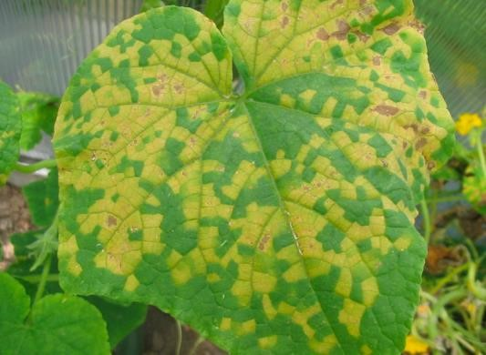
- Rusts: these are rusty orange/white colored sports that result in rupturing of the epidermis and formation of swellings. They are caused by fungi that attack leaves and stems e.g. coffee rust, bean rust
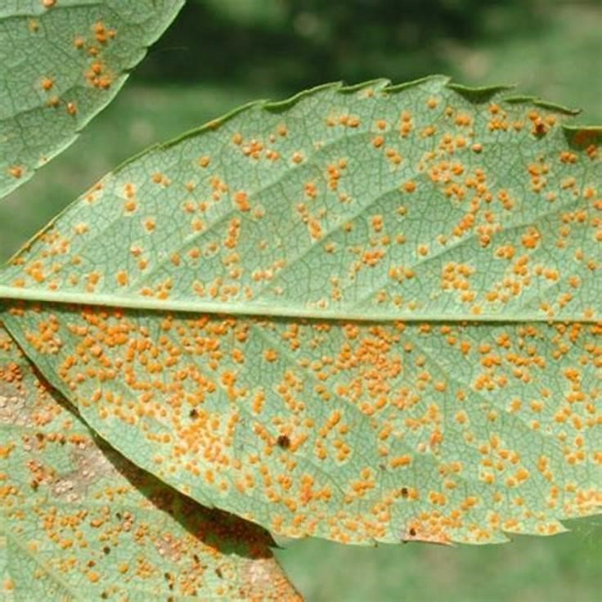
- Smuts are black dusty masses that resemble soot normally found in cereals like maize, wheat, sugar cane and sorghum. They are caused by fungi.
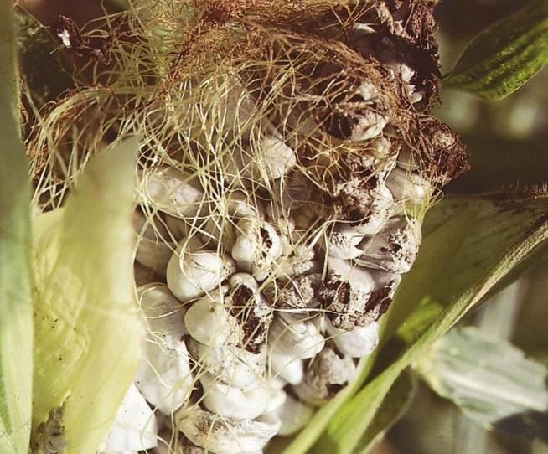
- Anthrocnose are small sunken water soaked lesions on leaves, stems and ponds. They caused by fungi e.g. bean anthrocnose.
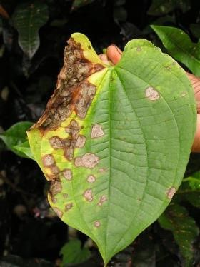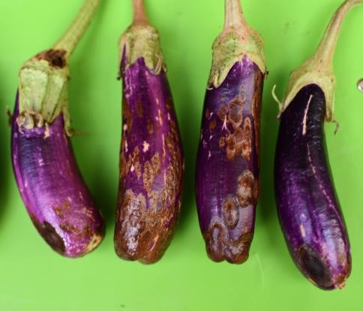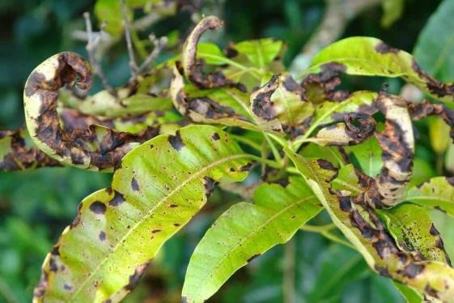

- Rots are degeneration of plant tissues due attack by pathogens. They are common in vegetables and fruits
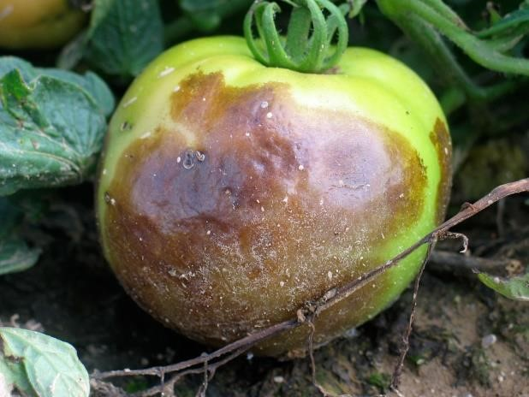
- Rosette occurs in leaves and makes the leaves to be grouped closely and packed together with limited spaces and there appears to be no internodes. E.g. groundnut rosette cause by viruses.
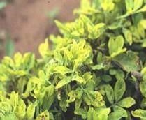
- Galls are swellings along the structure of a plant that may interfere with transportation and absorption of water and nutrients. They are caused by nematodes and fungi.
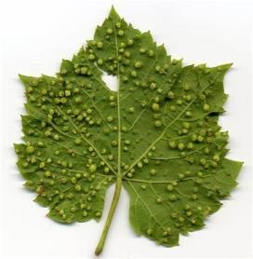
- Chlorosis is the uniform yellowing of leaves

- Necrosis is the death of plant tissues resulting from attack by pathogens.
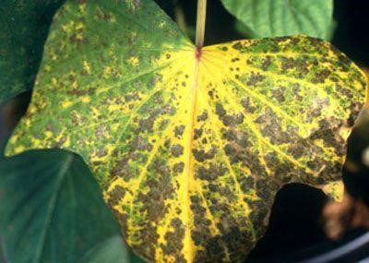
- Wilts: plant tissues become flaccid and drop/collapse caused by fungi.
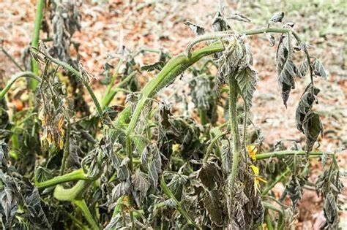
- Leaf spot and blights are limited non-expanding necrosis patches on leaves. If the spots are fast spreading, they kill the whole part of the plant and become blights.
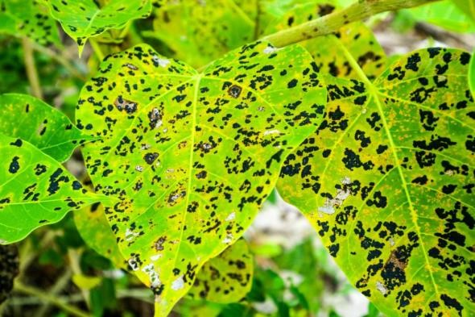
- Dumping off is the rotting or collapse of the seedlings at the ground level. It is caused by fungi.
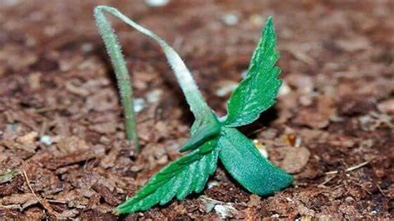
Dumping is promoted by
  - Heavy soil/poor drainage
  - Very high plant population
  - Heavy weed infestation
  - Excess soil moisture and nitrogen
- Mildew is the massive production of spores and mycelia that rapidly covers the leaf surface producing a powdery substance e.g. downy mildew.
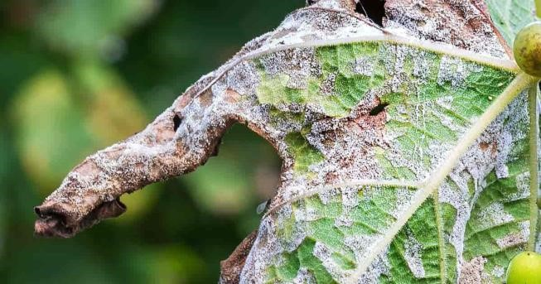
- Cankers are wounds created on plant tissue due to attack by pathogens
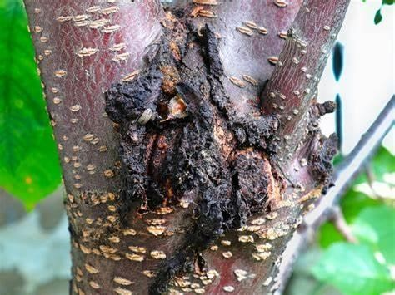
- Hypotrophy is the production of small sized cells induced by pathogens.
- Hypertrophy is the abnormal increase in the size of the plant organs due to increase in the size of the cells of a particular tissue
- Hyperplasia is the abnormal increase in the size of the plant organs due to increase in the number of cells of which the tissue or organ is composed, owing to increased cell division. (r) Phyllody is the abnormal development of floral parts into leafy structures (s) Mottling is the yellowing of leaves but with no pattern.

The environmental factors that cause diseases in plants

- Temperature
  - Sun scald exposed sites of fresh fruits and vegetables
  - Wilting due to high evaporation
  - Over sweetening of potatoes due to low temperature
- Soil
  - Cause stunted growth due to inadequate nutrients
  - Increase yellowing and leaf senescence due to lack of water
  - Rotting due to too much water
  - Chlorosis and early senescence due to inadequate supply of nitrogen
- Lack of soil moisture cause wilting and stunted growth
- Limited sunshine/shadows causes etiolation and weakening of plant stems (e) Air pollutants such as sulphur dioxide cause plant lesions

The nursery bed maintenance and how they can contribute to pest management
- Irrigation and water leads to healthy seedlings that can tolerate pests.
- Appropriate and regular watering wash off pests from seedlings
- Weeding eliminate weeds that act as breeding ground for pests
- Thinning reduces congestion and spread of pests
- Monitoring and picking out infected seedlings prevents spread of pests and diseases
- Spraying kills pesticides
- Application of fertilizers boot seedlings vigour which help them to tolerate pests and diseases
- Soil sterilization by heating soil kills pest

Factors that make fungi the most successful plant pathogens
- They have wide range of host
- They are saprophytic in nature and thus have food available
- Produce vast amount of spores to increase chance of survival
- Light spore is easily dispersed
- Can exist in different forms
- Readily undergo mutation
- Resistant to chemicals

Factors that contribute to the prevalence (increase) of pests in tropics
- Crop improvement that has made crops of better quality which favor multiplication of pests.
- Change in farming system the introduction of large supply of food to pests hence favoring their existence.
- Decline in species diversity elimination of species diversity disturbs the ecosystem through bush burning deforestation hence increasing pressure of pests to crops.
- Climatic change that leads to destruction of ecosystem and habitats for the organism.
- Introduction of new crops that come with new crop pests.
- Increased use pesticides leading to pesticide resistance. - Crop storage that enables pests to hide for long time - Improved transport that enable transport of pests.
- Change in demand patterns for crops; crops that are not in demand are neglected and their pests left to multiply for instance it happens with coffee when prices fall.

Revision question 3
- Painting of wood on a farm structure is done in order to
  - Block entry of air
  - Prevent termites attack
  - Block penetration of moisture
  - Seal off wood defects
- Frequent use of pesticide like DDT in an ecosystem is discouraged because it
  - Accumulates in consumer tissue
  - Cause migration of beneficial organisms from the areas
  - Leads to emergence of secondary pests in an area
  - Is too strong and cannot be diluted
- The best way of controlling scale insect pest in a sugar cane plantation is to
  - Spray the field with soil sterilants
  - Fumigate the soil
  - Crop rotation with legume
  - Expose them to their predators
- Which of the following does not affect sprayer performance
  - Operating pressure
  - Forward speed of operator
  - Height of the crop
  - Distance from the crop
- The best way of controlling scale insects pest in a sugar cane plantation is to
  - Spray the field with soil sterilants
  - Fumigate the soil
  - Crop rotation with legumes
  - Expose them to their predators

- Which one of the following does not affect sprayer performance?
  - Operating pressure
  - Forward speed of operator
  - Height of the crop
  - Distance from the crop

- Which of these sets of diseases given below are protozoan?
  - Fowl pox (iv) black quarter
  - Trypanosomiasis (v) anaphlasmosis
  - Riderpest (vi) Hog cholera
  - (i), (iv) (v)
  - (ii), (iv)
  - (i), (iii), (iv) D. (iii), (vi)
- Which of the following types of pesticides is the most effective in controlling aphids?
  - Contact pesticide
  - Surface sterilants
  - Fumigants
  - systematics
- one of the reasons for not treating millet seeds with chemicals during storage is the
  - it is difficult to clean off chemicals before consumption
  - the grain embryo is easily killed by chemicals
  - the tough grain coat resist pest attack
  - the small grain sizes discourage pest attack
- Pesticide like DDT have been discouraged mainly because
  - They are highly toxic to use
  - They are not easily degraded
  - They kill beneficial insects
  - They are not expensive
- Anaphlamosis is caused by
  - Ticks
  - Protozoa
  - Bacteria
  - viruses
- Which one of the following is a vector of the lift valley disease of sheep?
  - Mosquito
  - Tick
  - Tsetse fly
  - snail
- Which of the following is an example of an irregular pest?
  - Aphids
  - Locust
  - Grasshopper
  - White flies
- Which of the following agricultural chemicals is out of place
  - Agrocide
  - Gramoxone
  - Dalapon
  - agroxone
- which of the following pesticides is most suitable for controlling sap sucking pests
  - Contact pesticide
  - Surface sterilant
  - Systematic pesticide
  - fumigant
- The animal disease that is vector borne is
  - Anthrax
  - Foot and mouth
  - Rinderpest D. Trypanosomiasis
E.
- The bean characterized by brown, sunken and soaked lesions on the pond is
  - Bean mosaic
  - Bean rust
  - Bean anthrocnose
  - Angular leaf spot
- The fungus that causes browning in cotton lint is transmitted by A. Taybrgus sp.
  - Dysdercus sp.
  - Emposca sp.
  - Cryptophlebia sp.
- Which one of the following is a vector of Nairobi sheep disease?
  - Mosquito
  - Tick
  - Tsetse fly
  - snail

- Which of the following is a disinfectant on the farm?
  - Copper sulphate
  - Deknav
  - Terramycin
  - Dithane
- Maize streak is characterized by
  - Dark brown patches on the underside of leaves
  - Papery lesion on leaves
  - Narrow yellow stripes parallel to the leaf veins
  - Sooty appearance on the cob
- A cotton pest controlled by growing the hairy cotton variety is
  - Cotton stainer
  - American boll worm
  - Jassids
C. Spiny boll worm
- Scale and mealy bugs cause damage to crops through
D. Sucking
  - Chewing
  - Biting
  - Boring
- How does close spacing of ground nuts prevent rosette?
  - So much moisture kill virus
E. Aphids are controlled
  - Host plants are suppressed
  - Maximum use of nutrients hinder viral growth
- The best option for prevention of fusarium within banana plantation is to kill the disposing factors using A. Bacteria
  - Virucides
  - Nematocides
F. fungicides
- How a noxious weed such as stringa best is be controlled? By
  - Uprooting and burning
  - Crop rotation
  - Use of contact-non selective herbicide
  - Proper spacing

Answers to objective questions
1B 2C 3D 4D 5D | 6D | 7B | 8D | 9C | 10B | 11B | 12A | 13C
14A 15A 16D 17C 18B | 19B | 20A | 21C | 22C | 23A | 24B | 26D | 26B

- (a) Give five desirable characteristics of a pesticide
Should be
    - toxic to the target organism
    - specific to the target organism
    - biodegradable not to accumulate in the environment
    - harmless to the plants and animals
    - cheap and readily available - easy to store and transport
    - readily soluble in water
    - not accumulate in ecosystem
(b) State five factors that limit the use of pesticide by farmers
    - they and application equipment are expensive
    - application of pesticides requires skill especially in measuring and mixing - they kill beneficial organism as well for example pollinator.
    - They pollute the environment
    - They lower the value and/quality of products
    - They are poisonous to the farmer and livestock
    - Lead to chemical resistant pests
    - Accumulate in ecosystem
- What is biological control?
This is the control of the pest population below the economical threshold using their natural enemies in form of predator, pathogen, parasite etc.
- (a) Give the meaning of the following as applied in pesticide use
  - Pre-harvest period: it the duration/length of time which must elapse before crops sprayed with agricultural chemical can be consumed
  - Lethal dose 50 (LD50) is the dose of agricultural chemical that will kill 50% of the pest/animal in a test population.
- Explain characteristics that make pests successful in nature - Have high rate of multiplication e.g. lay very many eggs.
  - Most of them are small making it easy to hide
  - They resemble the host crop for easy camouflage
  - Have hard cuticle to protect them from adverse conditions
  - Most fly leading fast dispersal
  - Have defense mechanisms such as production of offensive smell
  - Undergo metamorphosis such that different stages occupy different ecological niches to reduce competition
  - Develop resistance to pesticides
  - Have alternative source of food
  - Have modified mouth parts to feed on crops such as mandibles for cutting and proboscises for sucking - Resistant to diseases.
- State the qualities of a good biological agent for pest control
  - Must have high searching ability
  - Should be adaptable to wide range of environments
  - Should be host specific
  - Should have ability to multiply in order to control the target organism
  - Should not cause a lot of damage to crops and animals
  - Should be easily raised artificially
  - Should be easy to distribute/apply
- Give the advantages of controlling pest using biological control method
    - It requires less labour
    - It is selective to the target organism
    - Long lasting from season to season
    - Can be easily employed to remote areas
    - cheap
- Explain the environmental factors that cause diseases in plants

(a) Temperature
    - Sun scald exposed sites of fresh fruits and vegetables
    - Wilting due to high evaporation
    - Over sweetening of potatoes due to low temperature
(b) Soil moisture
    - Cause stunted growth due to inadequate nutrients
    - Increase yellowing and leaf senescence due to lack of water
    - Rotting due to much water
    - Chlorosis and early senescence due to inadequate supply of nitrogen (c) Limited sunshine/shadows
    - Causes etiolation and weakening of plant stems (d) Water scarcity/drought/lack of rainfall
    - Causes stunted growth
- (a) What is meant by biological control of a crop pest (02marks)
  - Explain characteristics of a good biological control agent (09marks)
  - Give the advantages of controlling pest using biological control method (09marks)
- (a) Outline the various ways in which pests cause damage the crops
  - Explain the cultural methods of controlling crop pests (12marks)
    - Proper seed bed preparation: repeated tillage either exposes soil borne pests to their natural enemies on the surface or buries the pests very deep in the soil where they are suffocated and die.
    - Crop rotation: this controls pests which feed on specific crops; by not growing such crops, pests either migrate or die due to lack of food
    - Closed seasons: this involves foregoing cropping seasons without planting so as to control the build-up of pests in the field. Cropping is suspended for specific period to derive pests out of the host plants.
    - Use of resistant crop varieties that tolerate pests. The resistant varieties have characteristics such as hairiness, thick or hard epidermis, unattractive color and/or smell to the pest and early maturation
    - Destruction of crop residues after harvesting to eliminate breeding sites and kill the pests.
    - Use of certified seeds and planting materials that carry no pests
    - Regular weeding of the crops to eliminate breeding, hiding sites and alternative hosts.
    - Proper spacing reduces spread of pests from one crop to another
    - Proper pruning removes infected branches and micro habitats for the pests
    - Thinning prevents overcrowding and spreading of pests
    - Proper application of fertilizers ensures that crops grow faster or are able to tolerate pests - Rogueing eradicates pests by removing and destroying pest affected crops from the garden.
    - Mulching especially with black polythene controls nematodes in pineapple fields.
    - Timely planting ensures that the crops grow and mature before destructive stages of the pest.
    - Timely harvesting prevents attack of mature grains such as in millet, sorghum, rice and maize.
    - Destroying volunteer plants i.e. plants that provide alternative source of food or breeding ground.
    - Intercropping discourages spreading of pest from one crop to another and some crops like tobacco produce natural pest repellants.

- (a) Describe the dangers associated with the use of pesticides in agricultural production
    - Pesticides can be poisonous to farmers and their animals
    - Pollute the environment i.e. water, land and air
    - Some pesticides are inflammable and may cause fire hazards
    - Some pesticides such as DDT accumulate in food chain leading to toxic levels and may eliminate organisms in top food levels.
    - Continuous use of same pesticides leads to resurgence due to development of resistance.
    - Eliminate non-targeted organism such as pollinators that are useful to the farmers. - Expensive
(b) Outline the precautions to be taken by the farmers to ensure safe use of pesticides
    - Read the instructions on the container or leaflet before using the pesticide
    - Wear protective clothes such as overalls, gloves, rubber boots, head masks and eye shields.
    - Chemical should be stored in safe places away from children.
    - Do not eat or drink while working with pesticides
    - Wash any spillage from your body as soon as possible
    - Clean the equipment after use
    - Dispose of empty containers safely as instructed by the manufacturer.
    - Do not use empty containers for edible substances.
- (a) What is meant by pesticide resistance
It is a situation where the pest population remains relatively unaffected by application of a recommended pesticide in the right quantities and concentrations. Or it is a situation where pests acquire characteristics/traits that enable them to survive despite the recommended levels of pesticides.
  - Describe the factors that promote pesticide resistance in pest populations - Genetic factors; high genetic variation promote resistance
    - Mutation
    - Prolonged t use of a single pesticide
    - Unwarranted use of pesticides
    - Use of broad spectrum pesticides such as DDT that kill natural enemies of the pests.
    - Use of sub-lethal concentration of pesticides
    - High population of pesticide
    - Non-uniform application of pesticides in the field
- (a) Write short notes on the following
  - Integrated pest management (IPM)
It is a pest control measure involving use of a wide range of methods to control pests without harming the environment using methods such as biological control, burying/burning infected plant parts etc. use of chemicals is minimized.
  - Biological control
  - Cultural pest control
It is a pest control measure involving application of agronomic practices that interfere with the life cycle of pests such as proper seed bed, early planting, crop rotation, proper hygiene during harvesting and use of resistant varieties.
  - Chemical pest control
It a pest control measures that involve use of chemicals. Natural chemicals use includes a mixture of urine and ash, some plant extracts etc. Synthetic chemicals include DDT, ambush, deldrine, malathion etc.
(b) Discuss the nursery bed maintenance and how they can contribute to pest management - Irrigation and water leads to healthy seedlings that can tolerate pests.
- Appropriate and regular watering wash off pests from seedlings
- Weeding eliminate weeds that act as breeding ground for pests
- Thinning reduces congestion and spread of pests
- Monitoring and picking out infected seedlings prevents spread of pests and diseases
- Spraying kills pesticides
- Application of fertilizers boot seedlings vigour which help them to tolerate pests and diseases
- Soil sterilization by heating soil kills pest
37. (a) How can disease spread in crops?
- Through wind/air current blow spores from one diseased crop to another
- Through rain splash
- Contact between health and diseased plant
- Infected planting materials/seedlings/cuttings
- Pruning knives, pangas carry disease causing organisms
- Transfer of disease causing organisms by pests and vectors
- Irrigation with contaminated water
- Application of infected mulches
- Through infected crop wastes/residues
- Through infected organic manure
- Through contact with infected animals
(b) Describe the methods that can be used to control crop diseases
- Plant resistant/tolerant plants to diseases
- Timely weeding to remove alternative hosts or breeding grounds
- Crop rotation to prevent building up host specific diseases
- Spraying with recommended chemicals to control vectors or to kill disease causing agents
- Seed dressing can be used to destroy spores on the seeds
- Heat treatment can be used to destroy spores on the seeds.
- Sterilizing soil by heat to kill pathogens
- Early planting to escape buildup of pests and diseases
- Proper spacing to minimize spreading of diseases
- Quarantine to restrict movement of diseased plant materials
- Destruction of crop residues that contain pathogens
- Pruning to reduce micro-climate that favor growth of microorganisms
- Disinfect tools to prevent spread of diseases
- Proper hygiene
- (a) Explain six ways through which crop diseases spread on farms. (06marks)
  - Through wind/air current blow spores from one diseased crop to another
  - Through rain splash
  - Contact between health and diseased plant
  - Infected planting materials/seedlings/cuttings
  - Pruning knives, pangas carry disease causing organisms
  - Transfer of disease causing organisms by pests and vectors
  - Irrigation with contaminated water
  - Application of infected mulches
  - Through infected crop wastes/residues
  - Through infected organic manure
  - Through contact with infected animals

  - Suggest four conditions necessary for successful disease infection of a crop in a field?
(04marks)
  - There must be pathogen host contact
  - Plant must be susceptible to the pathogen
  - The pathogen must be in pathogenic stage
  - Presence of favorable temperature
  - Favorable humidity
- The figure below shows the transfer of energy in kJyr-1 (on top) and the amount of pesticide in parts per million (at the bottom) at different levels in the food chain in an ecosystem. Study the figure and answer the questions that follow:
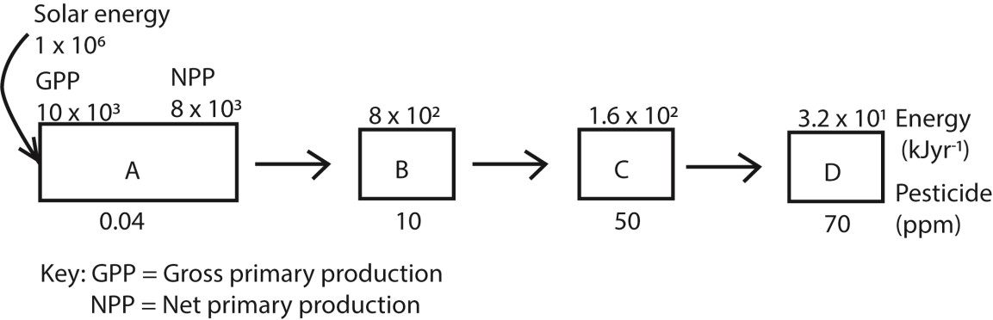
(a)(i)What organisms occupy A on the diagram?
Producers

  - What is the percentage of incident energy absorbed by the organisms at level A?
Percentage = 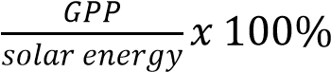
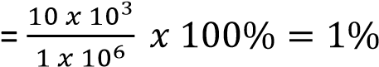
  - Where does the rest of the energy which is not absorbed at level A Go? It is reflected into the atmosphere as heat or absorbed by non-living organism

  - Calculate the percentage of energy of the net primary production in the organism at level A which is transferred to organism at
    - Level B
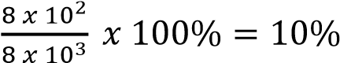

    - Level C
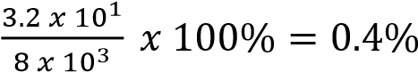

  - What conclusions can be made from your answer in (b) about the transfer of energy along trophic levels?
The energy transfer from producers along the trophic levels reduces
  - Explain why all the energy at one trophic level is not transferred to the next trophic level - Energy is lost through respiration, excretion, egestion death and decomposition - Not all materials ingested is digested.

  - (i) Describe the trend of the pesticide concentration from organisms at level A to those of level D.
In pesticide concentration in organisms increases with the increase in trophic levels from A to D.
    - Explain the trend of the concentration of pesticide in e(i)
The consumer at high trophic eats several organism and accumulates the pesticide in its tissues
    - Suggest one property of the pesticides. Explain your answer
It is non-biodegradable because it accumulates in the organisms along the trophic levels.
  - What is meant by pesticide resistance
It is a situation where the pest population remains relatively unaffected by application of a recommended pesticide in the right quantities and concentrations. Or it is a situation where pests acquire characteristics/traits that enable them to survive despite the recommended levels of pesticides.
  - Describe the factors that promote pesticide resistance in pest populations
    - Genetic factors; high genetic variation promote resistance
    - Mutation
    - Prolonged t use of a single pesticide
    - Unwarranted use of pesticides
    - Use of broad spectrum pesticides such as DDT that kill natural enemies of the pests.
    - Use of sub-lethal concentration of pesticides
    - High population of pesticide
    - Non-uniform application of pesticides in the field
-

Revision question
- Painting of wood on a farm structure is done in order to
  - Block entry of air
  - Prevent termites attack
  - Block penetration of moisture
  - Seal off wood defects
- Frequent use of pesticide like DDT in an ecosystem is discouraged because it
  - Accumulates in consumer tissue
  - Cause migration of beneficial organisms from the areas
  - Leads to emergence of secondary pests in an area
  - Is too strong and cannot be diluted
- The best way of controlling scale insect pest in a sugar cane plantation is to
  - Spray the field with soil sterilants
  - Fumigate the soil
  - Crop rotation with legume
  - Expose them to their predators
- Which of the following does not affect sprayer performance
  - Operating pressure
  - Forward speed of operator
  - Height of the crop
  - Distance from the crop
- The best way of controlling scale insects pest in a sugar cane plantation is to
  - Spray the field with soil sterilants
  - Fumigate the soil
  - Crop rotation with legumes
  - Expose them to their predators

- Which one of the following does not affect sprayer performance?
  - Operating pressure
  - Forward speed of operator
  - Height of the crop
  - Distance from the crop

- Which of these sets of diseases given below are protozoan?
  - Fowl pox (iv) black quarter
  - Trypanosomiasis (v) anaphlasmosis
  - Riderpest (vi) Hog cholera
  - (i), (iv) (v)
  - (ii), (iv)
  - (i), (iii), (iv) H. (iii), (vi)
- Which of the following types of pesticides is the most effective in controlling aphids?
  - Contact pesticide
  - Surface sterilants
  - Fumigants
  - systematics
- one of the reasons for not treating millet seeds with chemicals during storage is the
  - it is difficult to clean off chemicals before consumption
  - the grain embryo is easily killed by chemicals
  - the tough grain coat resist pest attack
  - the small grain sizes discourage pest attack
- Pesticide like DDT have been discouraged mainly because
  - They are highly toxic to use
  - They are not easily degraded
  - They kill beneficial insects
  - They are not expensive
- Anaphlamosis is caused by
  - Ticks
  - Protozoa
  - Bacteria
  - viruses
- Which one of the following is a vector of the lift valley disease of sheep?
  - Mosquito
  - Tick
  - Tsetse fly
  - snail
- Which of the following is an example of an irregular pest?
  - Aphids
  - Locust
  - Grasshopper
  - White flies
- Which of the following agricultural chemicals is out of place
  - Agrocide
  - Gramoxone
  - Dalapon
  - agroxone
- which of the following pesticides is most suitable for controlling sap sucking pests
  - Contact pesticide
  - Surface sterilant
  - Systematic pesticide
  - fumigant
- The animal disease that is vector borne is
  - Anthrax
  - Foot and mouth
  - Rinderpest I. Trypanosomiasis
J.
- The bean characterized by brown, sunken and soaked lesions on the pond is
  - Bean mosaic
  - Bean rust
  - Bean anthrocnose
  - Angular leaf spot
- The fungus that causes browning in cotton lint is transmitted by E. Taybrgus sp.
  - Dysdercus sp.
  - Emposca sp.
  - Cryptophlebia sp.
- Which one of the following is a vector of Nairobi sheep disease?
  - Mosquito
  - Tick
  - Tsetse fly
  - snail

- Which of the following is a disinfectant on the farm?
K. Copper sulphate
  - Deknav
  - Terramycin
  - Dithane
- Maize streak is characterized by
  - Dark brown patches on the underside of leaves
  - Papery lesion on leaves
L. Narrow yellow stripes parallel to the leaf veins
F. Sooty appearance on the cob
- A cotton pest controlled by growing the hairy cotton variety is
  - Cotton stainer
  - American boll worm
M. Jassids
F. Spiny boll worm
- Scale and mealy bugs cause damage to crops through
N. Sucking
  - Chewing
  - Biting
  - Boring
- How does close spacing of ground nuts prevent rosette?
D. So much moisture kill virus
O. Aphids are controlled
  - Host plants are suppressed
  - Maximum use of nutrients hinder viral growth
- The best option for prevention of fusarium within banana plantation is to kill the disposing factors using D. Bacteria
  - Virucides
  - Nematocides
P. fungicides
- How a noxious weed such as stringa best is be controlled? By
  - Uprooting and burning
  - Crop rotation
  - Use of contact-non selective herbicide
  - Proper spacing

Answers to objective questions
1B 2C 3D 4D 5D 6D 7B 8D 9C 10B 11B 12A 13C
14A 15A 16D 17C 18B 19B 20A 21C 22C 23A 24B 26D 26B

SECTION B

- (a) Give five desirable characteristics of a pesticide
Should be
  - toxic to the target organism
  - specific to the target organism
  - biodegradable not to accumulate in the environment
  - harmless to the plants and animals
  - cheap and readily available - easy to store and transport
  - readily soluble in water
  - not accumulate in ecosystem
(b) State five factors that limit the use of pesticide by farmers
  - they and application equipment are expensive
  - application of pesticides requires skill especially in measuring and mixing - they kill beneficial organism as well for example pollinator.
  - They pollute the environment
  - They lower the value and/quality of products
  - They are poisonous to the farmer and livestock
  - Lead to chemical resistant pests
  - Accumulate in ecosystem
- What is biological control?
This is the control of the pest population below the economical threshold using their natural enemies in form of predator, pathogen, parasite etc.
- (a) Give the meaning of the following as applied in pesticide use
  - Pre-harvest period: it the duration/length of time which must elapse before crops sprayed with agricultural chemical can be consumed
  - Lethal dose 50 (LD50) is the dose of agricultural chemical that will kill 50% of the pest/animal in a test population.
- Explain characteristics that make pests successful in nature - Have high rate of multiplication e.g. lay very many eggs.
  - Most of them are small making it easy to hide
  - They resemble the host crop for easy camouflage
  - Have hard cuticle to protect them from adverse conditions
  - Most fly leading fast dispersal
  - Have defense mechanisms such as production of offensive smell
  - Undergo metamorphosis such that different stages occupy different ecological niches to reduce competition
  - Develop resistance to pesticides
  - Have alternative source of food
  - Have modified mouth parts to feed on crops such as mandibles for cutting and proboscises for sucking - Resistant to diseases.
- State the qualities of a good biological agent for pest control
  - Must have high searching ability
  - Should be adaptable to wide range of environments
  - Should be host specific
  - Should have ability to multiply in order to control the target organism
  - Should not cause a lot of damage to crops and animals
  - Should be easily raised artificially
  - Should be easy to distribute/apply
- Give the advantages of controlling pest using biological control method
    - It requires less labour
    - It is selective to the target organism
    - Long lasting from season to season
    - Can be easily employed to remote areas
    - cheap
- Explain the environmental factors that cause diseases in plants

(f) Temperature
    - Sun scald exposed sites of fresh fruits and vegetables
    - Wilting due to high evaporation
    - Over sweetening of potatoes due to low temperature
(g) Soil moisture
    - Cause stunted growth due to inadequate nutrients
    - Increase yellowing and leaf senescence due to lack of water

Rotting due to much water
Chlorosis and early senescence due to inadequate supply of nitrogen (h) Limited sunshine/shadows
    - Causes etiolation and weakening ofplant stems (i) Water scarcity/drought/lack of rainfall
    - Causes stunted growth
- (a) What is meant by biological control of a crop pest (02marks)
  - Explain characteristics of a good biological control agent (09marks)
  - Give the advantages of controlling pest using biological control method (09marks)
- (a) Outline the various ways in which pests cause damage the crops
    - Eat the buds, flowers, shoot, fruits e.g. grasshopper, caterpillars and beetles eat leaves/cause defoliation
    - They bore into fruits and seeds e.g. bean bruchid, maize weevil etc. and eat inside causing holes, discoloring the tubers and causing them to have bitter taste e.g. sweet potato weevils.
    - Suck plant sap and reduce plant vigour e.g. aphids, mearly bugs and scales - Transmit diseases e.g. maize leaf hopper, white flies etc.
    - Change crop’s growth habits e.g. sorghum shoot flies
    - Cause loss of quality of crops
    - They penetrate and damage plant roots thus preventing absorption of water and nutrients - They reduce the yield of crops.
  - Explain the cultural methods of controlling crop pests (12marks)
    - Proper seed bed preparation: repeated tillage either exposes soil borne pests to their natural enemies on the surface or buries the pests very deep in the soil where they are suffocated and die.
    - Crop rotation: this controls pests which feed on specific crops; by not growing such crops, pests either migrate or die due to lack of food
    - Closed seasons: this involves foregoing cropping seasons without planting so as to control the build-up of pests in the field. Cropping is suspended for specific period to derive pests out of the host plants.
    - Use of resistant crop varieties that tolerate pests. The resistant varieties have characteristics such as hairiness, thick or hard epidermis, unattractive color and/or smell to the pest and early maturation
    - Destruction of crop residues after harvesting to eliminate breeding sites and kill the pests.
    - Use of certified seeds and planting materials that carry no pests
    - Regular weeding of the crops to eliminate breeding, hiding sites and alternative hosts.
    - Proper spacing reduces spread of pests from one crop to another
    - Proper pruning removes infected branches and micro habitats for the pests
Thinning prevents overcrowding and spreading of pests
Proper application of fertilizers ensures that crops grow faster or are able to tolerate pests - Rogueing eradicates pests by removing and destroying pest affected crops from the garden.
    - Mulching especially with black polythene controls nematodes in pineapple fields.
    - Timely planting ensures that the crops grow and mature before destructive stages of the pest.
    - Timely harvesting prevents attack of mature grains such as in millet, sorghum, rice and maize.
    - Destroying volunteer plants i.e. plants that provide alternative source of food or breeding ground.
    - Intercropping discourages spreading of pest from one crop to another and some crops like tobacco produce natural pest repellants.

- (a) Describe the dangers associated with the use of pesticides in agricultural production
    - Pesticides can be poisonous to farmers and their animals
    - Pollute the environment i.e. water, land and air
    - Some pesticides are inflammable and may cause fire hazards
    - Some pesticides such as DDT accumulate in food chain leading to toxic levels and may eliminate organisms in top food levels.
    - Continuous use of same pesticides leads to resurgence due to development of resistance.
    - Eliminate non-targeted organism such as pollinators that are useful to the farmers. - Expensive
(b) Outline the precautions to be taken by the farmers to ensure safe use of pesticides
    - Read the instructions on the container or leaflet before using the pesticide
    - Wear protective clothes such as overalls, gloves, rubber boots, head masks and eye shields.
    - Chemical should be stored in safe places away from children.
    - Do not eat or drink while working with pesticides
    - Wash any spillage from your body as soon as possible
    - Clean the equipment after use
    - Dispose of empty containers safely as instructed by the manufacturer.
    - Do not use empty containers for edible substances.
- (a) What is meant by pesticide resistance
It is a situation where the pest population remains relatively unaffected by application of a recommended pesticide in the right quantities and concentrations. Or it is a situation where pests acquire characteristics/traits that enable them to survive despite the recommended levels of pesticides.
  - Describe the factors that promote pesticide resistance in pest populations
    - Genetic factors; high genetic variation promote resistance
Mutation
Prolonged t use of a single pesticide
    - Unwarranted use of pesticides
    - Use of broad spectrum pesticides such as DDT that kill natural enemies of the pests.
    - Use of sub-lethal concentration of pesticides
    - High population of pesticide
    - Non-uniform application of pesticides in the field
- (a) Write short notes on the following
  - Integrated pest management (IPM)
It is a pest control measure involving use of a wide range of methods to control pests without harming the environment using methods such as biological control, burying/burning infected plant parts etc. use of chemicals is minimized.
  - Biological control
  - Cultural pest control
It is a pest control measure involving application of agronomic practices that interfere with the life cycle of pests such as proper seed bed, early planting, crop rotation, proper hygiene during harvesting and use of resistant varieties.
  - Chemical pest control
It a pest control measures that involve use of chemicals. Natural chemicals use includes a mixture of urine and ash, some plant extracts etc. Synthetic chemicals include DDT, ambush, deldrine, malathion etc.
(b) Discuss the nursery bed maintenance and how they can contribute to pest management - Irrigation and water leads to healthy seedlings that can tolerate pests.
- Appropriate and regular watering wash off pests from seedlings
- Weeding eliminate weeds that act as breeding ground for pests
- Thinning reduces congestion and spread of pests
- Monitoring and picking out infected seedlings prevents spread of pests and diseases
- Spraying kills pesticides
- Application of fertilizers boot seedlings vigour which help them to tolerate pests and diseases
- Soil sterilization by heating soil kills pest

